Maths for programming

Contents

Contents 1

Rotate a vector 2

Rotating a vector Using Quaternions 7

Quaternions 8

1D Vectors 11

2D Vectors 11

Dot Product 13

Spaces 15

Converting world space to local 15

Matrices 20

Cross Product 23

Drawing a playerDetect 28

Draw a bouncing laser 31

calculate the surface area of meshes 36

Trig 42

Tangent 44

Determinant 48

Drawing a polygon 50

Drawing a regular polygon ignoring density 51

Bezier Curves 59

quadratic bezier curve 60

Cubic Bezier curve 60

Rotation 61

Drawing a coil 63

Drawing a coil around a torus 65

Structure of a mesh 68

Generating a quad ring 74

# Maths Library

What to Include in maths library:

**Commutative**: to describe operations or elements that can be rearranged without affecting the result. it means that swapping the order of the operands does not alter the result.

For any two numbers a and b, the sum of a and b is the same regardless of the order: a + b = b + a.

**distributive over addition**: refers to a property that an operation can have in relation to addition.

The distributive property states that when you perform an operation on a number and a sum of two numbers, you can either perform the operation on each addend separately and then add the results, or you can perform the operation on the entire sum. In other words, the operation "distributes" over the addition.

a * (b + c) = (a * b) + (a * c)

**associative**: describe operations or elements that can be grouped together in different ways without affecting the result, The associative property states that when you perform an operation on three or more elements, the grouping of the elements does not change the outcome of the operation.

(a * b) * c = a * (b * c)

## Vectors

### Getting a Vector between Two Points: Subtraction

subtraction isn’t commutative (that is, a − b is not the same as b − a), the order is significant

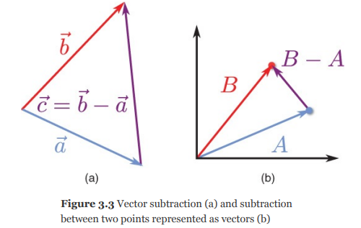

### Addition

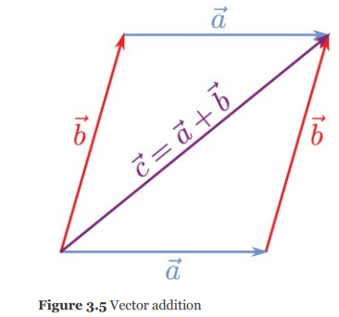

### Distance : Length

You use two vertical bars on either side of a vector variable to denote computing the magnitude (or length) of the vector. 

To calculate the length of a vector, take the square root of the sum of the squares of each component:

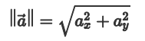

You can use the magnitude to compute the distance between two arbitrary points. Given points p and q, treat them as vectors and perform vector subtraction. The magnitude of the result of the subtraction is equal to the distance between the two points:

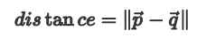

### Determining Directions: Unit Vectors and Normalization

A unit vector is a vector with a length of one. The notation for unit vectors is to write a “hat” above the vector’s symbol, such as û. You can convert a vector with a non-unit length into a unit vector through normalization. To normalize a vector, divide each component by the length of the vector

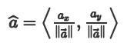

…

### Converting from an Angle to a Forward Vector

a rotation represented by an angle in radians. This allows you to rotate the way an actor faces. Because the rotations are in 2D for now, the angle directly corresponds to an angle on the unit circle.

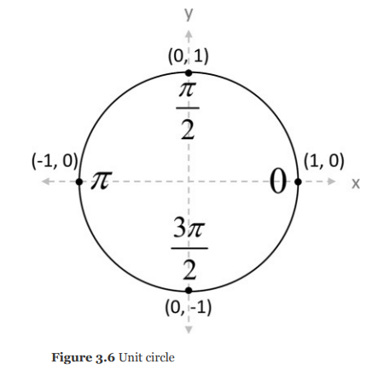

The equation of the unit circle in terms of an angle, theta, is:

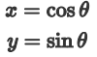

You can directly use these equations to convert the actor’s angle into a forward vector

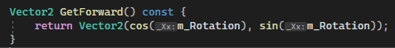

you don’t explicitly normalize the vector. This is because the circle equation always returns a unit length vector because the unit circle has a radius of one.

the unit circle has +y as up, whereas SDL 2D graphics use +y down. So for the correct forward vector in SDL

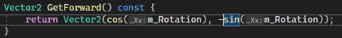

### Converting a Forward Vector to an Angle: Arctangent

Given a forward vector, you want to convert it into an angle. Recall that the tangent function takes in an angle and returns the ratio between the opposite and adjacent sides of a triangle.

you calculate a new “desired” forward vector for an actor, but you need to convert this to the angle for its rotation member variable. In this case, you can form a right triangle with this new forward vector and the x-axis

For this triangle, the x component of the forward vector is the length of the adjacent side of the triangle, and the y component of the forward vector is the length of the opposite side of the triangle. you can then use the arctangent function to calculate the angle θ.

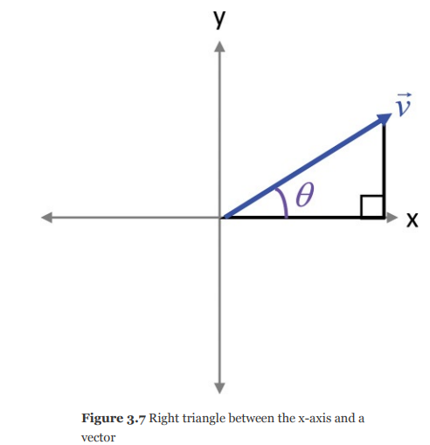

the preferred arctangent function is the atan2 function, which takes two parameters (the opposite length and the adjacent length) and returns an angle in the range [–π,π].

A positive angle means the triangle is in the first or second quadrant (a positive y value), and a negative angle means the triangle is in the third or fourth quadrant.

suppose you want a ship to face toward an asteroid. You can first construct the vector from the ship to the asteroid and normalize this vector. Next, use atan2 to convert the new forward vector to an angle.

Finally, set the ship actor’s rotation to this new angle. Note that you must negate the y component to account for +y down in SDL’s 2D coordinate system. This yields the following code:

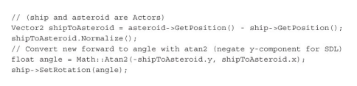

This arctangent approach works very well for 2D games. However, it only works in this form for 2D games because all objects remain on the x-y plane. For 3D games, it’s often preferable to use the dot product approach.

### Determining the Angle Between Two Vectors: Dot Product

The dot product between two vectors results in a single scalar value. One of the most common uses of the dot product in games is to find the angle between two vectors. The following equation calculates the dot product between vectors:

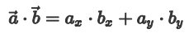

The dot product also has a relationship to the cosine of an angle, and you can use the dot product to compute the angle between two vectors:

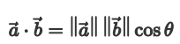

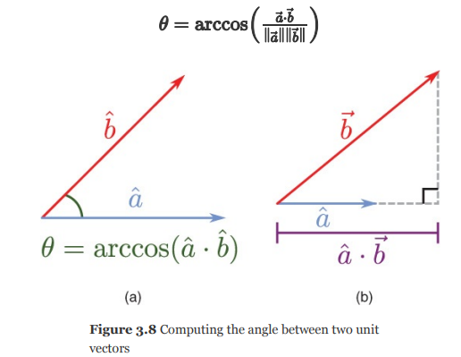

The dot product itself is not used to find the angle between two vectors directly, but rather it can be used in conjunction with other mathematical operations to calculate the angle.

If the two vectors and are unit vectors, you can omit the division because the length of each vector is one:

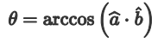

This is one reason it’s helpful to normalize vectors in advance if only the direction matters.

For example, consider a player at position p with a forward vector of . A new enemy appears at position e. Suppose you need the angle between the original forward vector and the vector from p to e. First, compute the vector from p to e, using the vector representations of the points:

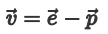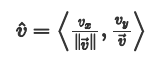

use the dot product equations to determine the angle between 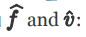



Because the dot product can calculate an angle between two vectors, a couple of special cases are important to remember.

One drawback of using the dot product to calculate the angle is that the arccosine function returns an angle in the range [0, π]. This means that while the arccosine gives the minimum angle of rotation between the two vectors, it doesn’t say whether this rotation is clockwise or counterclockwise

As with multiplication between two real numbers, the dot product is commutative, distributive over addition, and associative

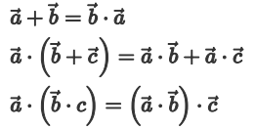

### Calculating a Normal: Cross Product

A normal is a vector perpendicular to a surface. Calculating the normal of a surface (such as a triangle) is a very useful calculation.

Given two 3D vectors that are not parallel, there is a single plane that contains both vectors. The cross product finds a vector perpendicular to that plane

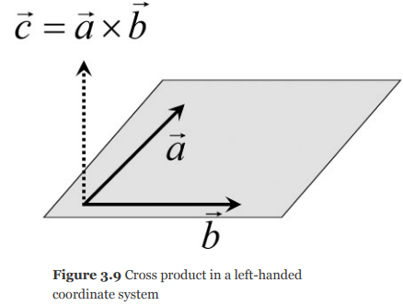

The cross product does not work with 2D vectors. The × symbol denotes a cross product between two vectors:

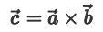

Note that there’s technically a second vector perpendicular to the plane 

the cross product. It’s not commutative but instead anticommutative:

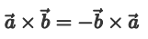

The numeric calculation of the cross product is

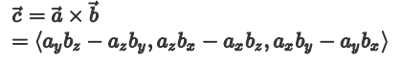

As with the dot product, there’s a special case to consider. If the cross product returns the vector 〈0,0,0〉, this means that a and b are collinear.

Two collinear vectors cannot form a plane, and therefore there’s no normal for the cross product to return.

Because a triangle lies on a single plane, the cross product can determine the normal of the triangle.

triangle ABC. To calculate the normal, first construct two vectors for edges of the triangle:

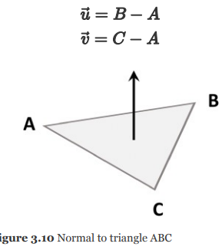

Then take the cross product between these two vectors and normalize the result. This yields the normal vector of the triangle:

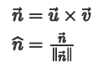

## Newtonian physics

its laws hold if objects are not moving near the speed of light and objects are larger than quantum particles.

movement without rotational forces, or linear mechanics

### force and mass

**Force** is an influence that can cause an object to move. Because force has a magnitude and direction, it’s natural to represent force with a vector.

**Mass** is a scalar that represents the quantity of matter contained in an object. It’s common to confuse mass with weight, but mass is independent of any gravity, whereas weight is not. The greater the mass of an object, the more difficult it is to change the movement of that object.

If you apply sufficient force to an object, it will start moving. Newton’s second law of motion encapsulates this idea:

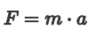

acceleration, or the rate at which the velocity of an object increases. An arbitrary object in the game has a mass, and you can apply forces to that object. From this, you can then compute the acceleration of the object

the typical symbolic representation of linear mechanics is that position, velocity, and acceleration are functions over time

Then, with calculus, you can calculate the velocity function as the derivative of the position function and the acceleration function as the derivative of the velocity function. Basically to get the velocity, you differentiate the position with respect to time and for acceleration you differentiate the velocity.

**this standard formulation in terms of symbolic equations and derivatives is not particularly applicable in a game. A game needs to apply a force to an object and, from that force, determine the acceleration over time. Once you have an object’s acceleration, you can compute the change in the object’s velocity. Finally, given a velocity, you can compute the change in the object’s position. A game only needs to compute this in terms of the discrete time step of delta time. It doesn’t need a symbolic equation. This requires using integration—but not symbolic integration. Instead, you must use numeric integration, which approximates the symbolic integral over a fixed time step.**

### Computing Positions with Euler Integration

Numeric integration allows a game to update the velocity based on the acceleration and then update the position based on the velocity. However, to compute the acceleration of an object, the game needs to know the mass of the object as well as the forces applied to the object.

There are multiple types of forces to consider. Some forces, such as gravity, are constant and should apply on every frame. Other forces may instead be impulses, or forces that apply only for a single frame

For example, when a character jumps, an impulse force allows the player to get off the ground. However, the character will eventually return to the ground because of the constant force of gravity. Because multiple forces can act on an object simultaneously, and forces are vectors, adding up all the forces gives the total force applied to an object for that frame. Dividing the sum of forces by mass yields acceleration



Next, you can use the Euler integration method of numeric integration to compute the velocity and the position:

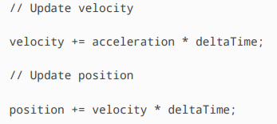

Note that force, acceleration, velocity, and position are all represented as vectors in these calculations. Because these calculation depend on the delta time, you can put them in the Update function of a component that simulates physics

For games that rely on physics simulation, variable frame times (or time steps) can cause problems. This is because the accuracy of numeric integration depends on the size of the time step. The smaller the time step, the more accurate the approximation.

If the frame rate varies from frame to frame, so does the accuracy of the numeric integration. The accuracy changing could affect the behavior in very noticeable ways. Imagine playing Super Mario Bros., where the distance Mario can jump varies depending on the frame rate. The lower the frame rate, the further Mario can jump. This is because the error amount in numeric integration increases with a lower frame rate, which results in an exaggerated jump arc.

For this reason, any game that uses physics to calculate the positions of objects should not use a variable frame rate—at least not for the physics simulation code. Instead, you can use the frame-limiting approach, which works if the frame rate doesn’t go below the target frame rate. A more complex alternative is to divide the larger time step into multiple fixed-size physics time steps

## TRANSFORMATION BASICS

# Rotate a vector

Lets say you have your coordinate system, the regular cartesian coordinate system and you have the unit circle, so with the unit circle, you can use the trigonometric functions to get a vector pointing from the origin to some location on this unit circle based off of an angle that we usually call theta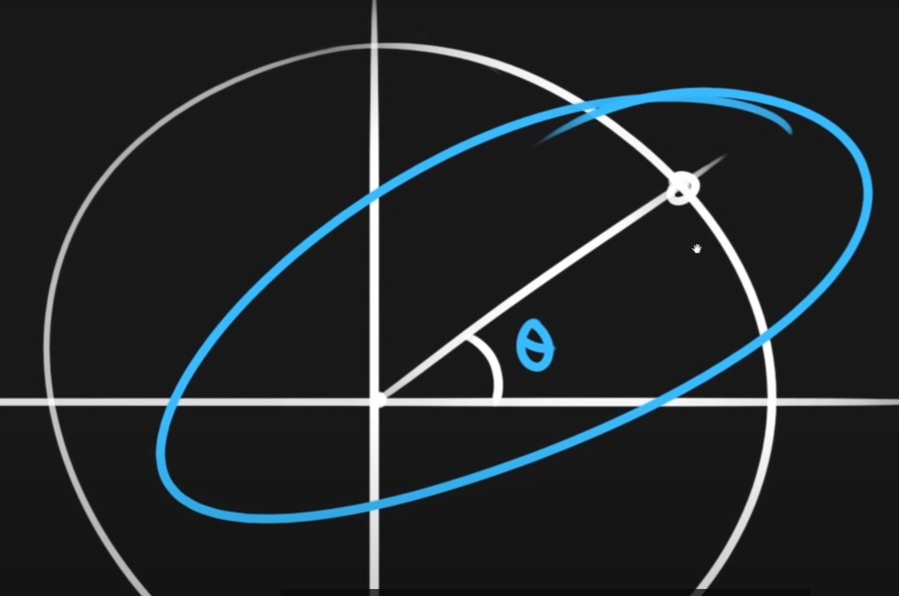

So we can use this relationship in order to figure out how to rotate vectors. So lets say that we have some arbitrary points we want to rotate, lets say this is the point that we want to rotate by some angle, then what we can do is construct a coordinate space using our sine and cosine functions because we know that the cosine gives us the x coordinate.

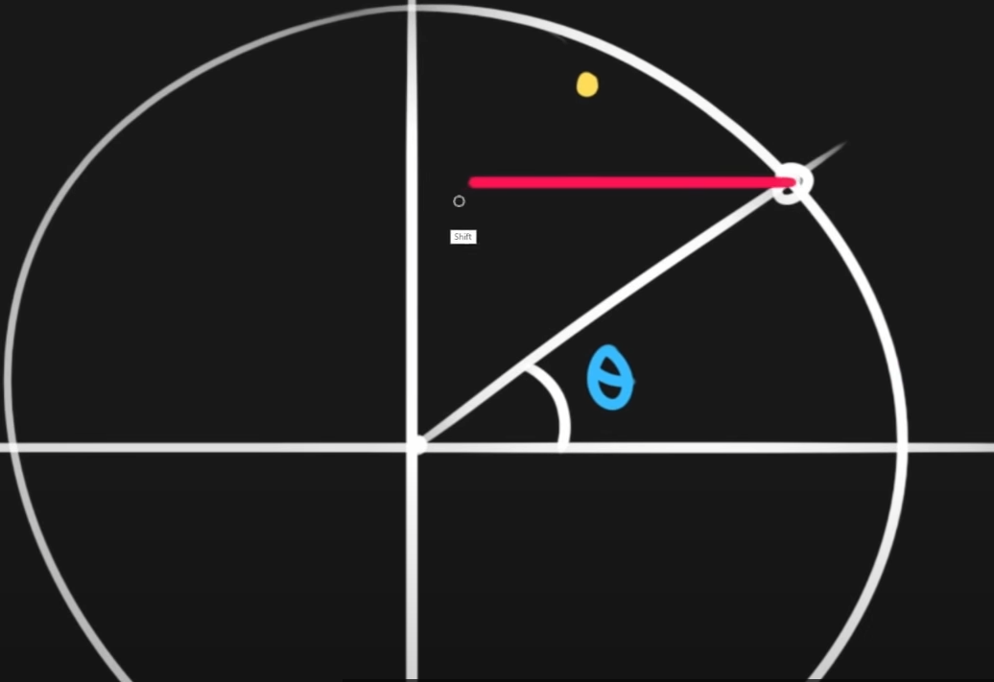

And the sine gives us the y-coordinate of this point and so what we can do is using sine and cosine we get this direction vector.

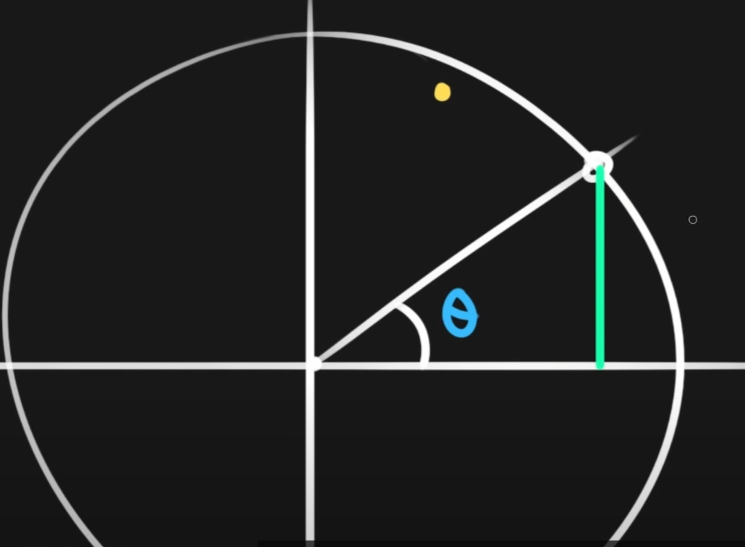

Then after we have this (red) vector which is you know the x coordinate would the cosine of theta and the y coordinate would be the sine of theta.

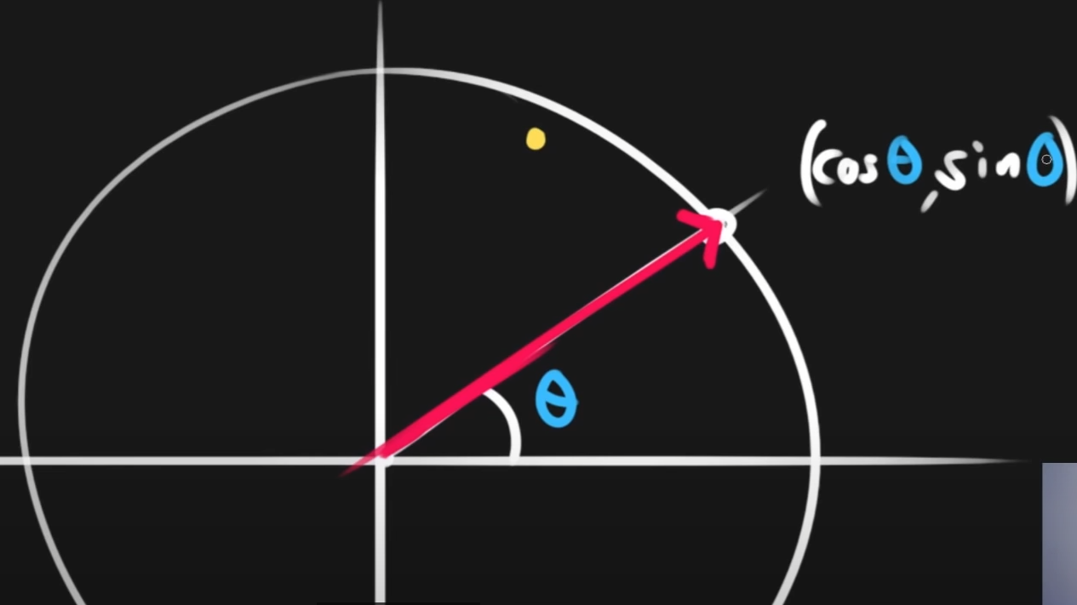

That’s how we get that vector, now if we want to get the other vector, if we want to construct a coordinate system then we can do is swap them (sin0, cos0) and negate one of them, then we rotate this vector 90 ( basically if you want to rotate by 90 degrees you swap these 2 and negate the sine)and depending on which one we negate we will either rotate counter clockwise or clockwise and so from this it’s very easy to get the rotated vector and again this would just be and .

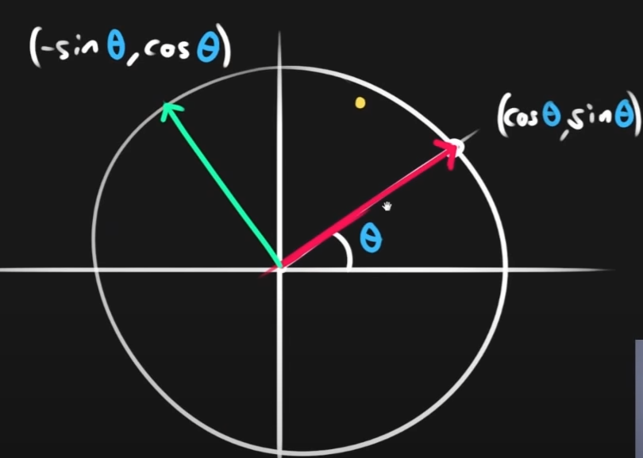

We’ve constructed a coordinate system because we have two perpendicular vectors right, so these are perfectly perpendicular and so now what we can do using this coordinate system is that we can transform things with it, so if we have another vector, this one doesn’t even have to be normalized, this could be anywhere then what we’re effectively doing (if we want to rotate to the yellow point) is transforming it from the local space to world space. So we want to multiply the x coordinate of the yellow point by the red vector and the y-coordinate by the green vector and that does the transformation for us.

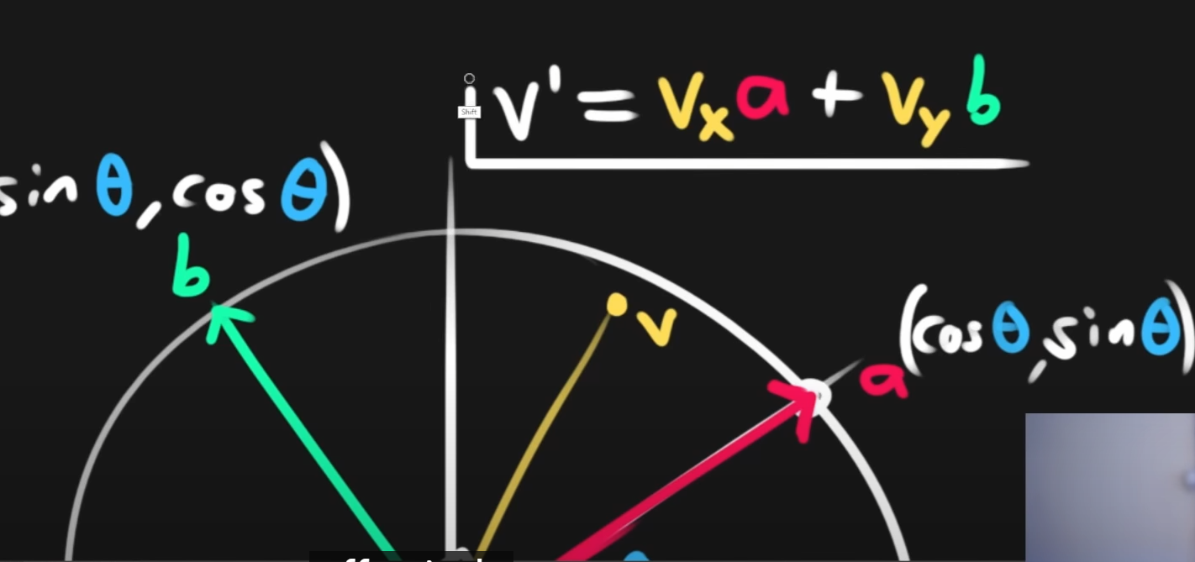

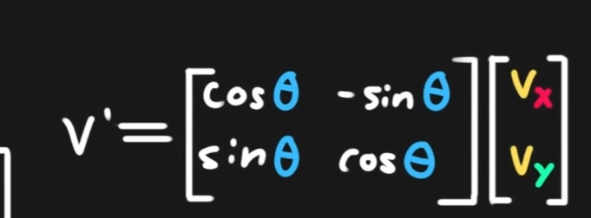

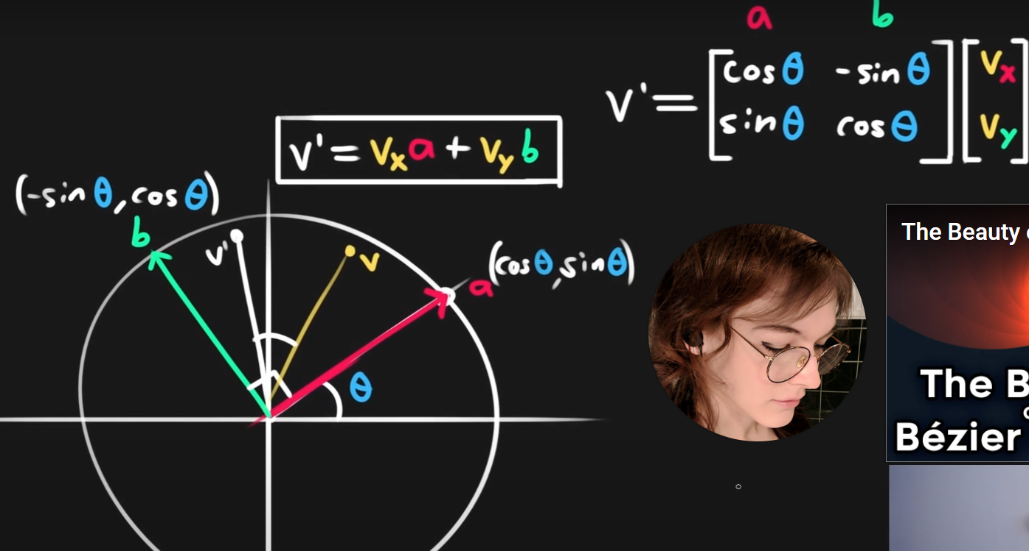

What about rotating around a pivot?

v' = R(v,θ) this rotates v around the origin by angle θ, as described in the video

v' = R(v-p,θ)+p rotates v around p by angle θ

all it does is, subtract the pivot from the vector, then rotate, then add the pivot!

<https://www.youtube.com/watch?v=7j5yW5QDC2U&list=PL1PRjgWrp75z5KidcljI6mhnPiwjiyWCj&index=2&t=1s>

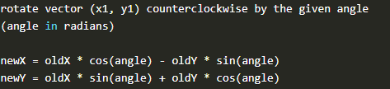

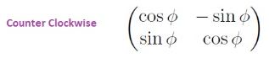

For clockwise rotation you do:

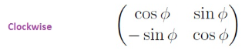

Which is:

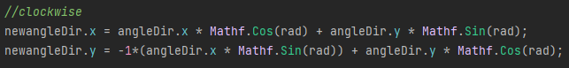

If you also want to rotate it like unity rotation where

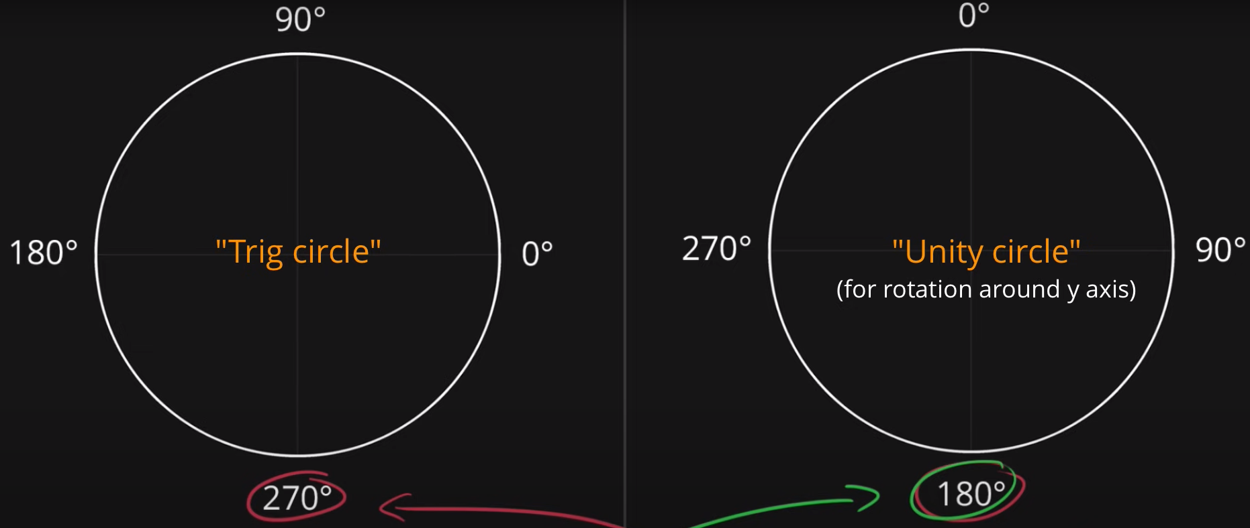



To rotate the player to face your input direction



But instead of doing “90 –“ you can just swap the arguments in the Atan2 method and get the same results

# Rotating a vector Using Quaternions

So we have a forward vector called result and we want to modify it, the easiest way is to multiply by a quaternion. Euler and we’ll rotate it around the y axis but along the XZ plane. The rotation would be the same as you would apply to the unity transform but it wont work unless you multiply it by a vector (with the quaternion always on the left side) when order is important like in this case it is called Non/commutative properties.

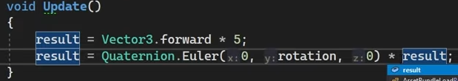

You can also multiply a quaternion by a quaternion but the code below is just doubling the degrees

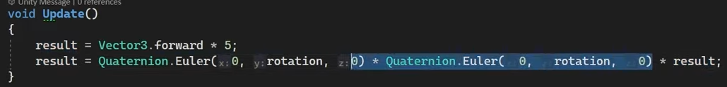

### Quaternions

A really good way for describing 3D orientation which is not susceptible to the bugs and edge cases for other cases. A common way many programmes like to think about constructing a rotation matrices for a desired orientation is to imagine rotating an object around 3 axes, where the relevant angles for these rotations are called Euler angles, this works but its vulnerable to gimble lock, where 2 of the axes of rotation get lined up you lose a degree of freedom.

It can also cause difficulties when trying to interpolate between 2 orientations.

Quaternions avoid gimble lock and give a very seamless way to interpolate between 2/3 dimensional orientations. Complex numbers give a slick method for computing 2D rotations. Specifically lets say you have some point in 2D space like (4,1) and you wan to rotate it 30 degrees.

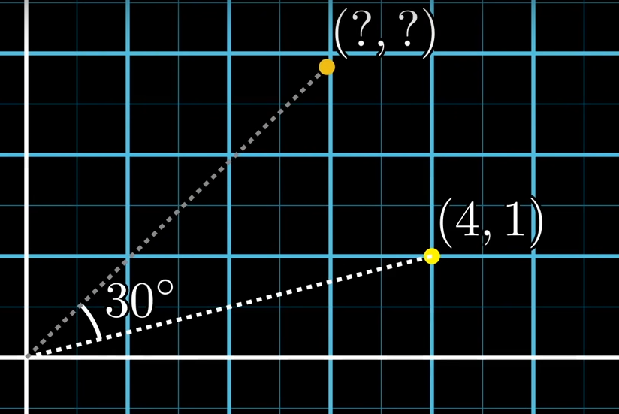

With complex numbers you take the numberthe number that’s 30 degrees off the horizontal with magnitude 1.

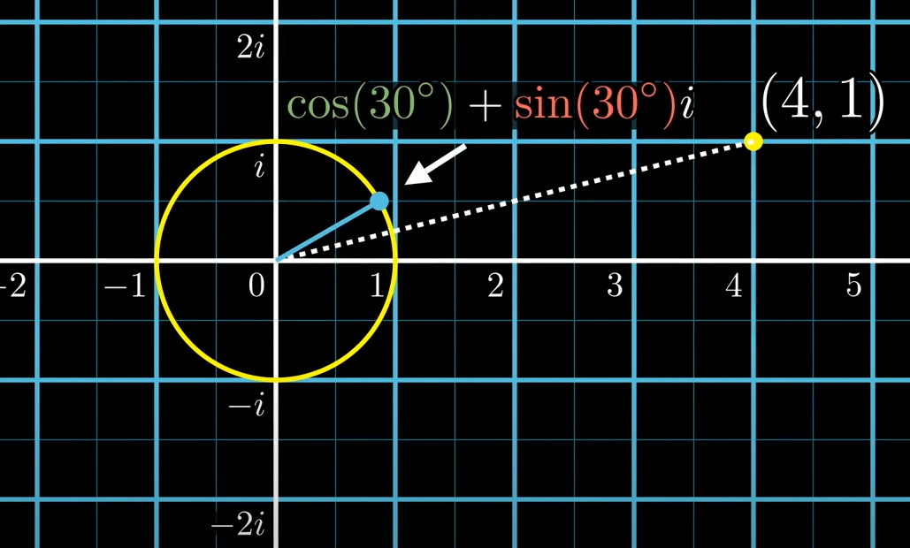

Which is cos(30o) + sin(30o)I and then you multiply this by your point represented by a complex number

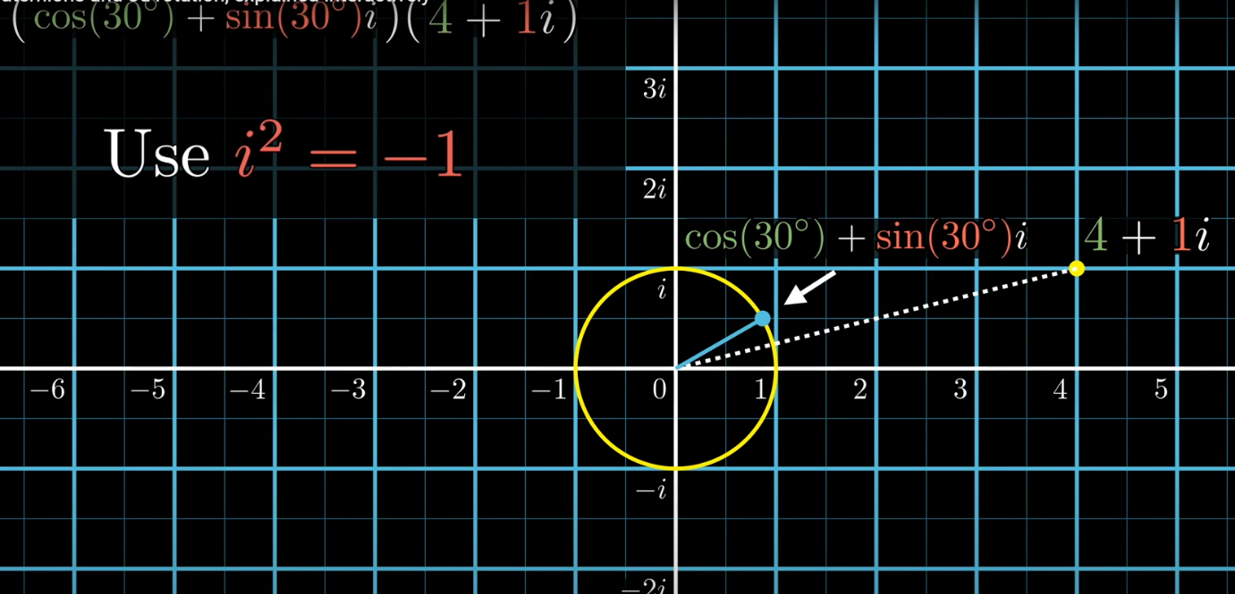

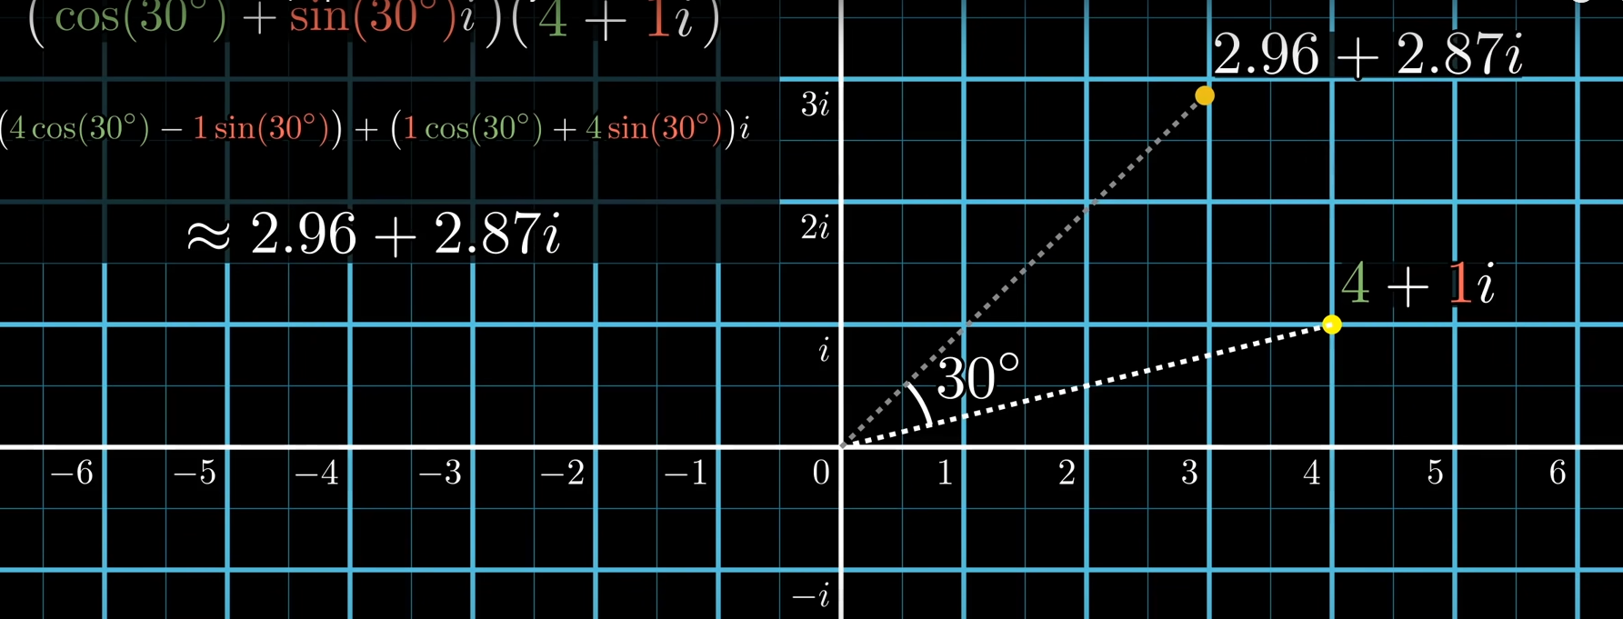

Using quaternions to describe 3d rotation is similar, though the look and feel is slightly different. E.g. you want to rotate some angle about some axis, first define that axis with a unit vector, which we’ll write as having I,j and k components, normalized so that the sum of their squares is one. Similar to the case of complex numbers, you use the angle to construct a quaternion by taking cos(of the angle) as the real part and the sin (of that angle) as the imaginary part

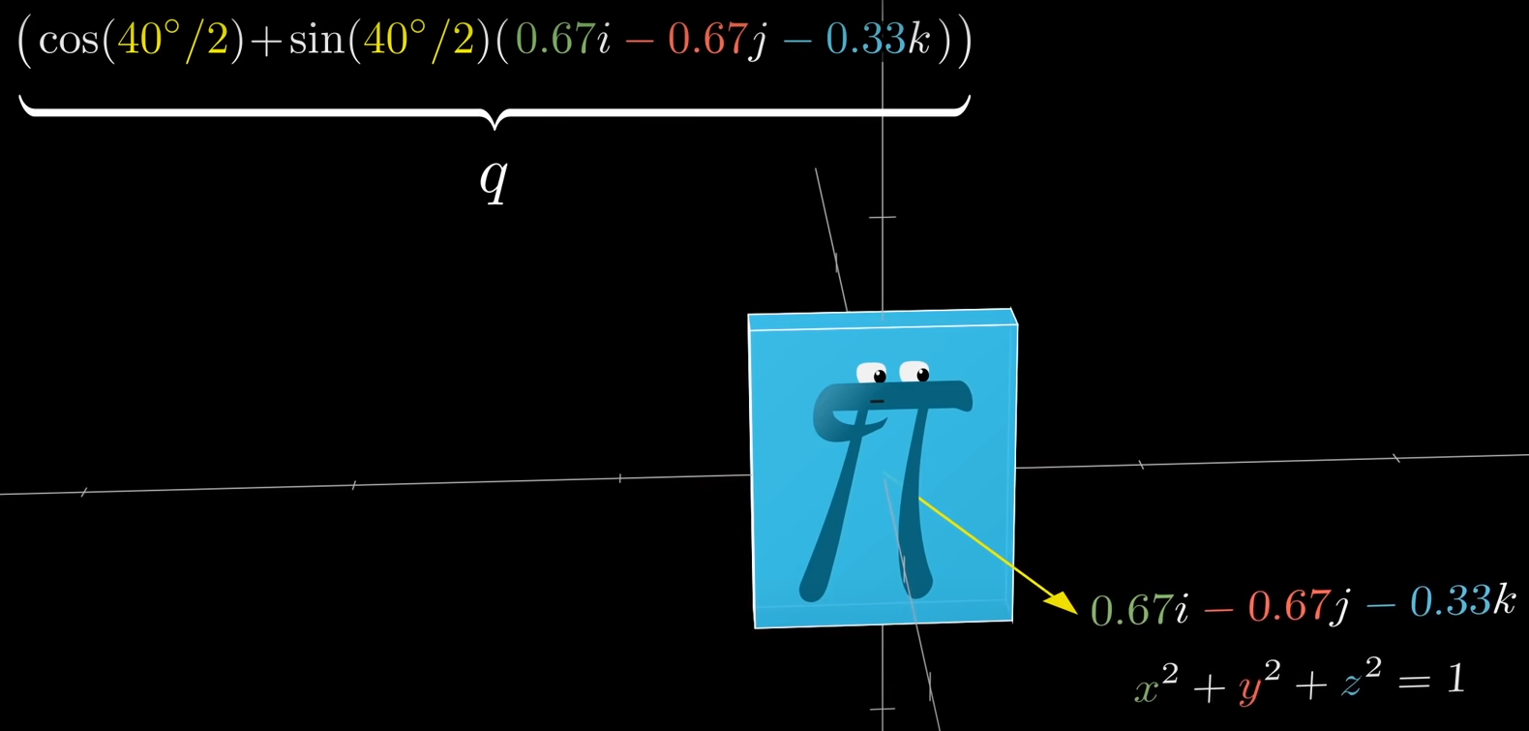.

Now lets say you have a 3D point, which we’ll write with ijk, components, and you want to know the coordinate you’ll get by rotating this point by your specified angle by your specified axis. What you do is not just a single product, but a quaternion sandwich, where you multiply by q from the left and the inverse of q from the right.

## 1D Vectors

One thing with maths in game dev is that numbers aren’t just number, its only there to represent something else, so then you can ask what is this number. You can only have a direction that’s -1 or 1 and sometimes its called a sign. (e.g. sign(x) = +1 or -1, there are exceptions like x = 0 but it depends because it might). Distance (a,b) = abs (b-a).

1D vectors are usually called scalars or floating point values

## 2D Vectors

Normalize vectors means that it has the length of 1. Basically If you have any vector, if you want to normalize it, what that means is that you make the length 1 so you basically just have a direction or if you pick a vector with the length smaller than 1, its going to normalize into being longer. You need to normalize a vector when you just need to calculate a direction and control the speed, acceleration and/or magnitude. The way to calculate a normalized point, you cand do the point divided by the length/magnitude of that said point.

If you want a direction vector you would need to normalize the vector (by vector I mean the vector you get from point a to point b (which is b - a)) and it doesn’t matter how far apart they are they will always have the length of 1. But if you want the direction vector always pointing at point b. the origin will be at point a and in order to make it relative to a we do a + the direction

We do “a +” because we want to draw at that location. For a fixed distance away, you do 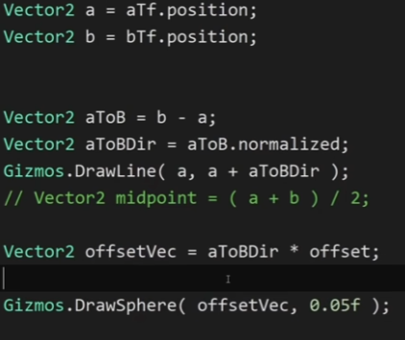

Or

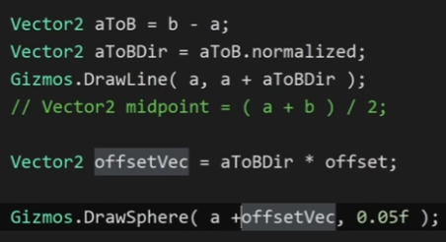

If you increase offset over time like do * time.delta time * speed then you have a projectile following a flight path

## Dot Product



This is the direct projection of one vector onto another and returning the length of the projection. E.g.

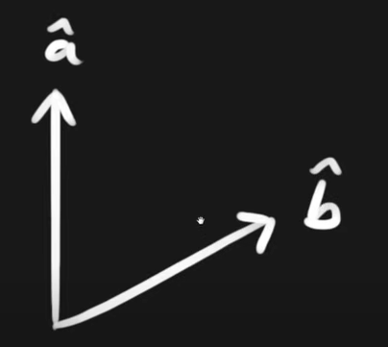

So you have 2 normalized vectors and then you project vector a onto vector b (can be either way as they give the same result )

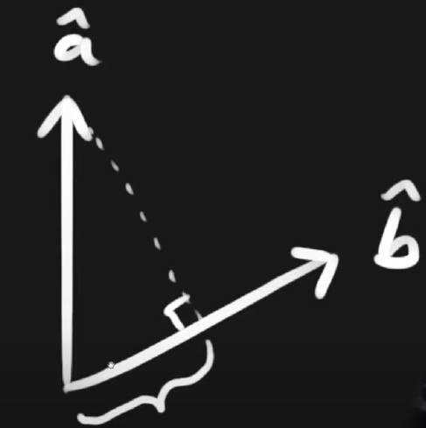

In this case we projected vector a onto vector b and that length highlighted is the result that will be returned.

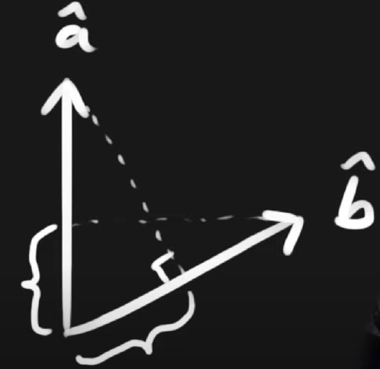

This is the same when vector b is projected onto vector a.

You can also clamp dot product results

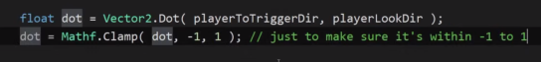

# Spaces

## Converting world space to local

A function that can transform from local space to world space that can take that vector (2,1) into world space

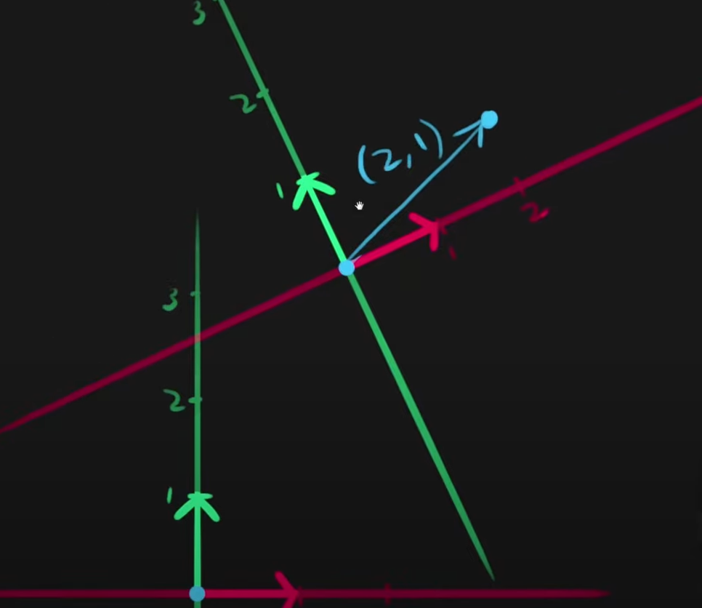

To solve this problem you get the vector from the world space origin to the objects position and we have the local space coordinates of the vector (2,1) which is the local space vector we want to get in world space. First we note that we have 2 basis vector, the object has a transform.up and a transform.right and we can use them to get the vector (2,1) in world space. What we do is take the transform.right vector and multiply it by the local space x-coordinates.

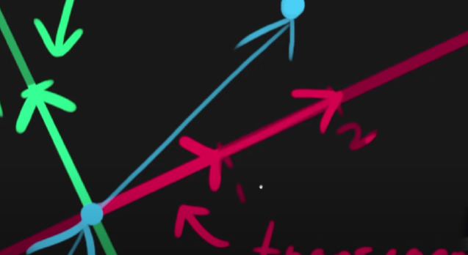

And what we end up with is a vector going all the way to the 2 and then we do the same thing for the y axis in this case it’s a 1 and now that we have the vector that’s like the scaled transform.right and if you add that with the transform.up one then you get the vector in world space.

Implementation

So the script resides on the objects who’s transform we will use for the transform.right

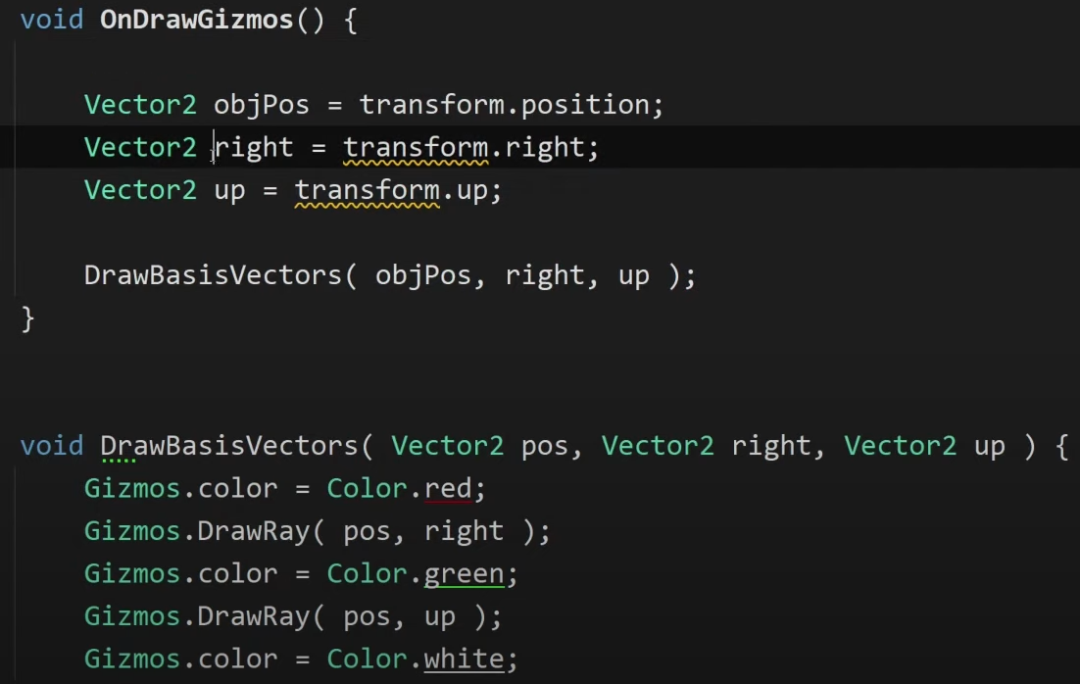

When you do transform.right and transform .up you get those vectors in world space but the local space cords of those vectors are (1,0) and (0,1)

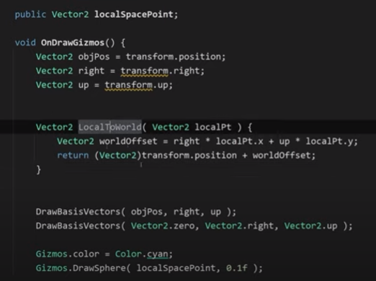

So in short the vector that is local space you multiply the x value by transform.right and the y value by transform.up and you add those 2 vectors to the world space of the object

World To Local

This is essentially reversing the order/ equations done. When going from local to world we add the world space position of the object, so now going from local to world we need to make the point we’re tryna change relative to the objects origin. So the reverse process take away the world space position of the object. Then you get the relative vector in world space.

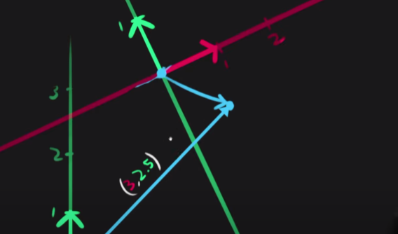

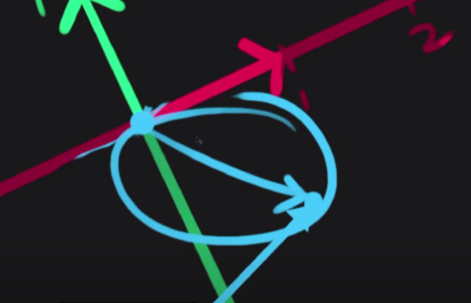

That vector relative to the object’s origin but the orientation is still referencing the world space transform.up and transform.right, the coordinates are not actually in local space yet, its still aligned with world space.

then you do the vector.dot with the basis vector (transform.right ) of the object and the relative vector (the vector circled ) and we do the same thing onto the vector basis transform.up

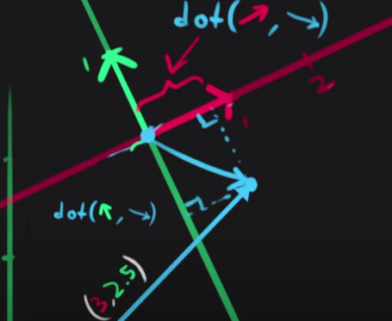

Like the image above

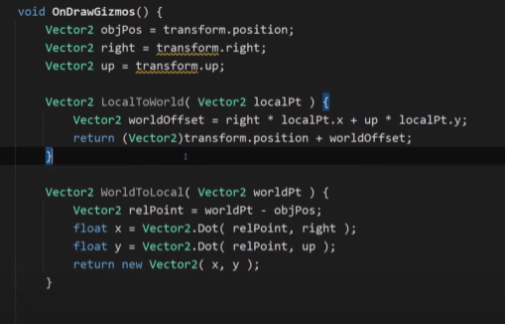

# Matrices

Matrices are used in a way that is called a transformation matrix. When you’re doing stuff with rotations, due to the way they are stored and the way positions and scale are stored is in a single data type called matrix. The way things usually work in games is that they have a matrix and in unity its called matrix 4x4 and a matrix is just a different way of saying you have a 2D array.

Rotation, position and scale are stored in a single matrix data type.

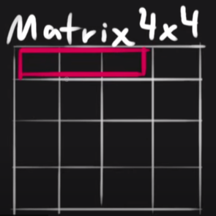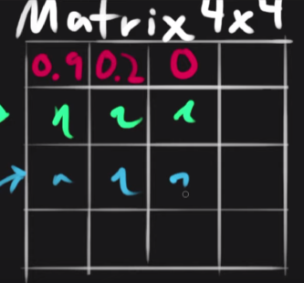

The x-axis is stored in the red area and they are the x,y,z cords, what they represent is the world space direction of the x basis vector. if your object had no rotation and is aligned with world space then for example the x axis would point directly along x and then it would be

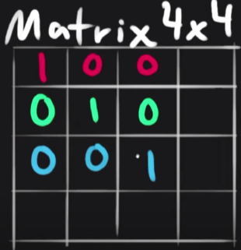

This is called the identity matrix and all it does is modify those numbers, it doesn’t store quaternions or eulers and is used for all transformations. Those number specify the orientation and position is store in the 4 column.

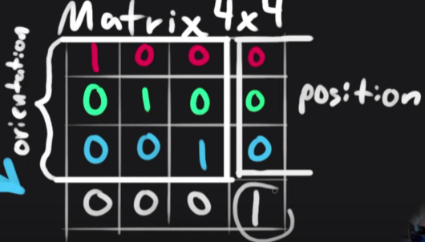

The bottom row is unuse but for the maths to work it needs to exists. 99% of the time it will b.

The way scale works is by modifying the orientation.

This is the actual layout but the information before still aplies

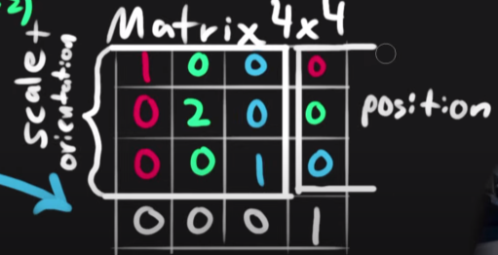.

When you have a vector its matrices has 4 values: x,y,z,w and w is usually 0 or 1. If w is 1 then you are transforming a point else they you’re gonna transform the vector and that means it wont take position into account

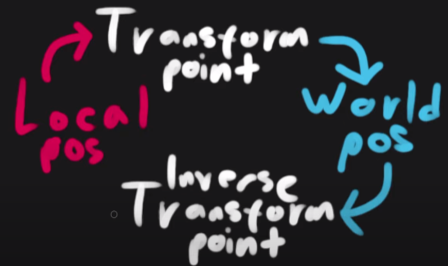

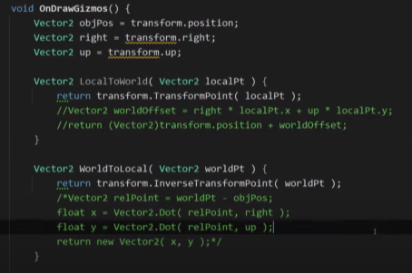

Whats the use case for matrix 4x4?

Having a transform component in unity mean you need to have a gameobject and all the things that come with that but a matrix doesn’t require a gameobject, so if youre doing things like instanced rendering where you draw meshes from code, then you need to supply matrices to say where you want to draw them at, at what scale and at what orientation

# Cross Product

Another way of multiplying vectors together. If you have the normal and the tangent vector then you might want to calculate the bitangent.

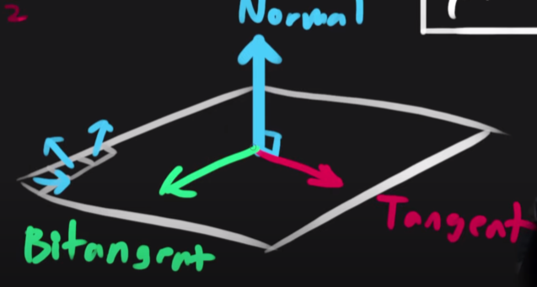

The cross product of 2 vectors returns a vector, if you give it the normal and the tangent it will give you the bitangent, if you give it 2 vectors it will always return a vector that is perpendicular to both. It is useful for many different things e.g. if you have an fps camera and you want to look around the world, quite often you need to use the cross product there to figure out what axes are we rotating around. In a lot of cases you have the normal of a surface and then the direction the player is facing in, which might not be perpendicular but you have the normal of the surface and the direction the player is looking in and you want to know what is the direction to the right.

If the 2 values in the cross product are perpendicular and normalized then the resulting vector will also be normalized but if they are not normalized then the resulting vector is gonna be shorter also depending on the order you pass in the 2 arguments the result is gonna point in different directions.

Also assuming that the 2 argument vectors are perpendicular the resulting vector will have a length of 1 but if they start going close to each other it will be shorter

A use case is triangles in a mesh.

If youre making a mesh in unity or any other application, you generally have vertices and each triangle is a set of 3 vertices and edges, if you have this normal in mesh data then generally theres a fixed way where you can use the cross product to get the normal of the surface.

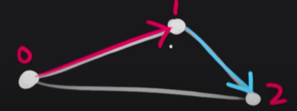

If you do the cross product of the red and blue vectors.

Another use case.

Lets say like in overwatch you want to place a turret but your game map has uneven terrain, how dyu figure out the rotation of the turret. So you point to the terrain and that has a normal and we could use that as the up vector for the turret but what about the other vectors?

It also doesn’t say what the forward vector of the turret is going to be. But you can use the direction that the player is looking

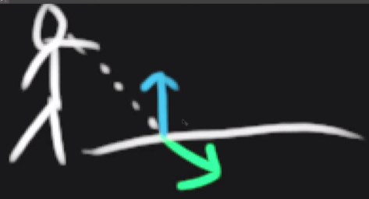

Green arrown is the look vector of the player but that is not orthogonal to the blue normal, but if you do the cross product between those 2 vectors you will get a vector that is perpendicular to both and you get this

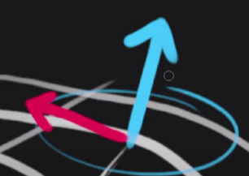

Now to get the last vector you do the cross product of those 2 vectors.

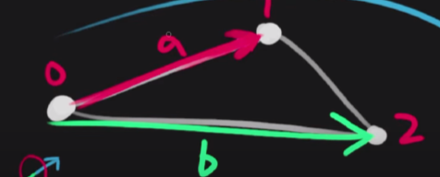

If you do the cross product of those vectors you get

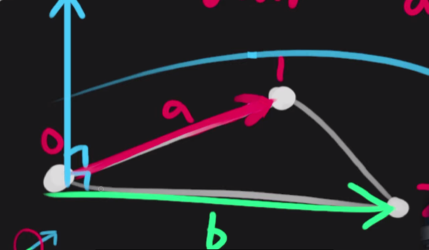

Now if you take the length of that vector  what you end up with is the area of the parallelogram that these 2 form, it represents the area of the plane

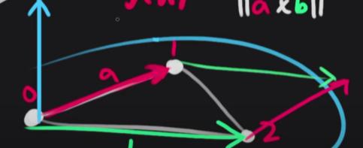

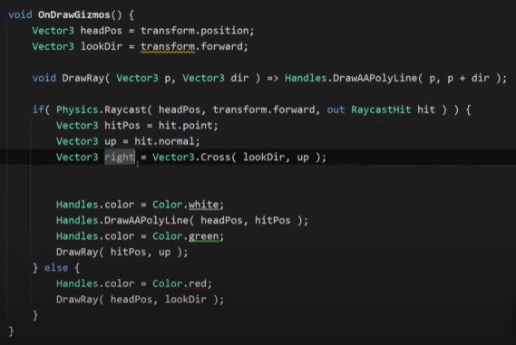

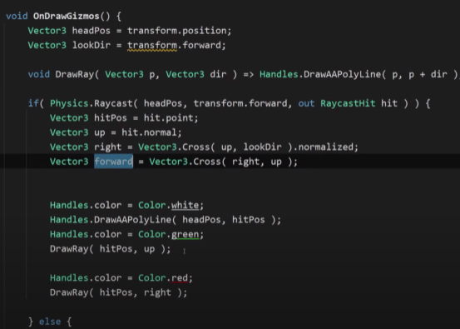

# Drawing a playerDetect

This should be placed on the object searching for the player

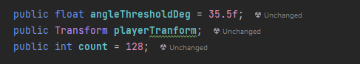

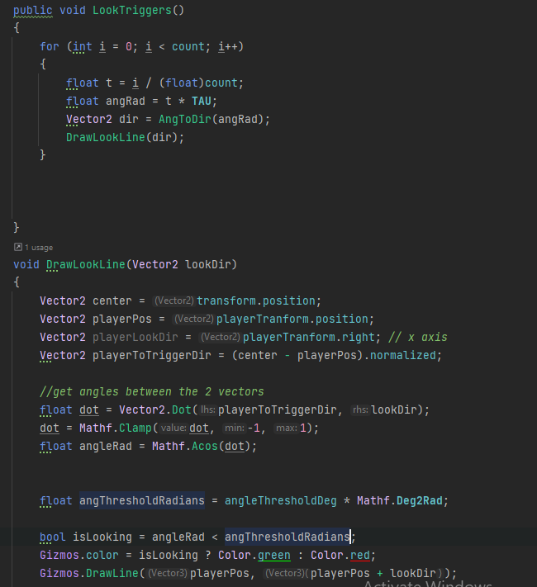

# Draw a bouncing laser

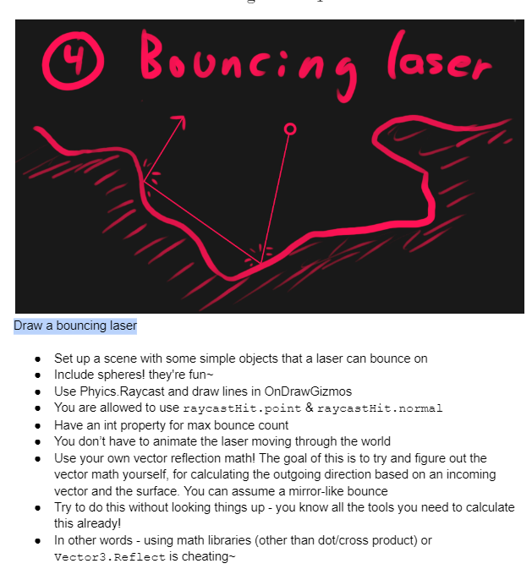

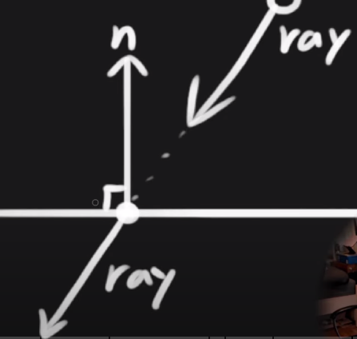

When we draw our ray or laser, and it hits something like a terrain or shape what we want to do is take the ray vector and reflect it to be on the other side.

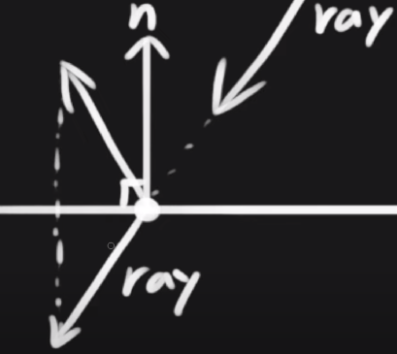

So, what we can do is project the ray onto the normal.

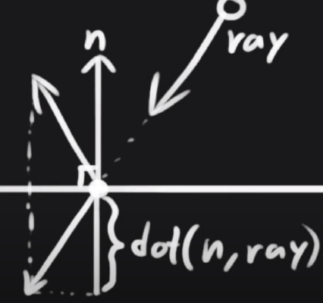

The dot product will be negative like a negative distance, we can convert it into a vector e.g. say we want the n vector (pointing down one) rather than just the n vector we can multiply the n vector by the dot product. Then we could do this offset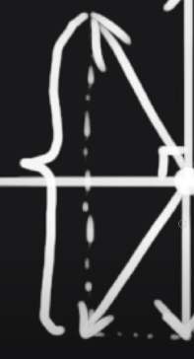 because now we know half of that distance because it’s the n vector (the pointing down one), so if we take the projected vector (n vector pointing down ) and multiply it by 2 and offset it up to the reflected point

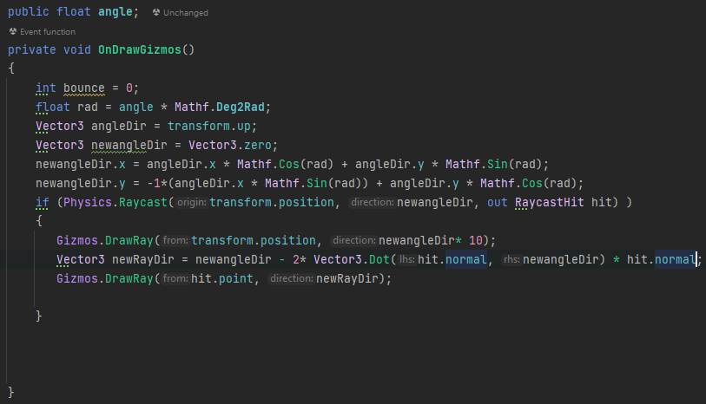

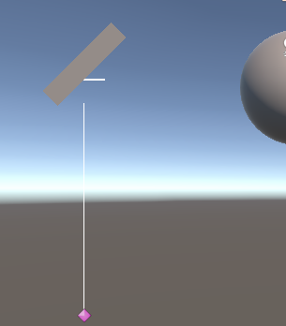

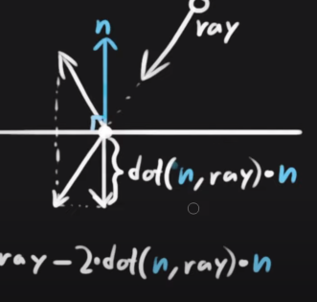

# calculate the surface area of meshes

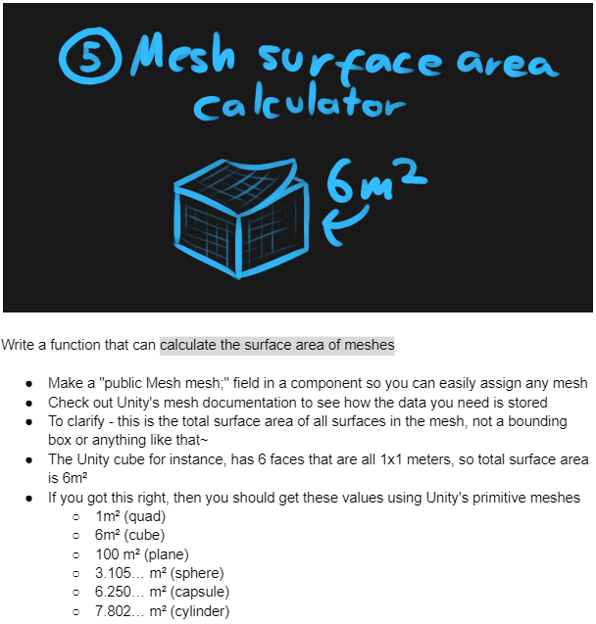

You have a bunch of vertices and they all make up triangles, if you want to access this data, you need to first figure out how the data is laid out for meshes, which is a very useful thing to know especially when you’re doing procedural mesh generation.

If you save a mesh then all data you need to construct a tangent space is two of the 3 vectors (normal, tangent and bitangent) because you can always use the cross product to get the third one

Meshes have a list of vertices and those vertices have an index and they are stored in an array. Then we have triangles which are also defined through indices as well, triangles are defined in an int array and integer arrays are in triplets as 3 numbers in a row define 1 triangle.

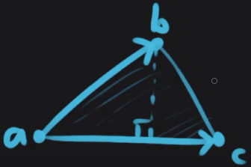

To find the area of this set of triangle would be the magnitude of the cross product of a to b(b minus a) and a to c(c minus a) basically ||abxac|| divided by 2

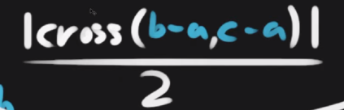

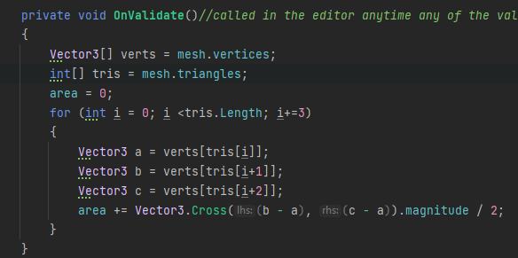

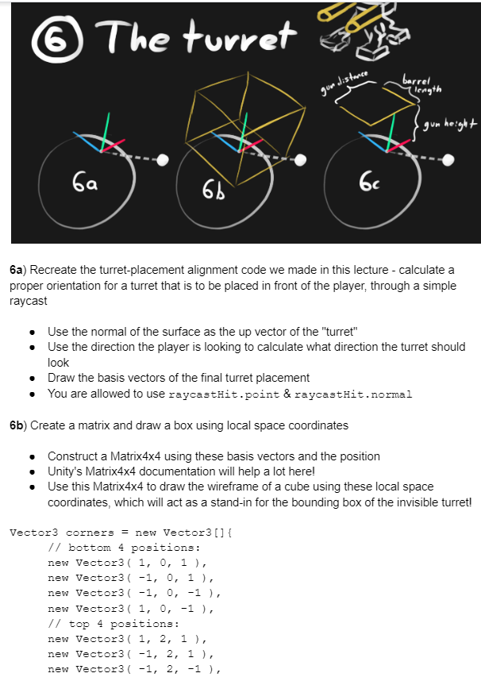

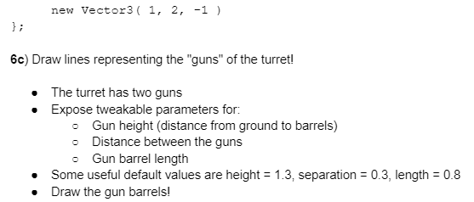

With the bounding box you need to work with the coord space that you constructed bounding box are generally in local space because its part of the mesh data.

Whenever you have a space that you keep working in but you want to also get world space coordinates is to set up a matrix because then you can quickly transform between local space and world space.

So we construct a matrix that we can use to do all the things we want to do with local space cords but then also be able to transform them to world space because that’s what we are drawing in.

A bad method

To draw it

We want to loop through the points

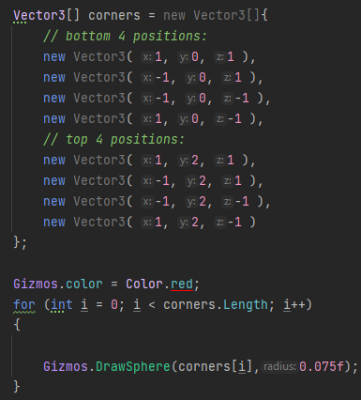

The points drawn from this are in world space but we want them in local space. We nnow want to set up a matrix for space transformation (local to world and vice versa) so we setup a matrix and make it equal to matrix.TRS which is translation, rotation and scale. This takes the origin, orientation and scale and then it will construct a matrix for you, so I don’t have to deal with the indices themselves. The translation is the origin which would be the hitpos. Rotation – you need to create a quaternion make it equal to quaternion.look rotation (this is a way of constructing a rotation where you provide 2 of these vectors) you could plae the forward axes and the up axes. Scale is simply vecto3.one.



Now you can start using the matrix to transform points

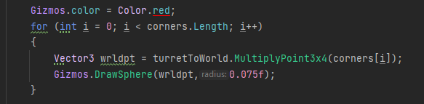

Radians

So we have a unit circle with a radius of 1, now lets say we want an arc length that is also the same length as the radius, and we end up with a very specific angle

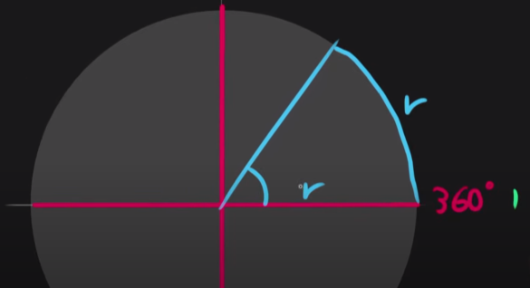

If we are measuring in radians we are gonna say that this is an angle of 1. If in degrees a full turn is 360 degree then in radian it is 6.28… and that number is the better circle constant called tau and it is exactly 2pi.

A ¼ turn in radians is 0.25*Tau.

An arc length, lets say you have an angle and you have a radius, if you are using radians then radius * angle is the arc length this is useful for things like angular velocity e.g. you have a rod that is spinning in some game and you have an object at the tip and you have some angular velocity that this one is rotating in and then you might be asking, what is the speed that the object should release in, how quickly should the object move incase we stop spinning the Rod.

You take the angular velocity, check the tangential speed and we do that by radius * the angles per second.

# Trig

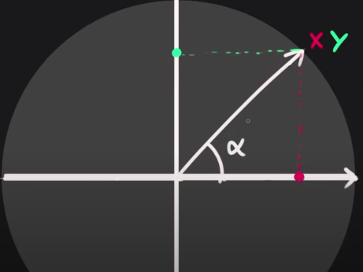

How to get the coordinates X and Y?

If you want the x coordinates it is usually cosine of theta and the Y is the sin of theta

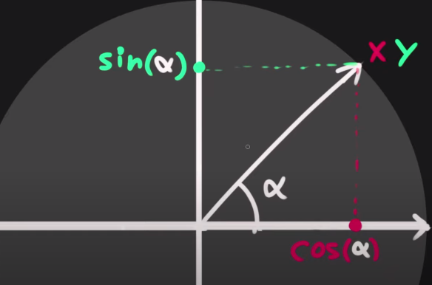

This is for radians (theta should be radians)

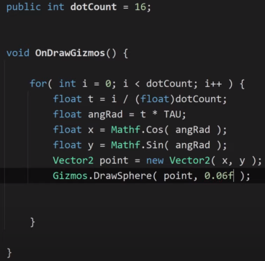

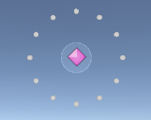

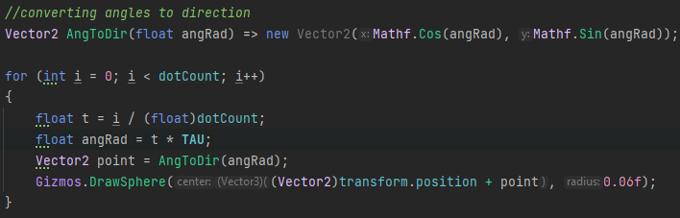

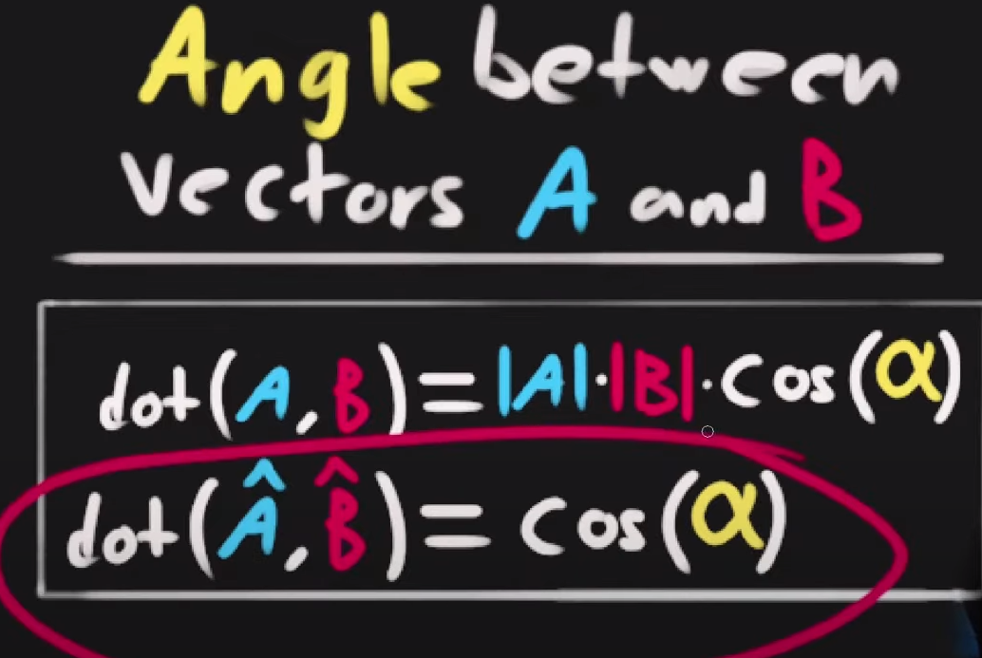

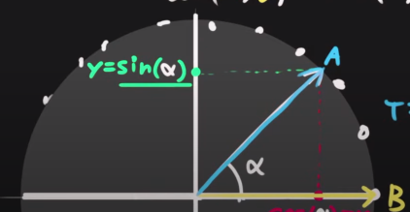

Vector2.Angle does the same thing but returns it in degrees.

## Tangent

The tangent function is something you mostly use when you’re solving triangles.

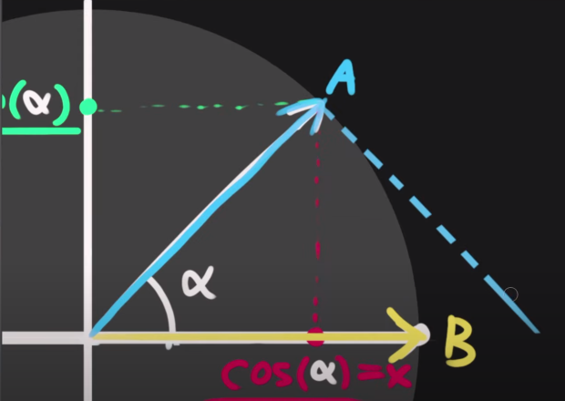

In this case the tangent is the blue dotted line from A.

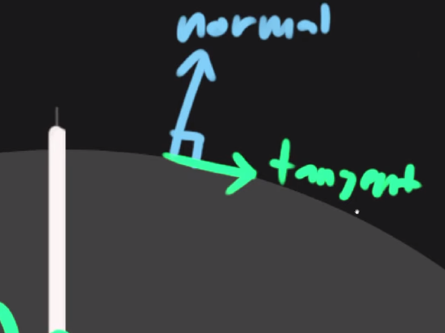

Things tangent can solve:

Let’s say you have a top-down view from a camera and you want to set the vertical FOV so that all the items on the screen fit in the camera view.

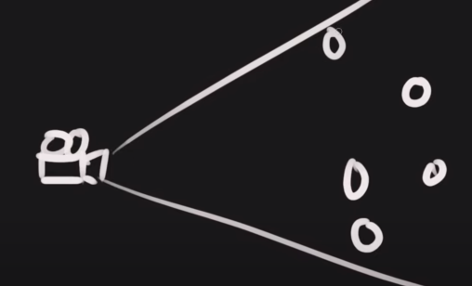

To get a right angle trangle out of this you, we know the furthest distance between the objects we want to encapsulate

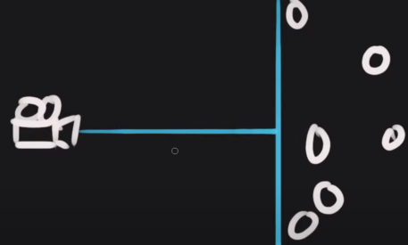

And we now have a right angle

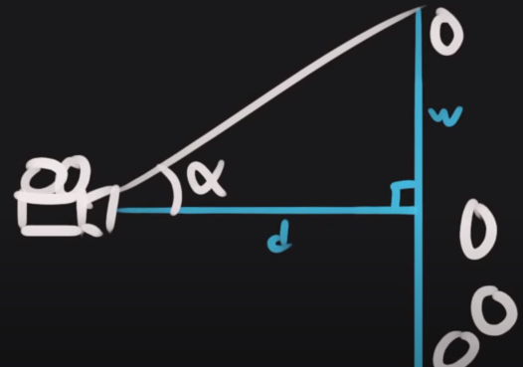

To get the theta angle we do tan(theta) = opp/adj which is theta = tan-1 (opp/adj) or atan

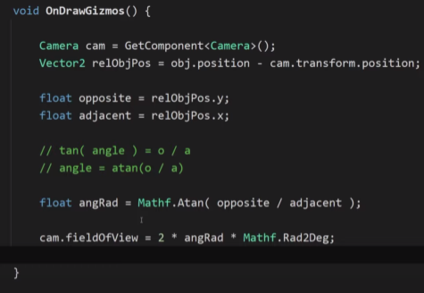

Atan2 – if you want to convert a vector into an angle you use Atan2 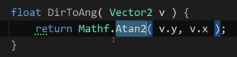

## Determinant



The determinant is useful for figuring out whether or not you’re looking to the left of something or to the right .

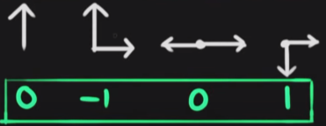

Very similar to the dot product.

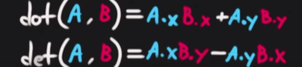

The dot product formula is above and the determinant formula is below.

A use case if you have a spaceship and its moving in a direction and you have some object and you want to know whether you should turn to the right or left, so you can take the determinant of that vector (the vector of the object minus transform.position ) and the direction vector and then you get a sign either positive or negative. Also with the determinant the order matters .

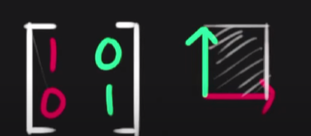

The determinant is the area shaded white

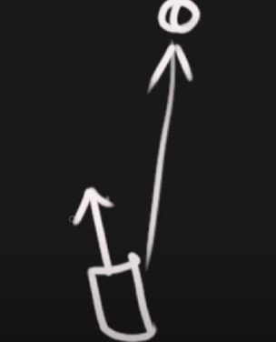

# Drawing a polygon

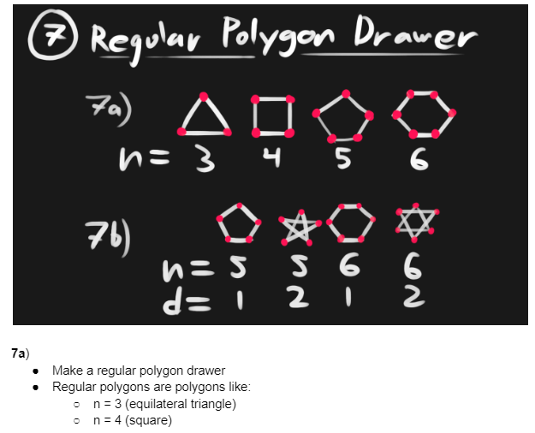

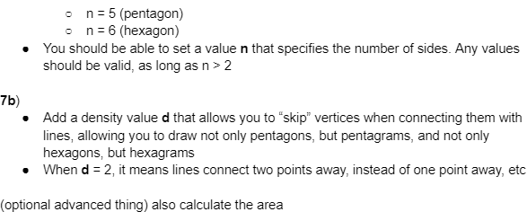

There are different ways of doing regular polygons and you can also change the density of a polygon

And that’s how you gets things like the pentagon.

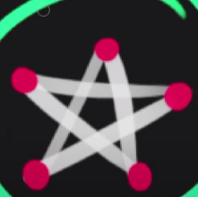

The idea of changing density is that instead of going from point to an adjacent point, you skip over a point and you end up with the red lines:

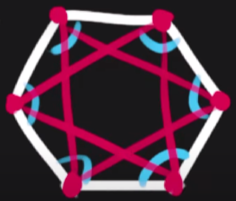

## Drawing a regular polygon ignoring density

You find the angle between each point

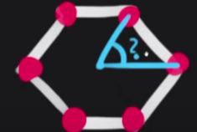

In this case because there are 6 side you would do TAU/6 but you cant do that for all shapes so you do TAU/n (n = number of sides)

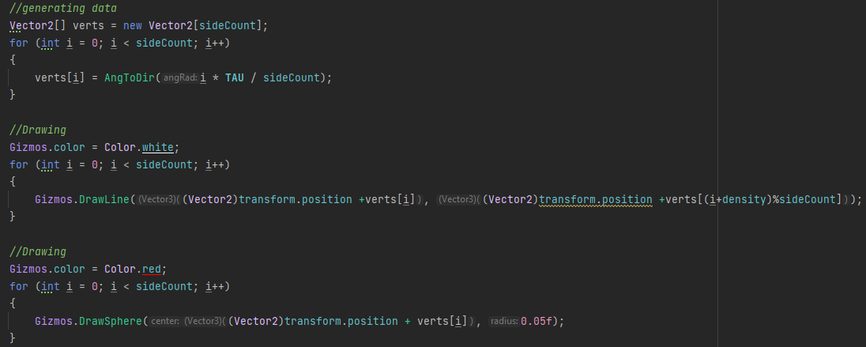

The line “verts[i] = angToDir…” you multiply by i because as soon as we go to the next one we want the angle to go from point 0 to 1, to point 0 to 2 and so on be cause we want it to be twice as big and the next one to be 3 times as big.

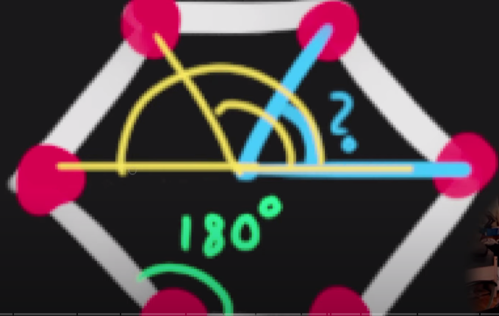

Setting a density – so all it does is set the number of points you want to skip ahead every time you draw a line

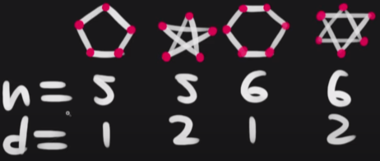

Adaptive FOV

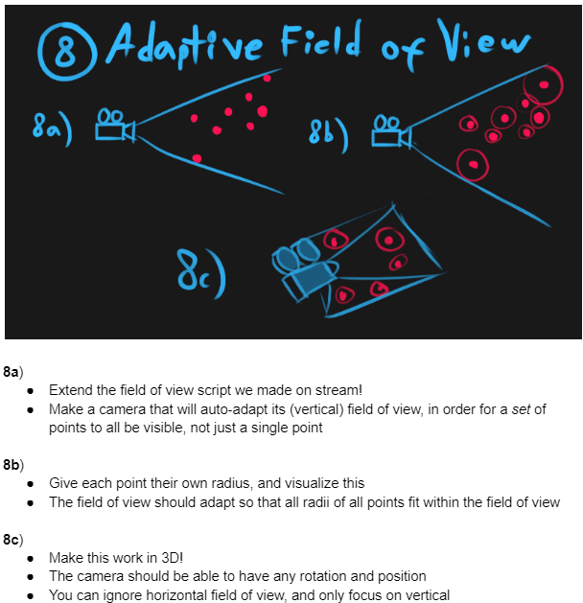



You need to figure out the angles to these as stated earlier , there are 2 steps to this (the earlier version only takes one point into consideration ) but you need to take care of all of these points.

Step 1:

What point is the outermost point?

You can calculate the angle to each of those points and assign the FOV to the biggest angle

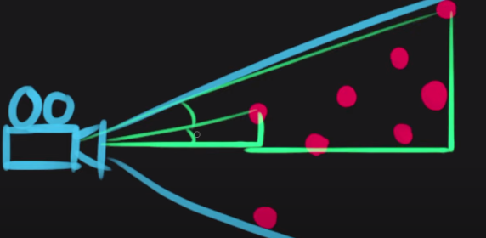

That is more expensive than figuring out which ones are the furthest away and then calculating the angle.

You need to find the furthest out and you can use the dot product for this because you have the direction of the camera and the direction of the point and you get how much it is pointing away from the camera.

You place this script in the camera GO

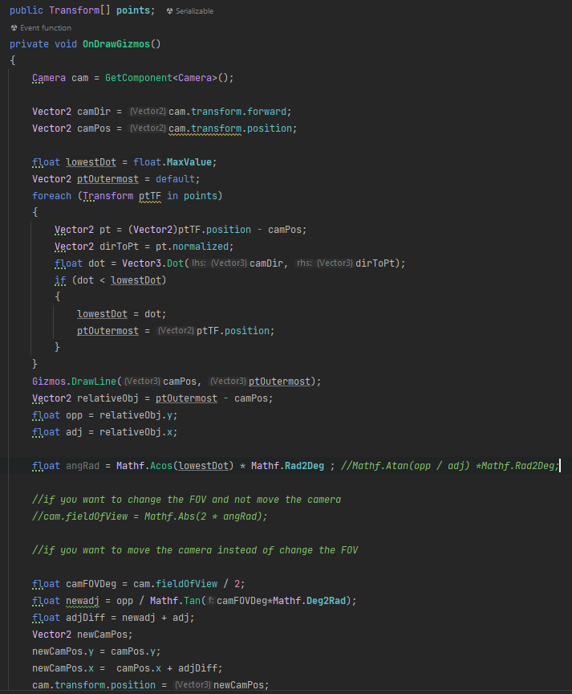

Now this is if each point had its own radius

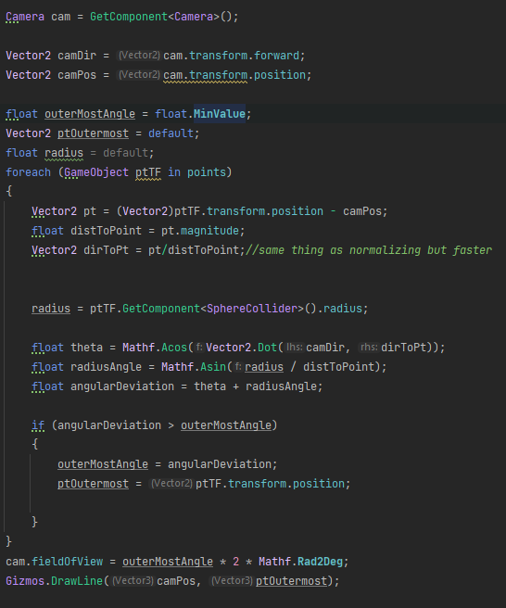

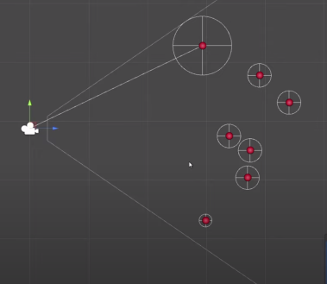

Converting it to work for 3D

First you need to convert it to the local space of the camera the you need to swizzle(mixixng the components of vectors ) them so you can project them into 2D this is because the camera’s forward position is z but when the earlier code was in 2 components, x and y.

In local space the camera dir is vector3. Forward because no matter how you rotate the cam it will always be forward and the camera pos is vector.zero because it is at the origin of its own space. The gameObject that we are iterating through’s position is supposed to be relative to the camera but before we were subtracting the camera position so that it was relative in world space but now, we want it to be relative to the local space of the camera so that’s why we use InverseTransformPoint

Basically, what we do is like we flatten all the points of the GO so they are all in a line down the middle, like though the Y-axes but just mathematically

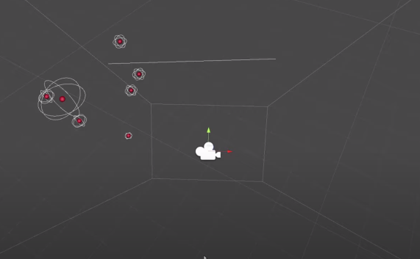

So the vector that we just turned into local space using inverse transform, we want to make sure that its in the projected space, which is the plane of the x axis, we’re going to flatten everything on the x axis. We want a 2D coordinate that represents the local space coordinate of the camera but we want the x coordinate to be what was previously the z coordinate.

What that means is we are converting the local 3D space to local 2D space on the zy plane space of the camera, basically as if it was like the 2D projection version above.

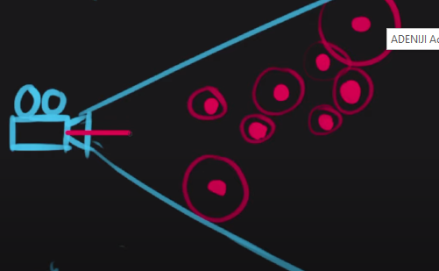

Like this. Also horizontal offset doesn’t matter. The camera direction is vector2.right because that’s how it is in the projection paces

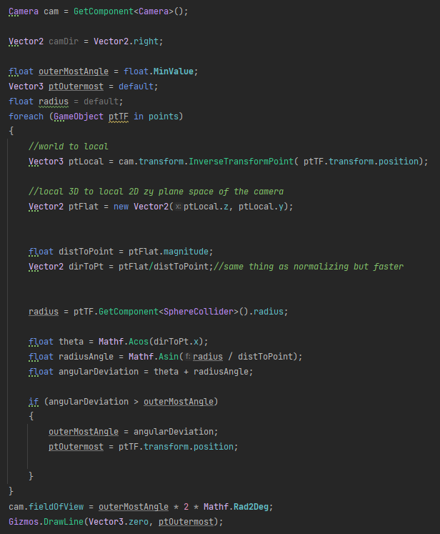

# Bezier Curves

There are many different types of Bezier curves like a quadratic bezier curve.

## quadratic bezier curve

In a quadratic Bezier curve you have 3 points and its in order, you have a starting point, mid-point and end point. (is a parabula)

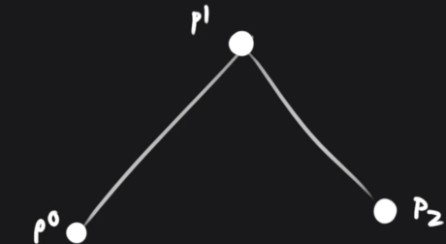

This what happens when you start nesting lerps, e.g. we have a lerp function where we have a T value of 0.25, lets use the T value when lerping between p0 and p1 called A and you do the same thing for p1 and p2 called B and be do another Lerp between A and B and all have a value of 0.25 as stated earlier

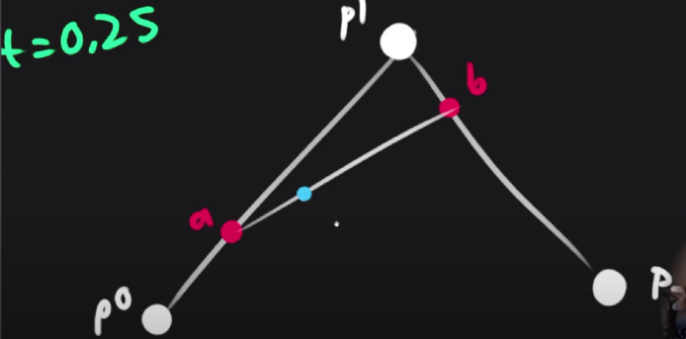

And if we change the T value from 0 to 1 you get a Bezier curve.

## Cubic Bezier curve

This is the most common one in image manipulation. Not a parabula

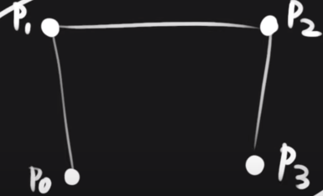

P1 and p2 are control point

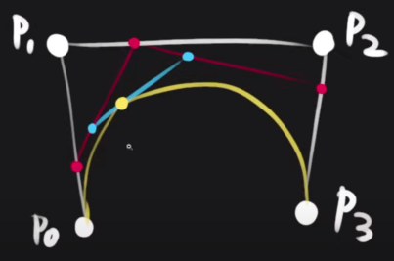

In this example the T value for all of them is 0.25

# Rotation

The way rotations are applied is using quaternions. Euler angles is a relatively easy way to like interface with quaternion because euler angle work by specifying the rotation on each axis. Euler angles suffer from gimble lock and they are not good for interpolating states of rotation. Rotations are a deviation from the original orientation.

Another useful way of applying relative rotations is you want to add a rotation to something else and there’s a useful shortcut you can use called angle-axis model. E.g. lets say you have some object and you want to rotate it about a very specific axis. In the quaternion class there is a function where you give it an axis and pass the vector you’re trying to rotate around and then you give it an angle (a float), for how much you want to rotate it. Also the faster its spinning the long the angle axis vector is going to be because the length represents the speed

This is mostly used in angular velocity.

You can also add angular velocity vectors to each other.

Lets say you have a vector in your coord system

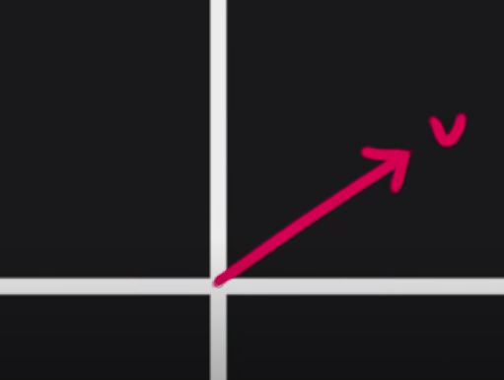

And you want to rotate this 90 degrees to get a perpendicular vector, what you do is

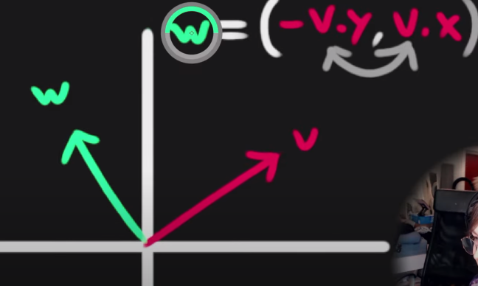

If you put the negative sign on the other side you get a clockwise rotation instead

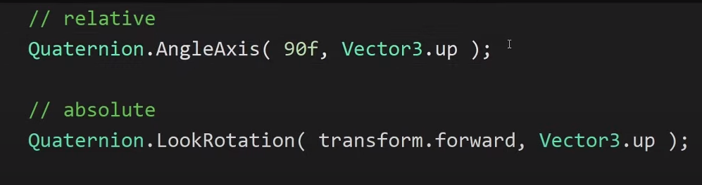

If you want to apply a rotation then use angle axis, if you want to set a rotation use lookrotation

# Drawing a coil

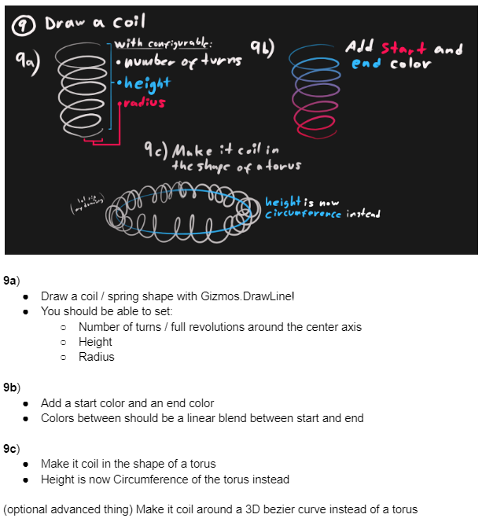

So you have a turnCount which is basically how many coils you get and the you have the radius and height.

Now we want to get the point between which we are gonna draw lines because the way we draw things in on drawGizmos is using a set of points and connecting those points

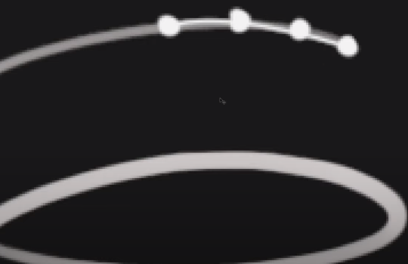

How do we get these points and how far from one another should each point be (this is called density) which in code we call points per turn.

The total number of point is the pointCCount. Then we set up an array of vectr3 for all the points that we’re gonna draw lines between.

Then we iterate through these points. As we’re drawing the coil the Y cords are increasing linearly across all the points and that’s purely based on the height value, so we have a value representing the fraction of which we progressed through the coil which we’ll call T which is from 0-1 and if we can multiply it by height and we then have our y cords.

Now we need to get the angle we need to start coiling and to get that you get the turns and find out how you compress it down, like what length is a single turn and then we compress it down to a repeat value to represent the number of turns which is for the winding. tWinding multiplies the current progress along the coil(tHeight) by the number of turns

If you want to switch between clockwise and anti clockwise negate the Twinding

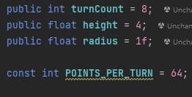

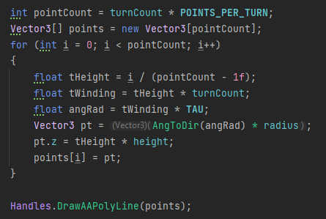

Now to add a start and an end colour

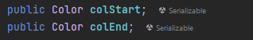

Add this after the first for loop and remove theDrawAApolyLine

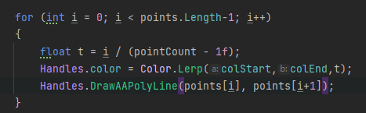

# Drawing a coil around a torus

Usually with a torus you have the minor radius and the major radius.

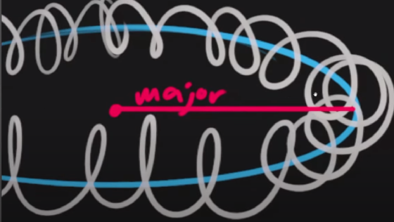

The major radius is from the middle of the shape to the edge and the minor radius is from the edge to the edge of the coil

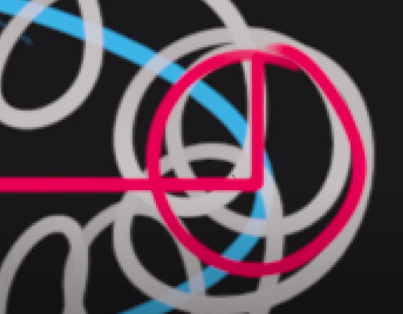

So now we’re generating the coil around the torus, so to start we will get the center point on the blue line going through the torus.

After we calculate the points going along the circle we need to figure out the coordinate system of it, we should make a system where the cords is aligned with the center of the taurus and a Y basis vector that points up.

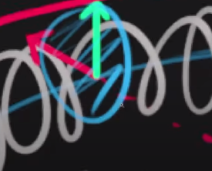

We want to generate the coil cords in that plane and as soon as we have those vectors, we can start getting points in those coord system based on some angle.

To get the x axis(the red axis) we take the vector of the center to that point and then normalize it because we already have the vector to that point

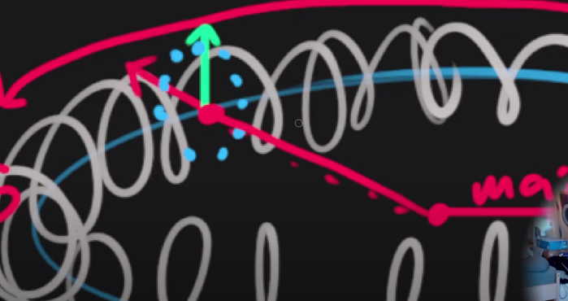

The green axis is the z axis because of the way the shape is facing

Now we need to transform the point on the torus to world space, so we now need to get a vector on the plane of the dotted blue line above

So we take the x coord and multiply by the x ais and same thing for the y

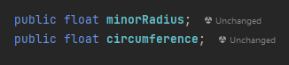

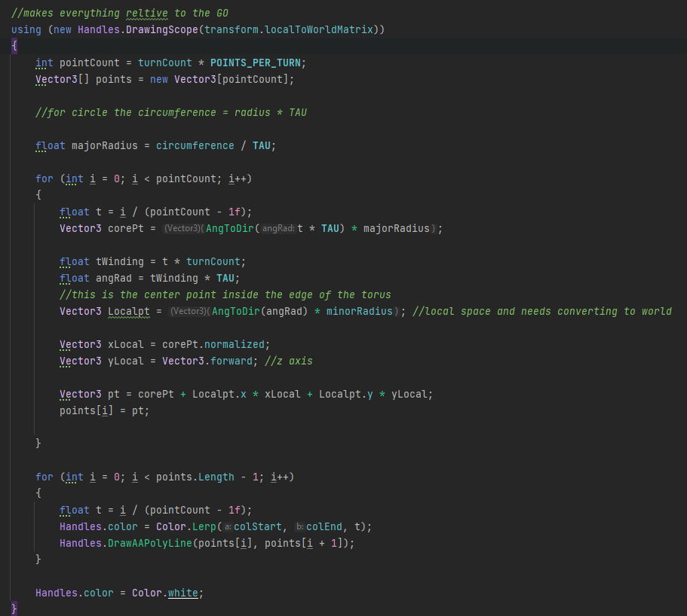

# Structure of a mesh

The very basis of a mesh is that they have a set of vertices and the vertices can be only positions in space relative to the space as whatever mesh you have or data containers of more things like normal, UV, tangent.

Then you have triangles, which have the connectivity info for how the vertices are connected

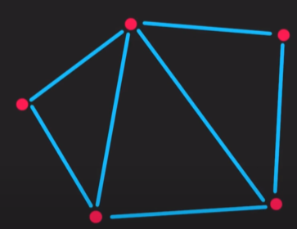

We will now make a quad

This is generally 2 triangle and 4 vertices.

First make an object where your scripts resides, then add a mesh filter and a mesh renderer and as soon as we generate that mesh we assign them to the mesh filter and then we can specify the material.

The we decide where we want our pivot to be (in this example we said we want our pivot to be in the middle (0,0))

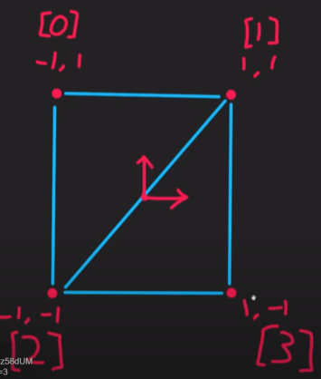

Defining triangles

The order in which you define the vertices give you the direction of

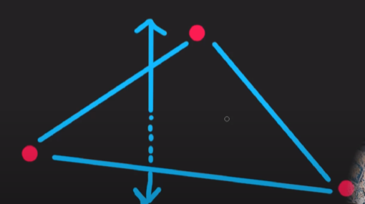(the longer one)

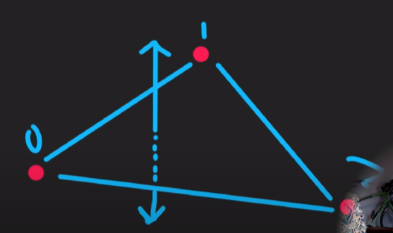

If you, do it in that order then the normal will point upward and if you reverse that the normal will point downwards. Depending on whether youre using a left or right hand coord system your thumb is the normal of the triangular face the way your fingers curl is the winding order of the triangles.

The way you define triangles is with the indices for the vertices, if you want to define 2 triangles for this one, we need to remember those numbers. Lets say we also want the normal to face towards us. Using the left handed rule we define the triangle order based on the indices.

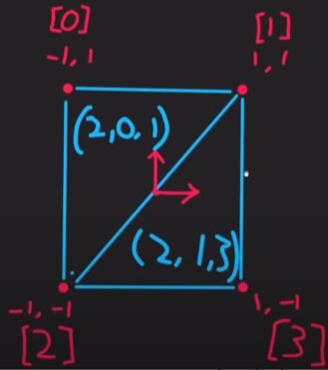

Starting from index 2 (which is [2]) we create our first triangle and for the second triangle (we still need to go clockwise if we want the normal to point to the camera) but this points in the negative z-axis.

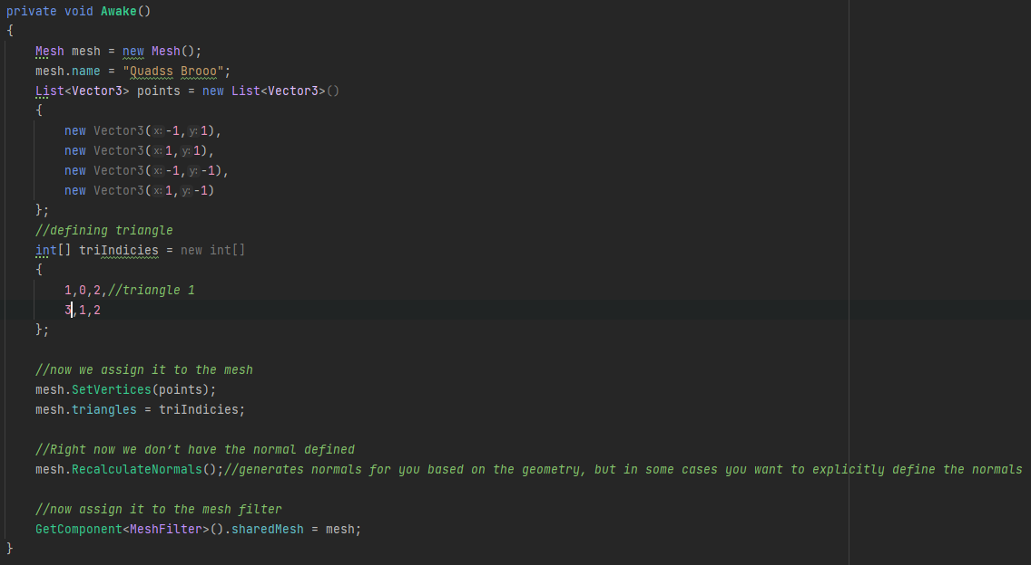

This method is where the face is facing the z axis. Also all of the points are in local space and the normal a well is in local space.

If we also want to recalculate normal manually because it is faster

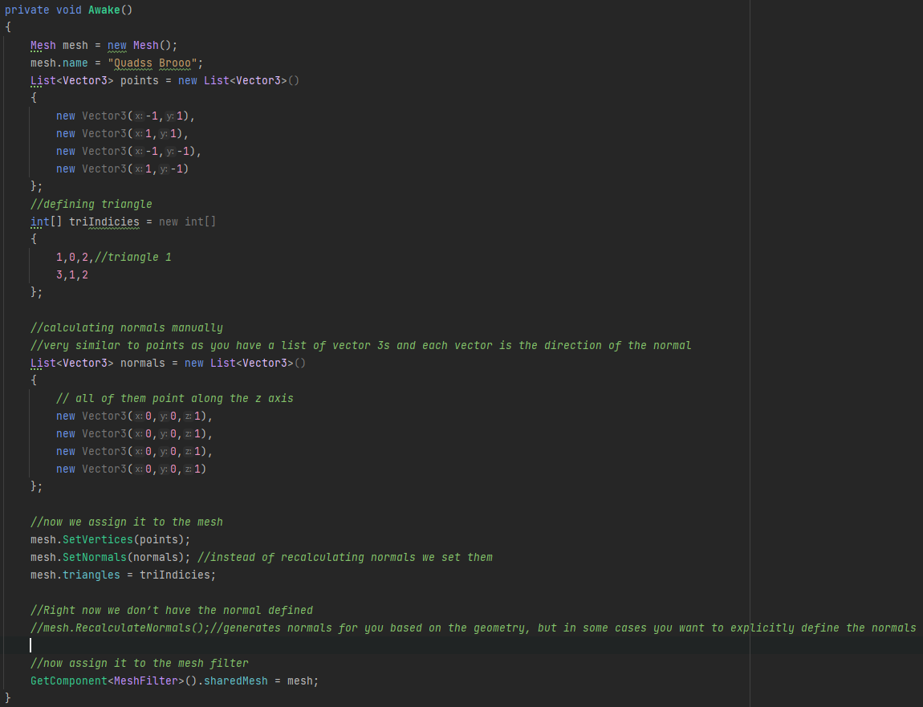

What happens if you build a triangle with opposing normal in the verts?

To start with we’ll talk about interpolation. Let’s say we’re looking at the cross section of a mesh, so we have this 2D mesh

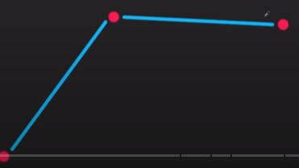

We define a pos for each vertex in model space. A normal is a normalized vector that is pointing in a specific direction per vertex, this is used to define what should be smooth and harded shading. The way it works is that if we want the top left edge to be a soft edge the shading of it should look like

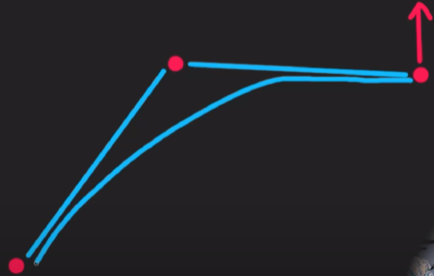

All the data of a vertices are:

Positions,

Normals,

UV Coords – 2D cords along the mesh used for mapping textures onto 3D mesh

Basically 2 vectices that are at the same point have different normal .

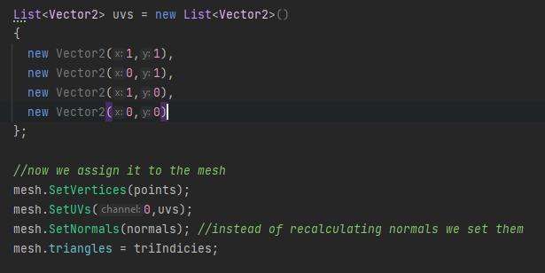

We create the UVs then set them

# Generating a quad ring

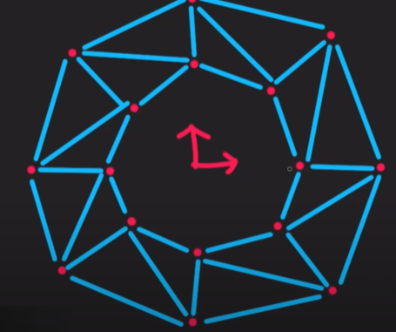

So we want a few parameters for inner radius

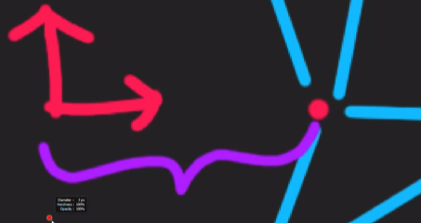

And outer radius

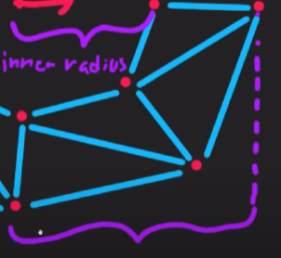

An then the detail level for the amount of lines

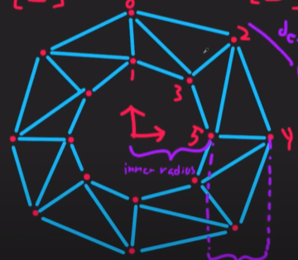

How do we want to define triangle and do we want to do 2 at a time.

We will do 1 iteration per angular segment

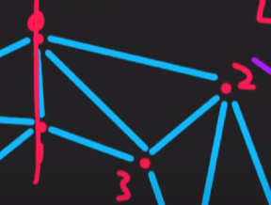

The first iteration will generate the first segment in the image above

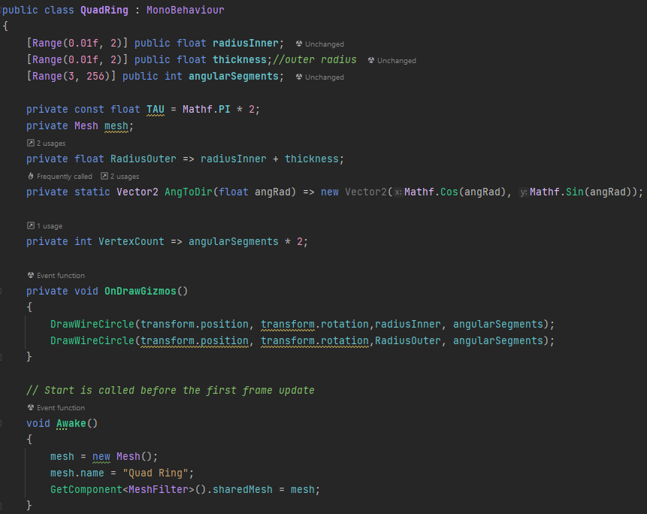 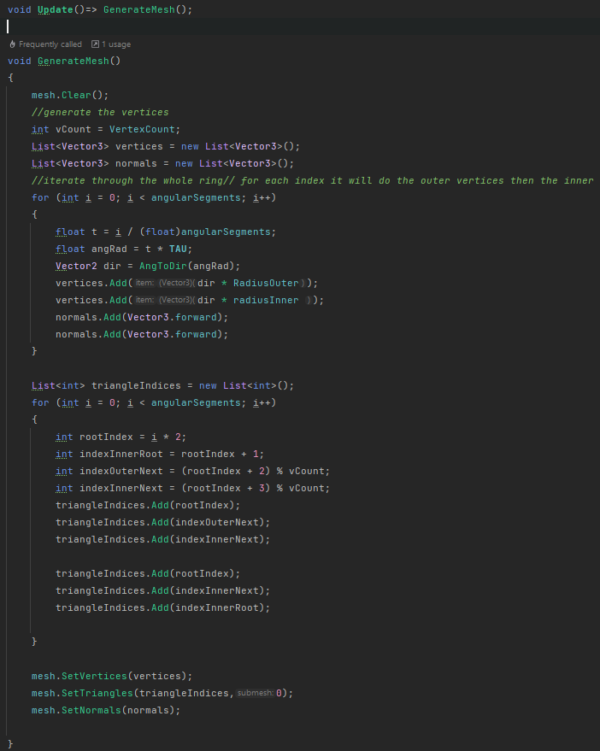

RootIndex would be 0,2,4 and so on and so forth, indexInnerRoot would be 1,3,5 etc. indexOuterNext would be 2, 4 etc and indexInnerNext is 3,5 etc.

When using UVs there are 2 types of projection this is assuming we want to map those textures to

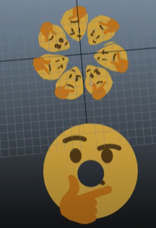

This shape

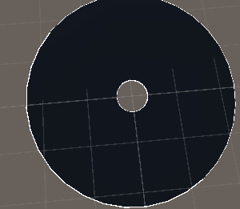

To do the top projection you do

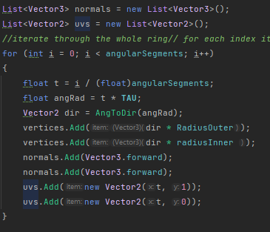

To fix the bug when it comes to wrapping the texture you do basically the difference is the angularsegment +1 and no more modulus

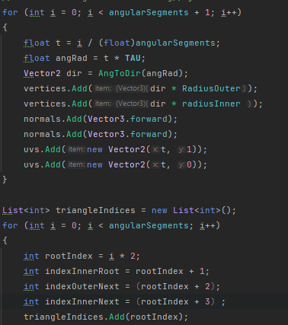

For top-down projection:

You use the dir variable, the direction is gonna be the coordinate we want for the outer one. The outer one is going to be the coord of the direction you have in the unit circle but we need to re map because this direction is between -1 and 1 and we want 0 and 1 and we do this by multiplying it by 0.5 and adding 0.5

# Physics Engine

#### VECTORS AND DIRECTIONS

vector is the change along each axis. So 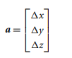where △x is the change in the position along the X axis from a0 to a1, given by  where x0 is the X coordinate of a0 and x1 is the X coordinate of a1. Similarly for △y and △z. Position and change in position are really two sides of the same coin. We can think of any position as a change of position from the origin.

A change in position, given as a vector, can be split into two elements:

a = dn

where d is the straight-line distance of the change (called the “magnitude” of the vector) and n is the direction of the change. The vector n represents a change, whose straight-line distance is always 1, in the same direction as the vector a.

We can find d using the three-dimensional version of Pythagoras’s theorem, which has the formula.

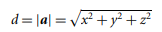

|a| is the magnitude of the vector.

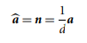

where ^a^ is a common (but not universal) notation for the unit-length direction of a. The equation is sometimes written as 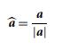 The process of finding just the direction n from a vector is called “normalizing”.

#### The Trigonometry of the Scalar Product

There is an important result for scalar products, which is not obvious from equation 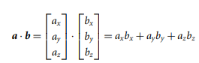.

It relates the scalar product to the length of the two vectors and the angle between them:

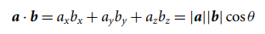

where θ is the angle between the two vectors. So, if we have two normalized vectors 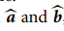, then the angle between them is given by equation 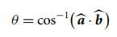.

Note the normalized vectors here. If a and b are just regular vectors, then the angle would be given by 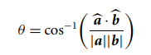

#### THE VECTOR PRODUCT

Whereas the scalar product multiplies two vectors together to give a scalar value, the vector product multiplies them to get another vector. In this way it is similar to the component product but is considerably more common.

The vector product is indicated by a multiplication sign, a × b, and so is often called the “cross product.” The vector product is calculated with the formula

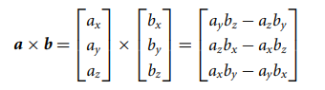

#### The Trigonometry of the Vector Product

the vector product has a trigonometric correspondence. This time the magnitude of the product is related to the magnitude of its arguments and the angle between them, as follows:

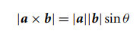

where θ is the angle between the vectors, as before. This is the same as the scalar product, replacing the cosine with the sine. In fact, we can write

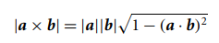

using the relationship between cosine and sine:

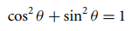

We could use equation 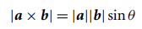to calculate the angle between two vectors, just as we did using equation for the scalar product. if we need to find the angle (which we rarely do), then using the scalar product would be a faster solution.

#### Commutativity of the Vector Product

You may have noticed in the derivation of the vector product that it is not commutative. In other words,  However, 

#### The Geometry of the Vector Product

Once again using the scalar product as an example, we can interpret the magnitude of the vector product of a vector and a normalized vector. For a pair of vectors, ^a^ and ^b^, the magnitude of the vector product represents the component of b that is not in the direction of a. Again, having a vector a that is not normalized simply gives us a magnitude that is scaled by the length of a.

Because it is easier to calculate the scalar product than the vector product, if we need to know the component of a vector not in the direction of another vector, we are better off performing the scalar product and then using Pythagoras’s theorem to give the result

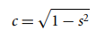

where c is the component of b not in the direction of ^a^ and s is the scalar product ^a^ · b.

### CALCULUS

There are two ways of understanding these changes: we describe the change itself, and we describe the results of the change. If an object is changing position with time, we need to be able to understand how it is changing position (i.e., its speed, the direction it is moving in, if it is accelerating or slowing) and the effects of the change (i.e., where it will be when we come to render it during the next frame of the game). These two viewpoints are represented by differential and integral calculus.

#### DIFFERENTIAL CALCULUS

we can view the differential of a quantity as the rate at which it is changing. In the majority of this book we are interested in the rate at which it is changing with respect to time. This is sometimes informally called its “speed.” When we come to look at vector calculus, however, speed has a different meaning. It is more common in mathematics and almost ubiquitous in physics programming to call it “velocity.”

#### Velocity

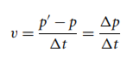

where v is the velocity of the object, p’ and p are its positions at the first and second measurements (so △p is the change in position), and △t is the time that has passed between the two. This would give us the average velocity over the time period. It wouldn’t tell us the exact velocity of the object at any point in time.

Object A travels at a constant velocity, whereas object B stays near its start location for a while and then zooms across the gap very quickly. Clearly they aren’t traveling at the same velocity. If we want to calculate the exact velocity of an object, we could reduce the gap between the first and second measurement. As the gap gets smaller, we get a more accurate picture of the velocity of the object at one instant in time. If we could make this gap infinitely small, then we would have the exact answer. In mathematical notation this is written using the “limit” notation.

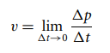

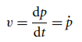

The dot over the p simply means that it is the velocity at which p is changing—its differential with respect to time.

#### Acceleration

If p is the position of an object and v is its velocity (where v = p˙), we can define its acceleration too. Acceleration is the rate at which velocity is changing. If an object is accelerating quickly, it is rapidly increasing in velocity. In normal English we use the word slowing to mean the opposite of acceleration or braking if we are talking about a car. In physics acceleration it can mean any change in velocity, either increasing or decreasing velocity. A positive value for acceleration represents speeding up, a zero acceleration means no change in velocity at all, and a negative acceleration represents slowing down. Because acceleration represents the rate at which velocity is changing, following the same process we arrive at

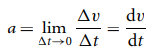

To avoid this confusion, it is typical to write accelerations in terms of the position only. This is called the “second differential.” Velocity is the first differential of position, and if we differentiate again, we get acceleration; so acceleration is the second differential. Mathematicians often write it in this way.

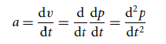 or 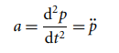

the rate at which the acceleration is changing (this is called the “jerk” or sometimes the “jolt,” and it is particularly important in the design of roller coasters, among other things.

applying a force to an object changes its acceleration: to make believable physics involving forces, all we need to keep track of are the position, velocity, and acceleration.

#### Vector Differential Calculus

If the position of the object is given as a vector in three dimensions, then its rate of change is also represented by a vector. Because a change in the position on one axis doesn’t change the position on any other axes, we can treat each axis as if it were its own scalar differential. The velocity and the acceleration of a vector depends only on the velocity and acceleration of its components:

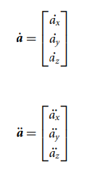

As long as the formulae we meet do not involve the products of vectors, this matches exactly with the way we defined vector addition and vector–scalar multiplication earlier in the chapter. The upshot of this is that for most formulae involving the differentials of vectors, we can treat the vectors as if they were scalars.

#### Velocity, Direction, and Speed

The speed of an object is the magnitude of this velocity vector, and the direction that the object is moving in is given by the normalized velocity. So

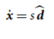

where s is the speed of the object, and ^d^ is its direction of movement. Using the equations for the magnitude and direction of any vector, the speed is given by 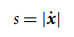and the direction by 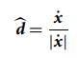

The speed of an object is rarely needed in physics development: it has an application in calculating aerodynamic drag, but little else.

#### INTEGRAL CALCULUS

In physics engines, integration is used to update the position and velocity of each object. The chunk of code that performs this operation is called the “integrator.” Although integration in mathematics is an even more complex process than differentiation, involving considerable algebraic manipulation, in game development it is very simple. If we know that an object is moving with a constant velocity (i.e., no acceleration), and we know this velocity along with how much time has passed, we can update the position of the object using the formula.

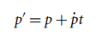only works for an object that is not accelerating.

where p˙ is the constant velocity of the object over the whole time interval. This is the integral of the velocity: an equation that gives us the position. In the same way we could update the object’s velocity in terms of its acceleration using the formula

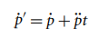

Rather than finding the position by the first integral of the velocity, we could find it as the second integral of the acceleration (just as acceleration was the second derivative of the position). This would give us an updated equation of

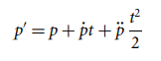assumes a constant acceleration. isn’t needed when it comes to updating the position; we can make do with the assumption that there is no acceleration.

In mathematics, when we talk about integrating, we mean to convert a formula for velocity into a formula for position; or a formula for acceleration into one for velocity—in other words, to do the opposite of a differentiation. In game development the term is often used slightly differently: to integrate means to perform the position or velocity updates. From this point on I will stick to the second use, since we will have no need to do mathematical integration again.

#### Vector Integral Calculus

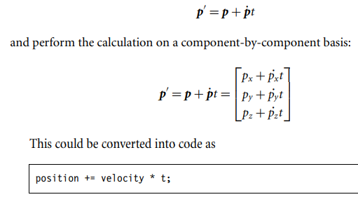

## THE LAWS OF MOTION – A PARTICLE

**Intro**

three laws of motion that describe with great accuracy how a point mass behaves. A point mass is what we call a “particle,” but shouldn’t be confused with particle physics, which studies tiny particles such as electrons or photons that definitely do not conform to Newton’s laws.

A particle has a position, but no orientation. we can’t tell in what direction a particle is pointing.

In the second category are pinpricks of light, from an explosion, for example: the light is a dot of light, and it doesn’t make sense to ask in which direction a spot of light is pointing.

**Physics**

For each particle we’ll need to keep track of various properties: we’ll need its current position, its velocity, and its acceleration. We will add additional properties to the particle as we go. The position, velocity, and acceleration are all vectors.

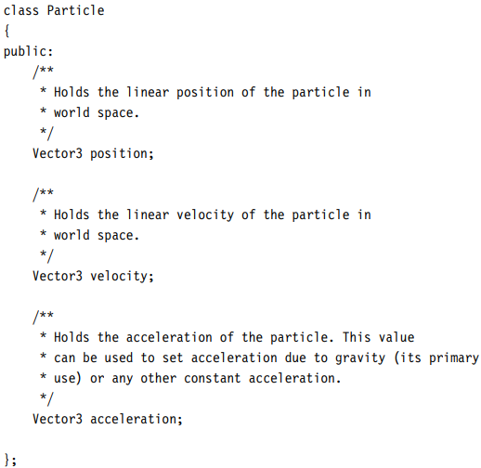

### THE FIRST TWO LAWS

The first two laws of motion are:

1. An object continues with a constant velocity unless a force acts upon it.
2. A force acting on an object produces acceleration that is proportional to the object’s mass.

if there are no forces around the object will continue to move with a constant velocity. In other words, the velocity of the particle will never change, and its position will keep on being updated based on the velocity. This may not be intuitive: moving objects we see in the real world will slow and come to a stop eventually if they aren’t being constantly forced along.

To simulate drag we could add special drag forces. This is fine for the simple engine, but it can cause problems with more complex systems. The problem arises because the processor that performs the physics calculations isn’t completely accurate. This inaccuracy can lead to objects getting faster of their own accord. A better solution is to incorporate a rough approximation of drag directly into the engine. This allows us to make sure objects aren’t being accelerated by numerical inaccuracy, and it can allow us to simulate some kinds of drag. If we need complicated drag (such as aerodynamic drag in a flight simulator or racing game), we can still do it the long way by creating a special drag force. We call the simple form of drag “damping” to avoid confusion.

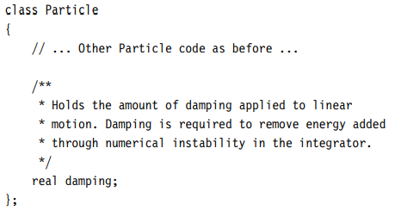

The damping parameter controls how velocity is left after the update. If the damping is zero, then the velocity will be reduced to nothing: this would mean that the object couldn’t sustain any motion without a force and would look odd to the player. A value of 1 means that the object keeps all its velocity (equivalent to no damping). If you don’t want the object to look like it is experiencing drag, then values near but less than 1 are optimal—0.995.

### THE SECOND LAW

A force is something that changes the acceleration of an object. An implication of this law is that we cannot do anything to an object to directly change its position or velocity; we can only do that indirectly by applying a force to change the acceleration and wait until the object reaches our target position or velocity. we will treat the acceleration of the particle different from velocity and position. Both velocity and position keep track of a quantity from frame to frame during the game. They change, but not directly, only by the influence of accelerations. Acceleration, by contrast, can be different from one moment to another. We can simply set the acceleration of an object as we see fit.

The acceleration property can be set at any time, and it will be left alone by the integrator.

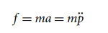

Where we are trying to find the acceleration, we have

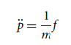

where f is the force and m is the mass.

#### ADDING MASS TO PARTICLES

Added to the position and velocity we have stored per particle, we need to store its mass so that we can correctly calculate its response to forces. Many physics engines simply add a scalar mass value for each object. There is a better way to get the same effect.

If the mass of an object is zero, then the acceleration will be infinite, as long as the force is not zero. This is not a situation that should ever occur: no particle that we can simulate should ever have zero mass. If we try to simulate a zero mass particle, it will cause divide-by-zero errors in the code. It is often useful, however, to simulate infinite masses. These are objects that no force of any magnitude can move. They are very useful for immovable objects in a game: the walls or floor, for example, cannot be moved during the game. If we feed an infinite mass into equation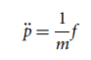 then the acceleration will be zero, as we expect.

Ideally we want a solution where it is easy to get infinite masses but impossible to get zero masses. we use 1 over the mass each time.

Because we never use the 3.1 form of the equation, we can speed up our calculations by not storing the mass for each object, but 1 over the mass. We call this the “inverse mass.” This solves our problem for representing objects of zero or infinite mass: infinite mass objects have a zero inverse mass, which is easy to set. Objects of zero mass would have an infinite inverse mass.

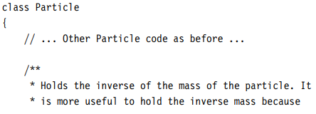

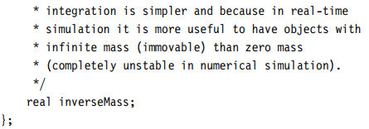

#### MOMENTUM AND VELOCITY

Momentum is the product of velocity and mass. Since mass is normally constant, we can assume that velocity is therefore constant – newton fist law

#### THE FORCE OF GRAVITY

The formula he gave us is the “law of universal gravitation”:

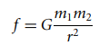

where m1 and m2 are the masses of the two objects, r is the distance between their centers, f is the resulting force, and G is the “universal gravitational constant”—a scaling factor derived from observation of planetary motion.

The effects of gravity between two objects the size of a planet are significant; the effects between (relatively) small objects such as a car, or even a building, are small.

First we can assume that m1 is always constant. Second, and less obviously, we can assume that r is also constant. For the accuracy we need in a game, we can therefore assume the r parameter is constant.

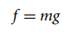

where m is the mass of the object we are simulating; f is the force, as before; and g is a constant that includes the universal gravitational constant

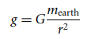

The constant, g, is an acceleration, which we measure in meters per second per second. On earth this g constant has a value of around 10 m/s2

Notice that the force depends on the mass of the object. If we work out the acceleration using

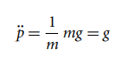

In other words, no matter what mass the object has, it will always accelerate at the same rate due to gravity.

There is no point using equation  to calculate a force and then using equation 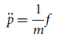 to convert it back into an acceleration. In this iteration of the engine we will introduce gravity as the sole force at work on particles, and it will be applied directly as an acceleration.

The acceleration due to gravity can therefore be represented as a vector with the form

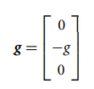

### THE INTEGRATOR

At each frame, the engine needs to look at each object in turn, work out its acceleration, and perform the integration step. The calculation of the acceleration in this case will be trivial: we will use the acceleration due to gravity only.

The integrator consists of two parts: one to update the position of the object, and the other to update its velocity. The position will depend on the velocity and acceleration, while the velocity will depend only on the acceleration.

#### THE UPDATE EQUATIONS

we saw that integrating the acceleration twice gives us this equation for the position update:

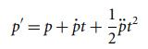

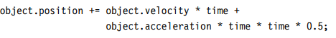

If we look at the acceleration part of this equation, we are taking half of the squared time (which gives 0.0005). This is such a small value that it is unlikely the acceleration will have much of an impact on the change in position of an object. For this reason we typically ignore the acceleration entirely in the position update and use the simpler form.

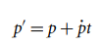

If your game regularly uses short bursts of huge accelerations, then you might be better off using the longer form of the equation. If you do intend to use huge accelerations, however, you are likely to get all sorts of other accuracy problems in any case: all physics engines typically become unstable with very large accelerations.

#### Velocity Update

The velocity update has a similar basic form

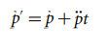

we introduced another factor to alter the velocity: the damping parameter. The damping parameter is used to remove a bit of velocity at each frame. This is done by simply multiplying the velocity by the damping factor.

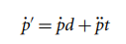

where d is the damping for the object

This form of the equation hides a problem, however. No matter whether we have a long or a short time interval over which to update, the amount of velocity being removed is the same. If our frame rate suddenly improves, then there will be more updates per second and the object will suddenly appear to have more drag. A more correct version of the equation solves this problem by incorporating the time into the drag part of the equation:

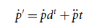

where the damping parameter d is now the proportion of the velocity retained each second, rather than each frame.

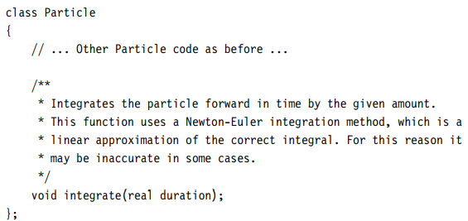

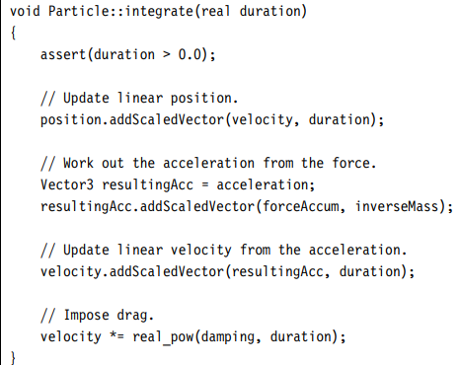

I have added the integration method to the Particle class because it simply updates the particles’ internal data. It takes just a time interval and updates the position and velocity of the particle, returning no data

## THE PARTICLE PHYSICS ENGINE

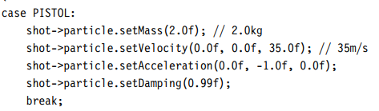

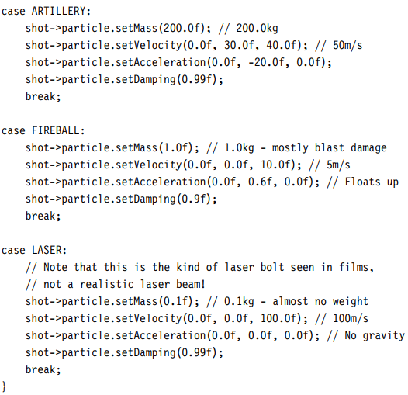

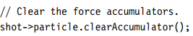

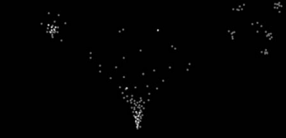

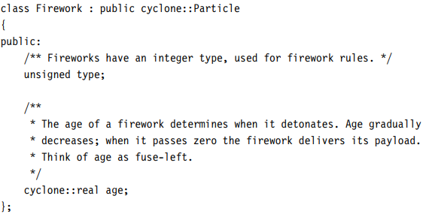

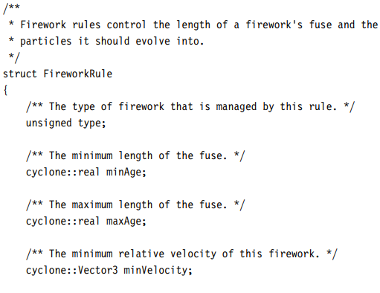

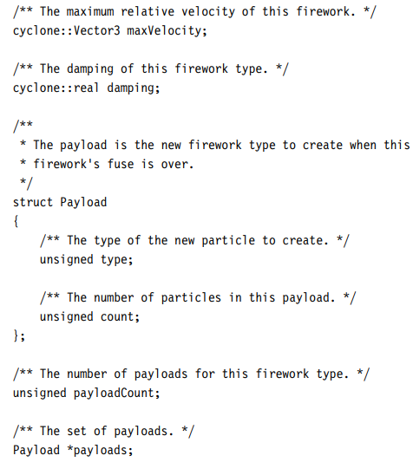

To define the effect of the whole fireworks display, we need to be able to specify how one type of particle changes into another. We do this as a set of rules: for each firework type we store an age and a set of data for additional fireworks that will be spawned when the age is passed. This is held in a Rules data structure with this form:

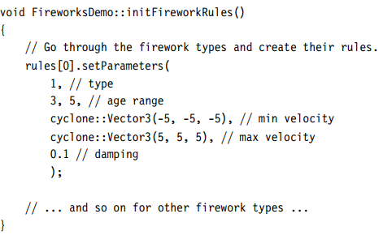

Rules are provided in the code, and they are defined in one function that controls the behavior of all possible fireworks. This is a sample of that function.

At each frame, each firework has its age updated and is checked against the rules. If its age is past the threshold, then it will be removed and more fireworks will be created in its place (the last stage of the chain reaction spawns no further fireworks). Using the particle update function to perform the physics, the firework update function now looks like this:

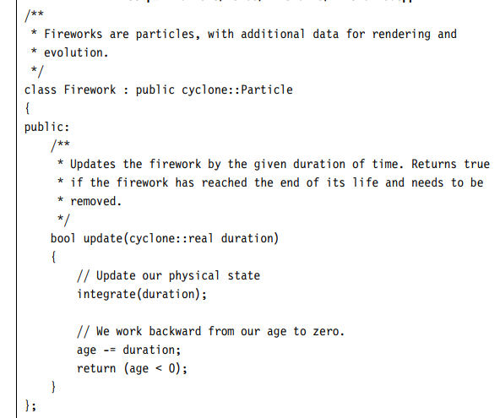

Notice that if we don’t have any spare firework slots when a firework explodes into its components, then not all the new fireworks will be calculated. In other words, when resources are tight, older fireworks get priority. This allows us to put a hard limit on the number of fireworks being processed, which can avoid having the physics slow down when things get busy. Many developers use a different strategy in their engines: they give priority to newly spawned particles and remove old particles to make way. This gives a slightly less pleasing effect

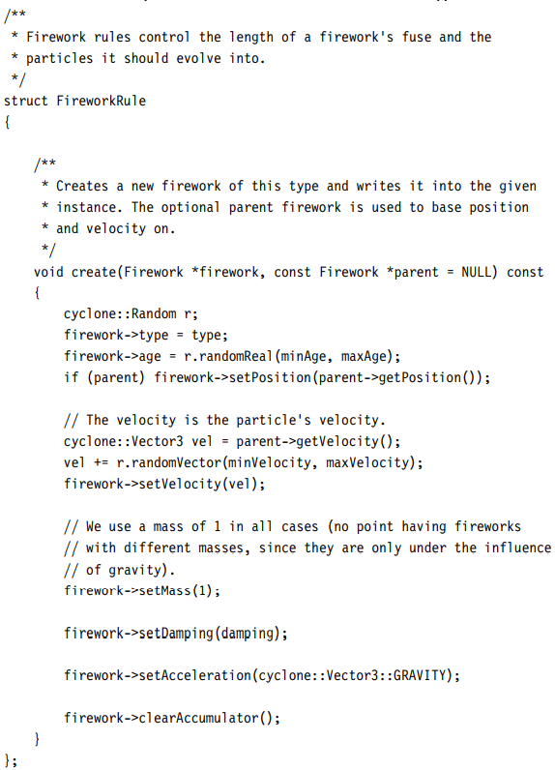

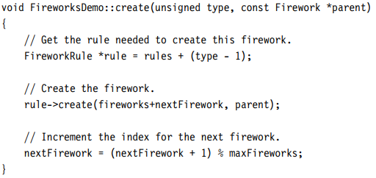

As fireworks are spawned, they have their particle properties set, with velocities determined with a random component. Notice that I’ve used high damping values for several of the firework types. This allows them to drift back down to the ground slowly, which is especially important for fireworks that need to hang in the air before exploding.

At each frame, all of the currently active fireworks are updated. This is performed by a simple loop that first checks to see whether the firework should be processed.

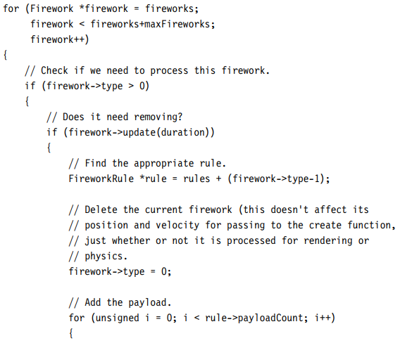

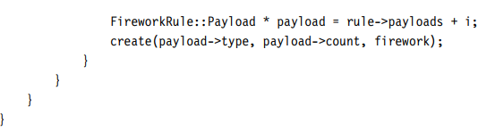

## ADDING GENERAL FORCES

### D’ALEMBERT’S PRINCIPLE

Clearly the behavior is going to be different than if either force acts alone: one force could be acting in the opposite direction to another, or reinforcing it in parallel. We need a mechanism to work out the overall behavior as a result of all forces.

For particles D’Alembert’s principle implies that, if we have a set of forces acting on an object, we can replace all those forces with a single force, which is calculated by:

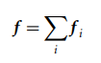

In other words, we simply add the forces together using vector addition, and we apply the single force that results.

To make use of this result, we use a vector as a force accumulator. In each frame we zero the vector and add each applied force in turn using vector addition. The final value will be the resultant force to apply to the object.

We add a method to the particle that is called at the end of each integration step to clear the accumulator of the forces that have just been applied

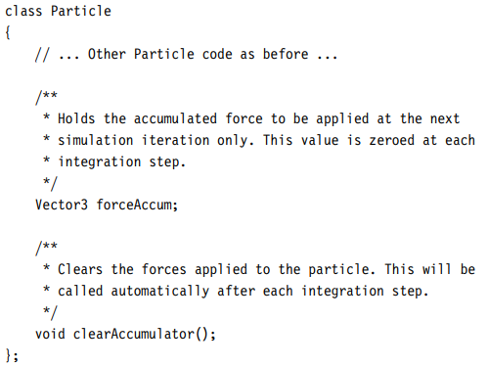

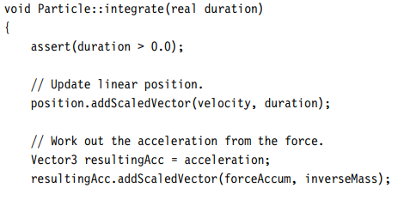

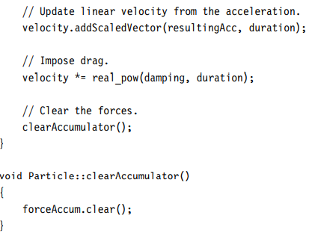

This accumulation stage needs to be completed just before the particle is integrated. All the forces that apply need to have the chance to add themselves to the accumulator. We can do this by manually adding code to our frame update loop that adds the appropriate forces. This is appropriate for forces that will only occur for a few frames. We can make it easier to manage these long-term forces by creating a registry. A force registers itself with a particle and then will be asked to provide a force at each frame.

### FORCE GENERATORS

We have a mechanism for applying multiple forces to an object. We now need to work out where these forces come from. The force of gravity is fairly intuitive: it is always present for all objects in the game.

Some forces arise because of the behavior of an object—a dedicated drag force, for example. Other forces are a consequence of the environment that an object finds itself in: a buoyancy force for a floating object and the blast force from an explosion are examples. Still other types of force are a result of the way objects are connected together

Most other forces are constantly changing. Some change as a result of the position or velocity of an object: drag is stronger at higher speeds, and a spring’s force is greater the more it is compressed.

If we simply programmed all these types of force into the physics engine, and set parameters to mix and match them for each object, the code would rapidly become unmanageable.

a structure called a “force generator.” There can be as many different types of force generator as there are types of force, but each object doesn’t need to know how a generator works. The object simply uses a consistent interface to find the force associated with each generator: these forces can then be accumulated and applied in the integration step. This allows us to apply any number of forces, of any type we choose, to the object. It also allows us to create new types of force for new games or levels

To implement this we will use an object-oriented design pattern called an “interface.”

The force generator interface needs to provide only a current force. This can then be accumulated and applied to the object. The interface we will use looks like this

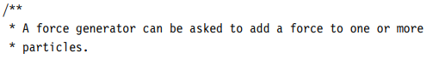

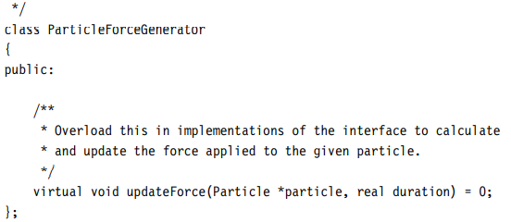

The updateForce method is passed for the duration of the frame for which the force is needed and a pointer to the particle requesting the force. The duration of the frame is needed for some force generators.

We pass the pointer of the object into the function so that a force generator does not need to keep track of an object itself. This also allows us to create force generators that can be attached to several objects at the same time. As long as the generator instance does not contain any data that is specific to a particular object, it can simply use the object passed in to calculate the force.

The force generator does not return any value. We could have it return a force to add to the force accumulator, but then force generators would have to return some force (even if it were zero), and that would remove the flexibility we’ll use.

As well as the interface for force generators, we need to be able to register which force generators affect which particles. We could add this into each particle, with a data structure such as a linked list or a growable array of generators.

This would be a valid approach, but it has performance implications: either each particle needs to have lots of wasted storage (using a growable array) or new registrations will cause lots of memory operations (creating elements in linked lists). For performance and modularity I think it is better to decouple the design and have a central registry of particles and force generators.

At each frame, before the update is performed, the force generators are all called. They will be adding forces to the accumulator which can be used later to calculate each particle’s acceleration

#### A GRAVITY FORCE GENERATOR

We can replace our previous implementation of gravity by a force generator. Rather than apply a constant acceleration at each frame, gravity is represented as a force generator attached to each particle.

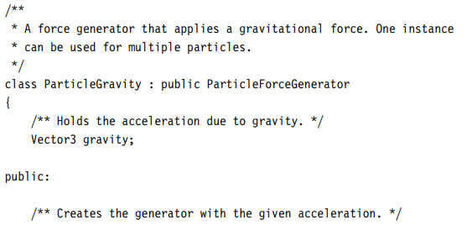

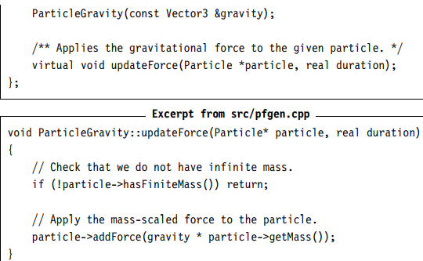

#### A DRAG FORCE GENERATOR

Drag is a force that acts on a body and depends on its velocity. A full model of drag involves more complex mathematics that we can easily perform in real time. Typically in game applications we use a simplified model of drag where the drag acting on a body is given by

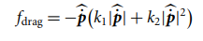

where k1 and k2 are two constants that characterize how strong the drag force is. They are usually called the “drag coefficients,” and they depend on both the object and the type of drag being simulated. The formula looks complex but is simple in practice. It says that the force acts in the opposite direction to the velocity of the object (this is the − p˙ part of the equation: p˙ is the normalized velocity of the particle), with a strength that depends on both the speed of the object and the square of the speed. Drag that has a k2 value will grow faster at higher speeds. This is the case with the aerodynamic drag that keeps a car from accelerating indefinitely. At slow speeds the car feels almost no drag from the air, but for every doubling of the speed the drag almost quadruples.

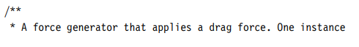

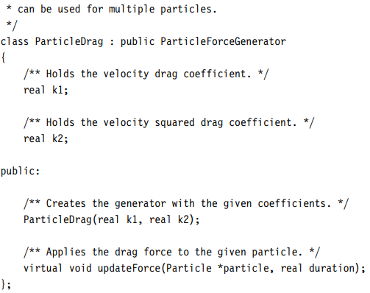

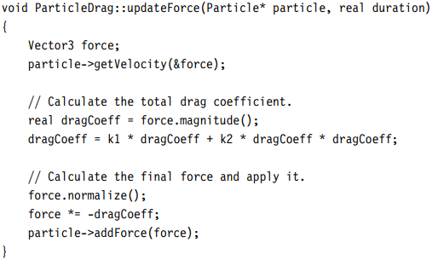

the force is calculated based only on the properties of the object it is passed. The only pieces of data stored by the class are the values for the two constants. As before, one instance of this class could be shared among any number of objects that have the same drag coefficients

This drag model is considerably more complex than the simple damping we used It can be used to model the kind of drag that a golf ball experiences in flight, for example. For the aerodynamics needed in a flight simulator, however, it may not be sufficient.

Using the generators discussed earlier we can replace both the damping and the acceleration due to gravity with force generators.

It allows us to remove the special code that processes damping, and it means we don’t need to store an acceleration due to gravity with the object; it can be calculated among all the other forces during transient force accumulation. Although it has some advantages in simplicity, this is not the approach I will use. Directly applying the damping and acceleration due to gravity, in the way we did in chapter 3, is fast. If we have to calculate forces for them each time, we waste extra time performing calculations for which we already know the answer.

## HARD CONSTRAINTS

### SIMPLE COLLISION RESOLUTION

To cope with hard constraints we’ll add a collision resolution system. When two objects collide, their movement after the collision can be calculated from their movement before the collision: this is collision resolution. We resolve the collision by making sure the two objects have the correct motion that would result from the collision. Because collision happens in such a small instant of time (for most objects we can’t see the process of collision happening; it appears to be instant), we go in and directly manipulate the motion of each object.

### THE CLOSING VELOCITY

The laws governing the motion of colliding bodies depend on their closing velocity. The closing velocity is the total speed at which the two objects are moving together.

that this is a closing velocity, rather than a speed, even though it is a scalar quantity.

if we have a scalar value, then the direction is given by the sign of the value. Two objects that are moving apart from each other will have a closing velocity that is less than zero, for example.

Closing velocity is a term used in physics to describe the relative velocity between two objects moving towards each other. It is calculated by finding the component of the velocity of each object in the direction towards the other object. The closing velocity is the speed at which the objects are moving closer to each other and helps in determining the potential outcome of their collision.

We calculate the closing velocity of two objects by finding the component of their velocity in the direction from one object to another.

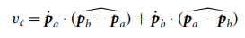

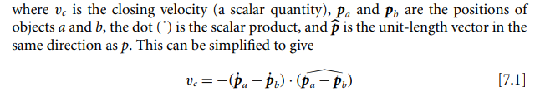

Although it is just a convention, it is more common to change the sign of this quantity. Rather than a closing velocity, we have a separating velocity. The closing velocity is the velocity of one object relative to another, in the direction between the two objects. In this case two objects that are closing in on each other will have a negative relative velocity, and objects that are separating will have a positive velocity. Mathematically this is simply a matter of changing the sign of equation 7.1 to give

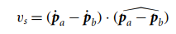

where vs is the separating velocity, which is the format we’ll use. you’ll have to flip the sign of various quantities in the engine to compensate.

### THE COEFFICIENT OF RESTITUTION

As we saw in the last chapter, when two objects collide, they compress together, and the springlike deformation of their surfaces causes forces to build up that bring the objects apart. This all happens in a very short space of time (too fast for us to simulate frame by frame, although long enough to be captured on very high-speed film). Eventually the two objects will no longer have any closing velocity.

All kinds of things can be happening during this compression, and the peculiarities of the materials involved can cause very complicated interactions to take place. In reality the behavior does not conform to that of a damped spring, and we can’t hope to capture the subtleties of the real process. In particular the spring model assumes that momentum is conserved during the collision:

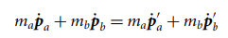

where ma is the mass of object a, p˙ a is the velocity of object a before the collision, and p˙ a is the velocity after the collision. Fortunately, the vast majority of collisions behave almost like the springlike ideal. We can produce perfectly believable behaviour by assuming the conservation of momentum, and we will use that equation to model our collisions.

It tells us about the total velocity before and after the collision, but it doesn’t tell us about the individual velocities of each object. The individual velocities are linked together using the closing velocity, according to the equation

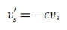

where v’ s is the separating velocity after the collision, vs is the separating velocity before the collision, and c is a constant called the “coefficient of restitution.” The coefficient of restitution controls the speed at which the objects will separate after colliding. It depends on the materials in collision. Different pairs of material will have different coefficients. Some objects such as billiard balls or a tennis ball on a racket bounce apart. Other objects stick together when they collide—a snowball and someone’s face. If the coefficient is 1, then the objects will bounce apart with the same speed as when they were closing. If the coefficient is 0, then the objects will coalesce and travel together (i.e., their separating velocity will be 0). Regardless of the coefficient of restitution the spring model equation just before this equation will still hold: the total momentum will be the same. Using the two equations, we can get values for 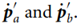

### THE COLLISION DIRECTION AND THE CONTACT NORMAL

we’ve talked in terms of collisions between two objects. Often, we also want to be able to support collisions between an object and something we’re not physically simulating. This might be the ground, the walls of a level, or any other immovable object. We could represent these as objects of infinite mass, but it would be a waste of time: by definition they never move.

If we have a collision between one object and some piece of immovable scenery, then we can’t calculate the separating velocity in terms of the vector between the location of each object: we only have one object. In other words, we can’t use the  in equation 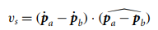

That part gives us the direction in which the separating velocity is occurring. The separating velocity is calculated by the dot product of the relative velocity of the two objects and this term. If we don’t have two objects, we can ask that the direction be given to us explicitly. It is the direction in which the two objects are colliding and is usually called the “collision normal” or “contact normal.” Because it is a direction, the vector should always have a magnitude of 1.

In cases where we have two particles colliding, the contact normal will always be given by

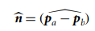

By convention we always give the contact normal from object a’s perspective. In this case, from a’s perspective, the contact is incoming from b, so we use pa − pb. To give the direction of collision from b’s point of view we could simply multiply by −1. In practice we don’t do this explicitly, but factor this inversion into the code used to calculate the separating velocity for b. But a minus sign can appear in B’s calculations.

When a particle is colliding with the ground, we only have an object a (the particle) and no object b. In this case from object a’s perspective, the contact normal will be

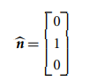

assuming that the ground is level at the point of collision. When we leave particles and begin to work with full rigid bodies, having an explicit contact normal becomes crucial even for inter-object collisions.

Here the two colliding objects, by virtue of their shapes, have a contact normal in almost exactly the opposite direction from that we’d expect if we simply considered their locations. The objects arch over each other, and the contact is acting to prevent them from moving apart rather than keeping them together

With the correct contact normal. This

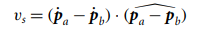

Becomes

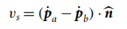

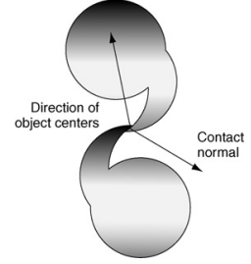

Contact normal is different from the vector between objects in contact.

### IMPULSES

The change we must make to resolve a collision is a change in velocity only. If the acceleration is applied for a long time, there will be a larger change in velocity. Here the changes are instant: the velocities immediately take on new values. Recall that applying a force changes the acceleration of an object. If we instantly change the force, the acceleration instantly changes too. We can think of acting on an object to change its velocity in a similar way. Rather than a force, this is called an “impulse”: an instantaneous change in velocity. In the same way that we have.

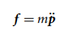

for forces, we have

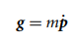 for impulses, g.

There is a major difference, however, between force and impulse. An object has no acceleration unless it is being acted on by a force: we can work out the total accel eration by combining all the forces using D’Alembert’s principle. On the other hand, an object will continue to have a velocity even if no impulses (or forces) are acting on it. The impulse therefore changes the velocity; it is not completely responsible for the velocity. We can combine impulses using D’Alembert’s principle, but the result will be the total change in velocity, not the total velocity:

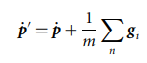

where g1 ... gn is the set of all impulses acting on the object. In practice we won’t accumulate impulses in the way we did forces. We will apply impulses as they arise during the collision resolution process. Each will be applied one at a time using the equation

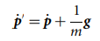

The result of our collision resolution will be an impulse to apply to each object. The impulse will be immediately applied and will instantly change the velocity of the object.

### COLLISION PROCESSING

To handle collisions we will create a new piece of code—the ContactResolver. It has the job of taking a whole set of collisions and applying the relevant impulses to the objects involved. Each collision is provided in a Contact data structure

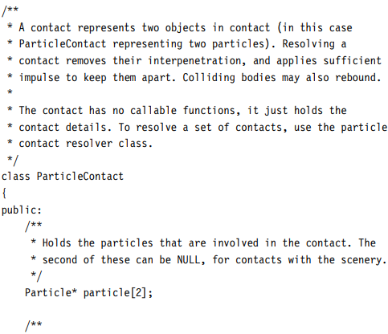

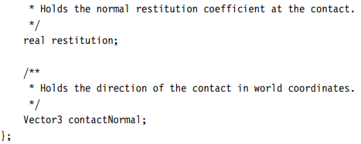

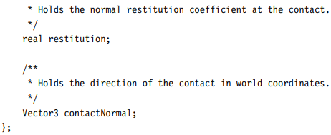

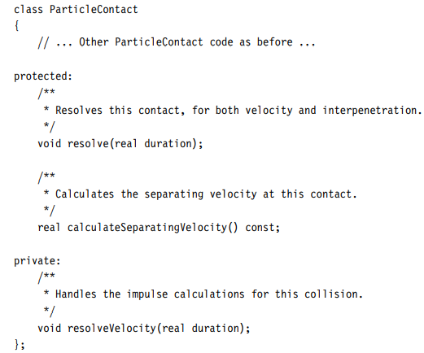

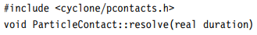

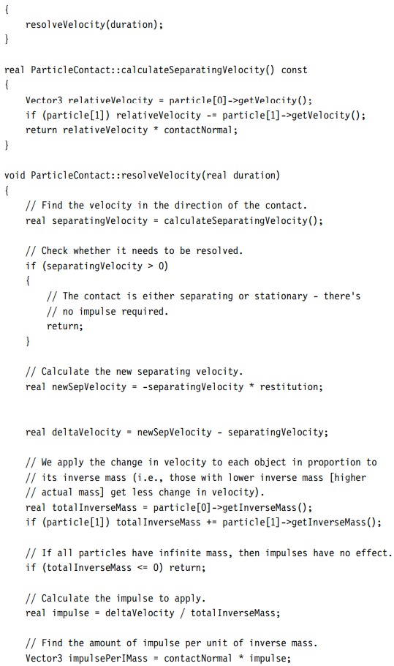

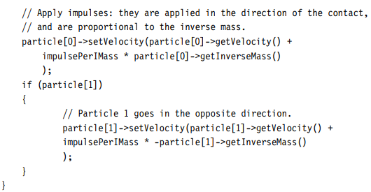

### COLLISION DETECTION

The collision points will normally be found using a collision detector. A collision detector is a chunk of code responsible for finding pairs of objects that are colliding or single objects that are colliding with some piece of immovable scenery.

the end result of the collision detection algorithm is a set of Contact data structures, filled with the appropriate information. Collision detection obviously needs to take the geometries of the objects into account: their shape and size. So far in the physics engine, we’ve assumed we are dealing with particles, which lets us avoid taking geometry into account at all.

When we’re processing a collision between partially embedded objects, it is not enough to only change their velocity. If the objects are colliding with a small coefficient of restitution, their separation velocity might be almost zero. In this case they will never move apart, and the player will see the objects stuck together in an impossible way. As part of resolving the collisions, we need to resolve the interpenetration.

### RESOLVING INTERPENETRATION

When two objects are interpenetrating, we move them apart just enough to separate them. We expect the collision detector to tell us how far the objects have interpenetrated, as part of the Contact data structure it creates. The calculation of the interpenetration depth depends on the geometries of the objects colliding, and as we saw earlier, this is the domain of the collision detection system rather than the physics simulator. We add a data member to the Contact data structure to hold this information.

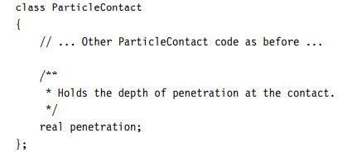

Note that, just like the closing velocity, the penetration depth has both size and sign. A negative depth represents two objects that have no interpenetration. A depth of zero represents two objects that are merely touching.

To resolve the interpenetration we check the interpenetration depth. If it is already zero or less, then we need take no action; otherwise, we can move the two objects apart just far enough so that the penetration depth becomes zero. The penetration depth should be given in the direction of the contact normal. If we move the objects in the direction of the contact normal, by a distance equal to the penetration depth, then the objects will no longer be in contact. The same occurs when we have just one object involved in the contact (i.e., it is interpenetrating with the scenery of the game): the penetration depth is in the direction of the contact normal.

So we know the total distance that the objects must be moved (i.e., the depth) and the direction in which they will be moving; we need to work out how much each individual object should be moved.

If we have only one object involved in the contact, then this is simple: the object needs to move the entire distance. If we have two objects, then we have a whole range of choices. We could simply move each object by the same amount: by half of the interpenetration depth. This would work in some situations but can cause believability problems. Imagine we are simulating a small box resting on a planet’s surface. If the box is found slightly interpenetrating the surface, should we move the box and the planet out of the way by the same amount? We have to take into account how the interpenetration came to be in the first place, and what would have happened in the same situation in reality. Figure 7.3 shows the box and planet, in penetration, as if real physics were in operation.

we move two objects apart in inverse proportion to their mass. An object with a large mass gets almost no change, and an object with a tiny mass gets to move a lot. If one of the objects has infinite mass, then it will not move: the other object gets moved the entire way. The total motion of each object is equal to the depth of interpenetration:

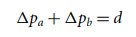

where pa is the scalar distance that object a will be moved (we’ll return to the direction later). The two distances are related to each other according to the ratio of their masses:



which combined gives us:

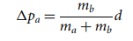

And

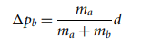

Combining these with the direction from the contact normal, we get a total change in the vector position of

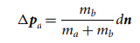

And

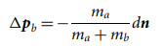

where n is the contact normal.

(Note the minus sign in the second equation: this is because the contact normal is given from object a’s perspective.)

We can implement the interpenetration resolution equations with this function

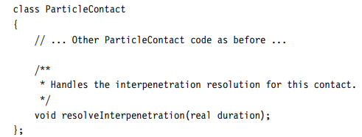

# Physics Engine 2

## Newtons Law of Motion

### Law I

A body tends to remain at rest or continue to move in a straight line at constant velocity unless acted upon by an external force. This is the concept of inertia.

### Law II

The acceleration of a body is proportional to the resultant force acting on the body, and this acceleration is in the same direction as the resultant force.

### Law III

For every force acting on a body (action) there is an equal and opposite reacting force (reaction), where the reaction is collinear(In geometry, two or more points are said to be collinear, if they lie on the same line.) to the acting force.

The second law is important in the study of dynamics, which is:

F=ma

F is the resultant force acting on the body, m is the mass of the body, and a is the linear acceleration of the body’s center of gravity.

## Units and Measures

you know that the weight of an object is measured in units of force, which can be broken down into component dimensions like so:

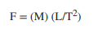

where M is mass, L is length, and T is time. if you consider that the component units for acceleration are (L/T2 ) and let a be the symbol for acceleration and m be the symbol for the mass of an object, you get:

F=ma

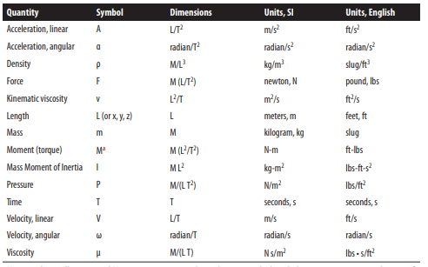

In general, we will use a capital M to represent a moment (torque (Torque is a measure of the force that can cause an object to rotate about an axis.)) acting on a body and a lowercase m to represent the mass of a body.

## Derivatives and Integrals

You can think of a derivative as the rate of change in one variable with respect to another variable, or in other words, derivatives tells you how fast one variable changes as some other variable changes. Take speed, for example. A car travels at a certain speed covering some distance in a certain period of time. Its speed, on average, is the distance traveled over a specific time interval. If it travels a distance of 60 kilometers in one hour, then its average speed is 60 kilometers an hour. When we’re doing simulations, we’re interested in what the car is doing over very short time intervals. As the time interval gets really small and we consider the distance travelled over that very short period of time, we’re looking at instantaneous speed. We usually write such relations using symbols like the following:



where v is the speed, ds is a small distance (a differential distance), and dt is a small, differential, period of time. In reality, for our simulations, we’ll never deal with infinitely small numbers; we’ll use small numbers, such as time intervals of 1 millisecond, but not infinitely small numbers.

you can think of integrals as the reverse, or the inverse, of derivatives; integration is the inverse of differentiation. The symbol ∫ represents integration.

You can think of integration as a process of adding up a bunch of infinitely small chunks of some variable. Here again, we are not going to deal with infinitely small pieces of any‐ thing, but instead will consider small, discrete parcels of some variable—for example, a small, discrete amount of time, area, or mass. In these cases, we’ll use the ∑ symbol instead of the integration symbol. Consider a loaf of bread that’s sliced into uniformly thick slices along its whole length. If you wanted to compute the volume of that loaf of bread, you can approximate it by starting at one end and computing the volume of the first slice, approximating its volume as though it were a very short, square cylinder; then moving on to the second slice, estimating its volume and adding that to the volume of the first slice; and then moving on to the third, and fourth, and so on, aggregating the volume of the loaf as you move toward the other end. Integration applies this technique to infinitely thin slices of volume to compute the volume of any arbitrary shape. The same techniques apply to other computations—for example, computing areas, inertias, masses, and so on, and even aggregating distance travelled over successive small slices of time, as you’ll see later. In fact, this latter application is the inverse of the derivative of distance with respect to time, which gives speed. Using integration and differentiation in this way allows you to work back and forth when computing speed, acceleration, and distance travelled

## Mass, Center of Mass, and Moment of Inertia

The properties of a body—mass, center of mass, and moment of inertia( a measure of how resistant an object is to changes in its rotational motion. ), collectively called mass properties—are absolutely crucial to the study of mechanics, as the linear and angular1 motion of a body and a body’s response to a given force are functions of these mass properties. Thus, in order to accurately model a body in motion, you need to know or be capable of calculating these mass properties.

people think of mass as a measure of the amount of matter in a body, we can also think of mass as a measure of a body’s resistance to motion or a change in its motion. Thus, the greater a body’s mass, the harder it will be to set it in motion or change its motion.

the center of mass (also known as center of gravity) is the point in a body around which the mass of the body is evenly distributed.

the center of mass is the point through which any force can act on the body without resulting in a rotation of the body.

The mass moment of inertia of a body is a quantitative measure of the radial distribution of the mass of a body about a given axis of rotation. Analogous to mass being a measure of a body’s resistance to linear motion, mass moment of inertia (also known as rotational inertia) is a measure of a body’s resistance to rotational motion.

For a given body made up of a number of particles, the total mass of the body is simply the sum of the masses of all elemental particles making up the body, where the mass of each elemental particle is its mass density times its volume. Assuming that the body is of uniform density, then the total mass of the body is simply the density of the body times the total volume of the body. This is expressed in the following equation:

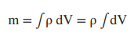

you rarely need to take the volume integral to find the mass of a body, especially considering that many of the bodies we will consider—for example, cars and planes—are not of uniform density. Thus, you will simplify these complicated bodies by breaking them down into an ensemble of component bodies of known or easily calculable mass and simply sum the masses of all components to arrive at the total mass.

The calculation of the center of gravity of a body - First, divide the body into a finite number of elemental masses with the center of each mass specified relative to the reference coordinate system axes. We’ll refer to these elemental masses as mi . Next, take the first moment of each mass about the reference axes and then add up all of these moments. The first moment is the product of the mass times the distance along a given coordinate axis from the origin to the center of mass. Finally, divide this sum of moments by the total mass of the body, yielding the coordinates to the center of mass of the body relative to the reference axes. You must perform this calculation once for each dimension—that is, twice when working in 2D and three times when working in 3D. Here are the equations for the 3D coordinates of the center of mass of a body:

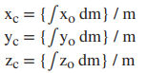

where (x, y, z)c are the coordinates of the center of mass for the body and (x, y, z)o are the coordinates of the center of mass of each elemental mass. The quantities xo dm, yo dm, and zo dm represent the first moments of the elemental mass, dm, about each of the coordinate axes.

In practice, you will be summing finite numbers of masses and the formulas will take on the friendlier forms shown here:

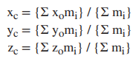

you can easily substitute weights for masses in these formulas since the con‐ stant acceleration due to gravity, g, would appear in both the numerators and denomi nators, thus dropping out of the equations. Recall that the weight of an object is its mass times the acceleration due to gravity, g, which is 9.8 m/s2 at sea level.

The formulas for calculating the total mass and center of gravity for a system of discrete point masses can conveniently be written in vector notation as follows:

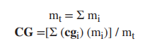

where mt is the total mass, mi is the mass of each point mass in the system, CG is the combined center of gravity, and cgi is the location of the center of gravity of each point mass in design, or reference, coordinates. Notice that CG and cgi are shown as vectors since they denote position in Cartesian coordinates.

let’s assume that the point masses making up the body are represented by an array of structures where each structure contains the point mass’s design coordinates and mass. The structure will also contain an element to hold the coordinates of the point mass relative to the combined center of gravity of the rigid body, which will be calculated later.

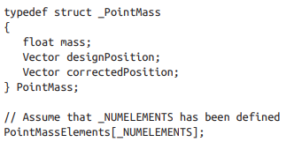

code that illustrates how to calculate the total mass and combined center of gravity of the elements:

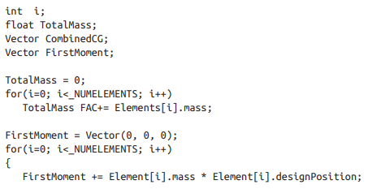

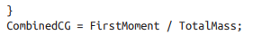

the combined center of gravity location has been found, you can calculate the relative position of each point mass as follows:

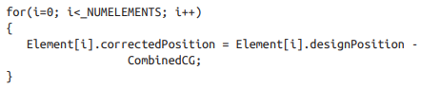

To calculate mass moment of inertia, you need to take the second moment of each elemental mass making up the body about each coordinate axis. The second moment is then the product of the mass times distance squared. That distance is not the distance to the elemental mass centroid along the coordinate axis as in the calculation for center of mass, but rather the perpendicular distance from the coordinate axis, about which we want to calculate the moment of inertia, to the elemental mass centroid.

# OpenGL

## Initializing and Creating a Window

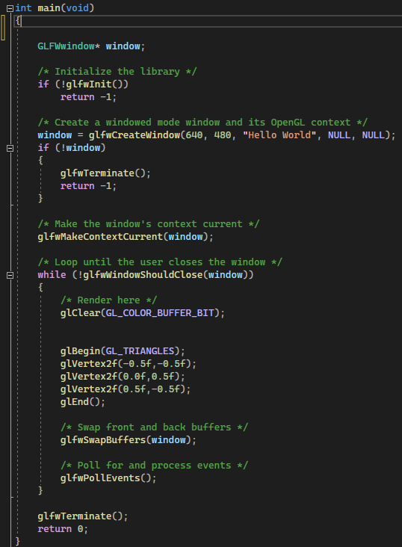

However, you should start error handling because if anything goes wrong, GLFW can say, errors are reported back using callback functions and it is set using the **glfwSetErrorCallback()** function.

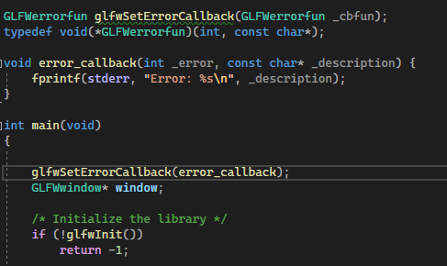

To actually use glfw for real work you need to first initialize it using **glfwInit()**, it should be called before almost any other GLFW routine because it initializes the GLFW library.

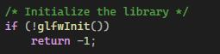

Then you have the glfwWindow which creates the window, If monitor is not NULL, the window will be created full-screen on the corresponding monitor and its resolution will be set to width by height.

**glfwCreateWindow()** creates both the rendering window and a new context with which to render into it. Before you can use that context, however, you need to make it current. You do this by calling the **glfwMakeContextCurrent()** function. This makes the context associated with the window specified in window current to the calling thread. The context will remain current to that thread either until another context is made current or until the specified window (and its associated context) is destroyed.

Now something is ready to be rendered

## SDL-OpenGL

### Setting Up the OpenGL Window

In SDL, when you create a window, you can request a window for OpenGL usage by passing in the SDL_WINDOW_OPENGL flag as the final parameter of the SDL_CreateWindow call:

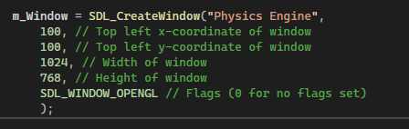

Prior to creating the OpenGL window, you can request attributes such as the version of OpenGL, the color depth, and several other parameters. To configure these parameters, you use the SDL_GL_SetAttribute function:

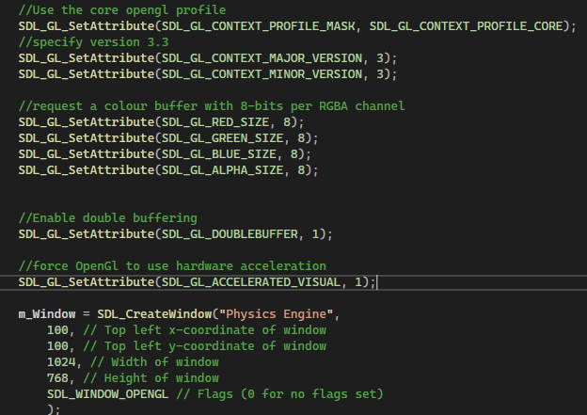

The attributes specify the bit depth of each channel. In this case, the program requests 8 bits per RGBA channel, for a total of 32 bits per pixel. The second-tolast attribute asks to enable double buffering. The final attribute asks to run OpenGL with hardware acceleration. This means that the OpenGL rendering will run on graphics hardware (a GPU)

### The OpenGL Context and Initializing GLEW

Once the OpenGL attributes are set and you’ve created the window, the next step is to create an OpenGL context. Think of a context as the “world” of OpenGL that contains every item that OpenGL knows about, such as the color buffer, any images or models loaded, and any other OpenGL objects. (While it is possible to have multiple contexts in one OpenGL program)

To create the context, first add the following member variable to Game:

Although the program now creates an OpenGL context, there is one final hurdle you must pass to gain access to the full set of OpenGL 3.3 features. OpenGL supports backward compatibility with an extension system. Normally, you must query any extensions you want manually, which is tedious. To simplify this process, you can use an open source library called the OpenGL Extension Wrangler Library (GLEW). With one simple function call, GLEW automatically initializes all extension functions supported by the current OpenGL context’s version. So in this case, GLEW initializes all extension functions

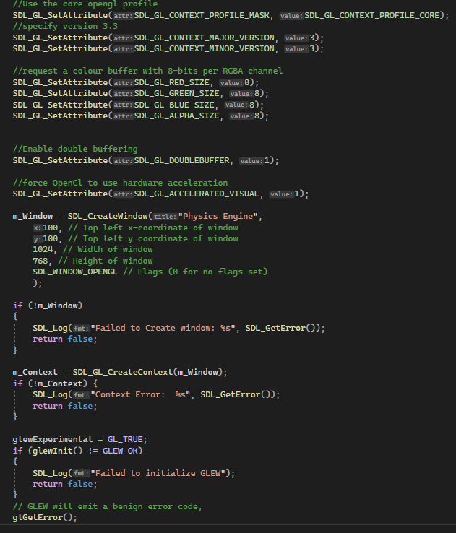

The glewExperimental line prevents an initialization error that may occur when using the core context on some platforms. Furthermore, because some platforms emit a benign error code when initializing GLEW, the call to glGetError clears this error code.

### Rendering a Frame

You now need to convert the clear, draw scene, and swap buffers process in Game::GenerateOutput to use OpenGL functions

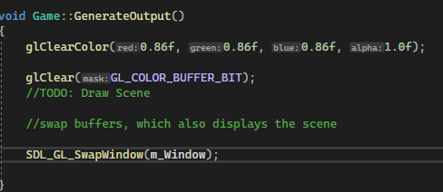

This code first sets the clear color to 86% red, 86% green, 86% blue, and 100% alpha, which yields a gray color. The glClear call with the GL_COLOR_BUFFER_BIT parameter clears the color buffer to the specified color. Finally, the SDL_GL_SwapWindow call swaps the front buffer and back buffer. At this point, running the game yields a gray screen because you aren’t drawing the SpriteComponents yet

most 2D games use sprites for their 2D characters. On the other hand, a 3D game features a simulated 3D environment that you somehow flatten into a 2D image that you show onscreen. y 2D games could simply copy sprite images into the desired locations of the color buffer. This process, called blitting, was efficient on sprite-based consoles such as the Nintendo Entertainment System (NES). However, modern graphical hardware is inefficient at blitting but is very efficient at polygonal rendering. Because of this, nearly all modern games, whether 2D or 3D, ultimately use polygons for their graphical needs.

Polygons are popular in games. Compared to other 3D graphics techniques, polygons do not require as many calculations at runtime. Furthermore, polygons are scalable: A game running on less-powerful hardware could simply use 3D models with fewer polygons. And, importantly, you can represent most 3D objects with polygons.

Triangles are the polygon of choice for most games. Triangles are the simplest polygon, and you need only three points (or vertices) to create a triangle. Furthermore, a triangle can only lie on a single plane. In other words, the three points of a triangle must be coplanar(in the same plane.).

Finally, triangles tessellate(**A tessellation or tiling is the covering of a surface, often a plane, using one or more geometric shapes, called tiles, with no overlaps and no gaps.)** easily, meaning it’s relatively simple to break any complex 3D object into many triangles.

2D games use triangles to represent sprites by drawing a rectangle and filling in the rectangle with colors from an image file.

### Normalized Device Coordinates

To draw a triangle, you must specify the coordinates of its three vertices. Recall that in SDL, the top-left corner of the screen is (0, 0), positive x is to the right, and positive y is down. More generally, a coordinate space specifies where the origin is and in which direction its coordinates increase. The basis vectors of the coordinate space are the direction in which the coordinates increase.

a Cartesian coordinate system:

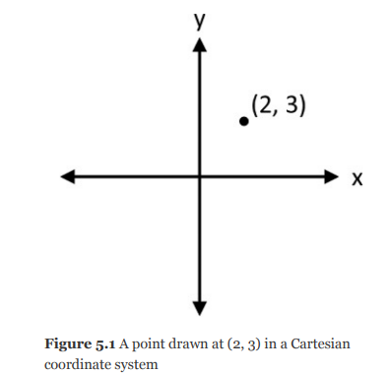

Normalized device coordinates (NDC) is the default coordinate system used with OpenGL. Given an OpenGL window, the center of the window is the origin in normalized device coordinates. Furthermore, the bottom-left corner is (–1, –1), and the top-right corner is (1, 1). This is regardless of the width and height of the window (hence normalized device coordinates).

Internally, the graphics hardware then converts these NDC into the corresponding pixels in the window.

For example, to draw a square with sides of unit length in the center of the window, you need two triangles. The first triangle has the vertices (–0.5, 0.5), (0.5, 0.5), and (0.5, –0.5), and the second triangle has the vertices (0.5, –0.5), (–0.5, –0.5), and (–0.5, 0.5). if the length and width of the window are not uniform, a square in normalized device coordinates will not look like a square onscreen.

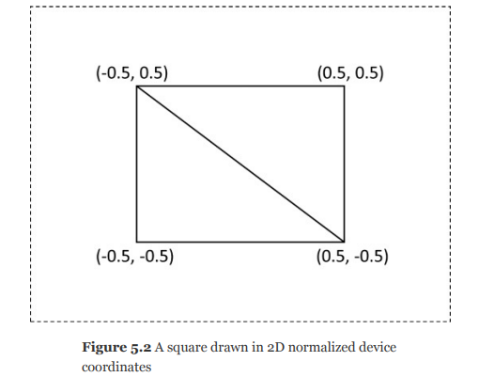

In 3D, the z component of normalized device coordinates also ranges from [–1, 1], with a positive z value going into the screen.

### Vertex and Index Buffers

Suppose you have a 3D model comprised of many triangles. You need some way to store the vertices of these triangles in memory. The simplest approach is to directly store the coordinates of each triangle in a contiguous array or buffer.

i.e. this array is for the vertices of 2 triangle:

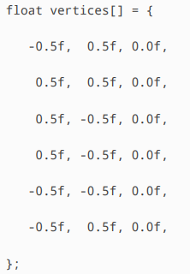

Even in this simple example, the array of vertices has some duplicate data.

If there were a way to remove these duplicates, you would cut the number of values stored in the buffer by 33%. Rather than having 12 values, you would have only 8. Assuming single-precision floats that use 4 bytes each, you’d save 24 bytes of memory by removing the duplicates. This might seem insignificant, but imagine a much larger model with 20,000 triangles. In this case, the amount of memory wasted due to duplicate coordinates would be high.

First, you create a vertex buffer that contains only the *unique* coordinates used by the 3D geometry. Then, to specify the vertices of each triangle, you index into this vertex buffer (much like indexing into an array). The aptly named index buffer contains the indices for each individual triangle, in sets of three. For this example’s sample square, you’d need the following vertex and index buffers

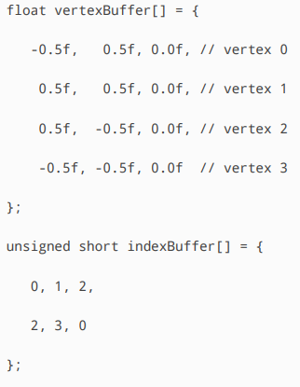

For example, the first triangle has the vertices 0, 1, and 2, which corresponds to the coordinates (–0.5, 0.5, 0.0), (0.5, 0.5, 0.0), and (0.5, –0.5, 0.0).

the index is the vertex number, not the floating-point element (for example, vertex 1 instead of “index 2” of the array). this code uses an unsigned short (typically 16 bits) for the index buffer, which reduces the memory footprint of the index buffer. You can use smaller bit size integers to save memory in the index buffer.

In this example, the vertex/index buffer combination uses 12 × 4 + 6 × 2, or 60 total bytes. On the other hand, if you just used the original vertices, you’d need 72 bytes. While the savings in this example is only 20%, a more complex model would save much more memory by using the vertex/index buffer combination.

To use the vertex and index buffers, you must let OpenGL know about them. OpenGL uses a vertex array object to encapsulate a vertex buffer, an index buffer, and the vertex layout. The vertex layout specifies what data you store for each vertex in the model. For now, assume the vertex layout is a 3D position (you can just use a z component of 0.0f if you want something 2D).

Because any model needs a vertex array object, it makes sense to encapsulate its behavior in a VertexArray class

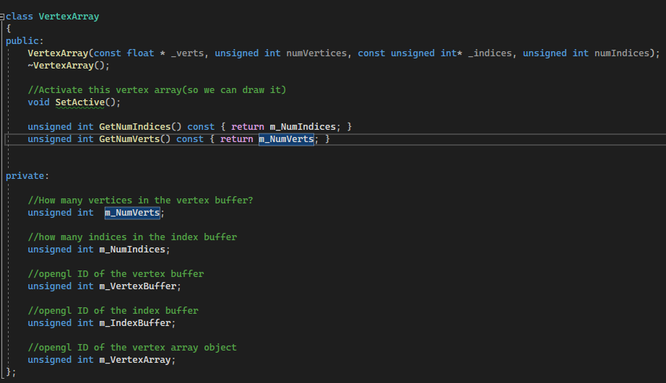

The constructor for VertexArray takes in pointers to the vertex and index buffer arrays so that it can hand off the data to OpenGL (which will ultimately load the data on the graphics hardware).

Note that the member data contains several unsigned integers for the vertex buffer, index buffer, and vertex array object. This is because OpenGL does not return pointers to objects that it creates. Instead, you merely get back an integral ID number. Keep in mind that the ID numbers are not unique across different types of objects. It’s therefore very possible to have an ID of 1 for both the vertex and index buffers because OpenGL considers them different types of objects.

The implementation of the VertexArray constructor is complex. First, create the vertex array object and store its ID in the mVertexArray member variable:

Once you have a vertex array object, you can create a vertex buffer. The GL_ARRAY_BUFFER parameter to glBindBuffer means that you intend to use the buffer as a vertex buffer. Once you have a vertex buffer, you need to copy the verts data passed into the VertexArray constructor into this vertex buffer. To copy the data, use glBufferData, which takes several parameters

you don’t pass in the object ID to glBufferData; instead, you specify a currently bound buffer type to write to. In this case, GL_ARRAY_BUFFER means use the vertex buffer just created. For the second parameter, you pass in the number of bytes, which is the amount of data for each vertex multiplied by the number of vertices. For now, you can assume that each vertex contains three floats for (x, y, z).

The usage parameter specifies how you want to use the buffer data. A GL_STATIC_DRAW usage means you only want to load the data once and use it frequently for drawing.

Next, create an index buffer.

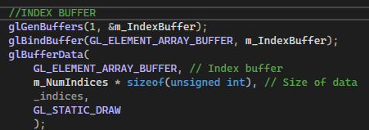

the type here is GL_ELEMENT_ARRAY_BUFFER, and the size is the number of indices multiplied by an unsigned int because that’s the type used for indices here.

you must specify a vertex layout, also called the vertex attributes. As mentioned earlier, the current layout is a position with three float values.

The first two parameters are 0 and 3 because the position is attribute 0 of the vertex, and there are three components (x, y, z).

Because each component is a float, you specify the GL_FLOAT type.

The fourth parameter is only relevant for integral types, so here you set it to GL_FALSE. Finally, the stride is the byte offset between consecutive vertices’ attributes.

But assuming you don’t have padding in the vertex buffer (which you usually don’t), the stride is just the size of the vertex. Finally, the offset is 0 because this is the only attribute. For additional attributes, you have to pass in a nonzero value for the offset.

the SetActive function calls glBindVertexArray, which just specifies which vertex array you’re currently using:

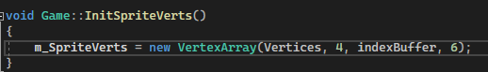

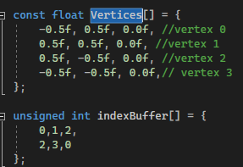

The vertex and index buffer variables here are the arrays for the sprite quad.

The vertex and index buffer variables here are the arrays for the sprite quad. In this case, there are 4 vertices in the vertex buffer and 6 indices in the index buffer (corresponding to the 2 triangles in the quad).

### SHADERS

Vertex Shaders

A vertex shader program runs once for every vertex of every triangle drawn. The vertex shader receives the vertex attribute data as an input. The vertex shader can then modify these vertex attributes as it sees fit.

Given that triangles have three vertices, you can think of a vertex shader as running three times per triangle. However, if you use vertex and index buffers, then you will invoke the vertex shader less often because some triangles share vertices. This is an additional advantage of using a vertex and index buffer instead just a vertex buffer. Note that if you draw the same model multiple times per frame, the vertex shader calls for each time you draw it are independent of each other.

Fragment Shaders

After the vertices of a triangle have gone through the vertex shader, OpenGL must determine which pixels in the color buffer correspond to the triangle. This process of converting the triangle into pixels is rasterization.

There are many different rasterization algorithms, but today’s graphics hardware does rasterization for us.

The job of a fragment shader (or pixel shader) is to determine the color of each pixel, and so the fragment shader program executes at least once for every pixel. This color may take into account properties of the surface, such as textures, colors, and materials. If the scene has any lighting, the fragment shader might also do lighting calculations. Because there are so many potential calculations, the average 3D game has a lot more code in the fragment shader than in the vertex shader.

Writing Basic Shaders

Although you could load in the shader programs from hard-coded strings in C++ code, it’s much better to put them in separate files.

uses the .vert extension for vertex shader files and the .frag extension for fragment shader files.

Because these source files are in a different programming language, they are in the Shaders subdirectory.

The Basic.vert File

Basic.vert contains the vertex shader code. Every GLSL shader file first must specify the version of the GLSL programming language used. Every GLSL shader file first must specify the version of the GLSL programming language used.

Next, because this is a vertex shader, you must specify the vertex attributes for each vertex. These attributes should match the attributes of the vertex array object created earlier, and are the input to the vertex shader. However, in GLSL the main function does not receive any parameters. Instead, the shader inputs look like global variables, marked with a special in keyword.

For now, you only have one input variable—the 3D position.

The type of inPosition variable is vec3, which corresponds to a vector of three floating-point values. This will contain the x, y, and z components corresponding to the vertex’s position.

a shader program has a main function as its entry point.

GLSL also uses global variables to define the outputs of the shader. In this case, you’ll use a built-in variable called gl_Position to store the vertex position output of the shader.

For now, the vertex shader directly copies the vertex position from inPosition to gl_Position. However, gl_Position expects four components: the normal (x, y, z) coordinates plus a fourth component called the w component. For now, assume that w is always 1.0. To convert inPosition from vec3 to vec4

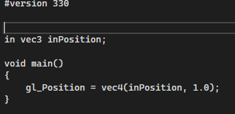

The Basic.frag File

The job of the fragment shader is to compute an output color for the current pixel.

As with the vertex shader, the fragment shader always begin with a #version line. Next, you declare a global variable to store the output color, using the out variable specifier

The outColor variable is a vec4 corresponding to the four components of the RGBA color buffer. Next, you declare the entry point of the fragment shader program. Inside this function, you set outColor to the desired color for the pixel.

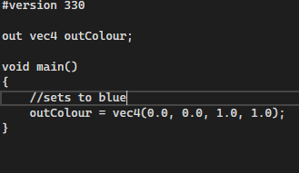

Loading Shaders

Once you have the separate shader files written, you must load in these shaders in the game’s C++ code to let OpenGL know about them. At a high level, you need to follow these steps:

1. Load and compile the vertex shader.

2. Load and compile the fragment shader.

3. Link the two shaders together into a “shader program.”

There are many steps to loading a shader, so we create a shader class

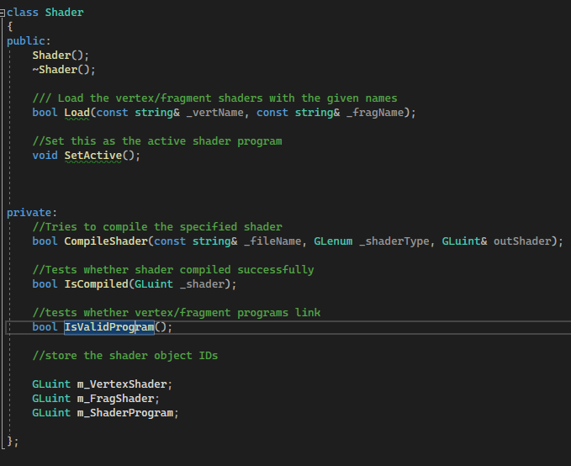

the member variables here correspond to shader object IDs.

You declare CompileShader, IsCompiled, and IsValidProgram in the private section because they are helper functions used by Load. This reduces the code duplication in Load.

The CompileShader Function

CompileShader takes three parameters: the name of the shader file to compile, the type of shader, and a reference parameter to store the ID of the shader. The return value is a bool that denotes whether CompileShader succeeded.

To implement the CompileShader Function First, create an ifstream to load in the file. Next, use a string stream to load the entire contents of the file into a single string, contents, and get the C-style string pointer with the c_str function.

Next, the glCreateShader function call creates an OpenGL shader object corresponding to the shader (and saves this ID in outShader). The shaderType parameter can be GL_VERTEX_SHADER, GL_FRAGMENT_SHADER, or a few other shader types. The glShaderSource call specifies the string containing the shader source code, and glCompileShader compiles the code. You then use the IsCompiled helper function (implemented in a moment) to validate that the shader compiles.

In the event of any errors, including being unable to load the shader file or failing to compile it, CompileShader outputs an error message and returns false

The IsCompiled Function

The IsCompiled function validates whether a shader object compiled, and if it didn’t, it outputs the compilation error message. This way, you can get some information about why a shader fails to compile.

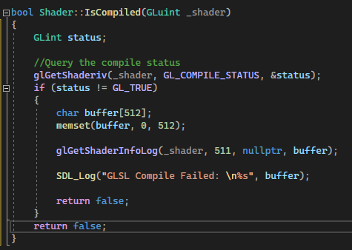

The glGetShaderiv function queries the compilation status, which the function returns as an integral status code. If this status is not GL_TRUE, there was an error. In the event of an error, you can get a human-readable compile error message with glGetShaderInfoLog.

The Load Function

The Load function takes in the filenames of both the vertex and fragment shaders and then tries to compile and link these shaders together.

you compile both the vertex and fragment shaders using CompileShader and then save their objects IDs in mVertexShader and mFragShader, respectively. If either of the CompileShader calls fail, Load returns false.

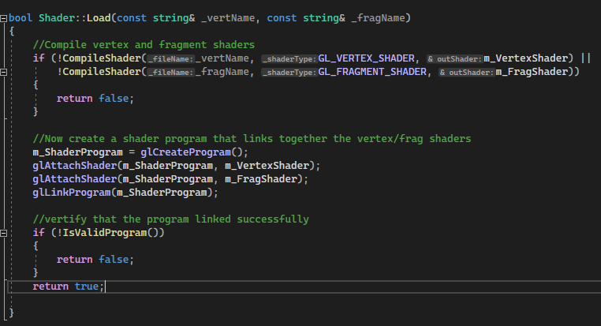

After you’ve compiled both the fragment and vertex shader, you link them together in a third object, called a shader program. When it’s time to draw an object, OpenGL uses the currently active shader program to render the triangles. You create a shader program with glCreateProgram, which returns the object ID to the new shader program. Next, use glAttachShader to add the vertex and fragment shaders to the combined shader program. Then use glLinkProgram to link together all attached shaders into the final shader program.

As with shader compilation, figuring out whether the link was successful requires additional function calls, which you can place in the IsValidProgram helper function.

The IsValidProgram Function

The code for IsValidProgram is very similar to the code for IsCompiled. There are only two differences. First, instead of calling glGetShaderiv, call glGetProgramiv

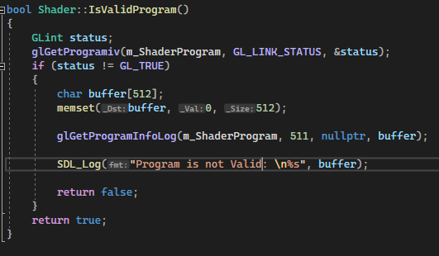

The SetActive Function

The SetActive function sets a shader program as the active one

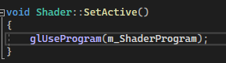

OpenGL uses the active shader when drawing triangles.

The Unload Function

The Unload function simply deletes the shader program, the vertex shader, and the pixel shader

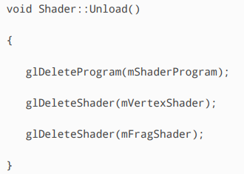

Adding a Shader to the Game

With the Shader class, you can now add a Shader pointer as a member variable to Game



This variable is called mSpriteShader because, ultimately, you’ll use it to draw sprites. The LoadShaders function loads in the shader files and sets the shader as active

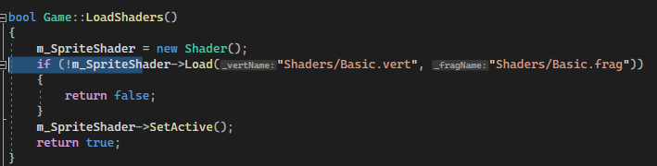

Drawing Triangles

As mentioned earlier, you can draw sprites with triangles by drawing rectangles onscreen. You’ve already loaded in the unit square vertices and a basic shader that can draw blue pixels. As before, you want to draw sprites in the Draw function in SpriteComponent.

the declaration of SpriteComponent::Draw so that it takes in Shader*. Next, draw a quad with a call to glDrawElements

The first parameter to glDrawElements specifies the type of element you’re drawing (in this case, triangles). The second parameter is the number of indices in the index buffer; in this case, because the index buffer for the unit square has six elements, you pass in 6 as the parameter. The third parameter is the type of each index, established earlier as unsigned int. The last parameter is nullptr.

The glDrawElements call requires both an active vertex array object and an active shader. On every frame, you need to activate both the sprite vertex array object and shader before drawing any SpriteComponents. You do this in the Game::GenerateOutput function.

Once you’ve set the shader and vertex array as active, you call Draw once for each sprite in the scene

the fragment shader only writes out a blue color. So you see blue squares for each sprite component. For every sprite, you use the same sprite verts. These sprite verts define a unit square in normalized device coordinates. This means that for every SpriteComponent, you merely draw the same unit square in NDC.

It may seem like the solution is to define different vertex arrays for each sprite. However, it turns out that with only this one vertex array, you can draw whichever sprites you want to. The key is to take advantage the vertex shader’s ability to transform vertex attributes

How the project should look:



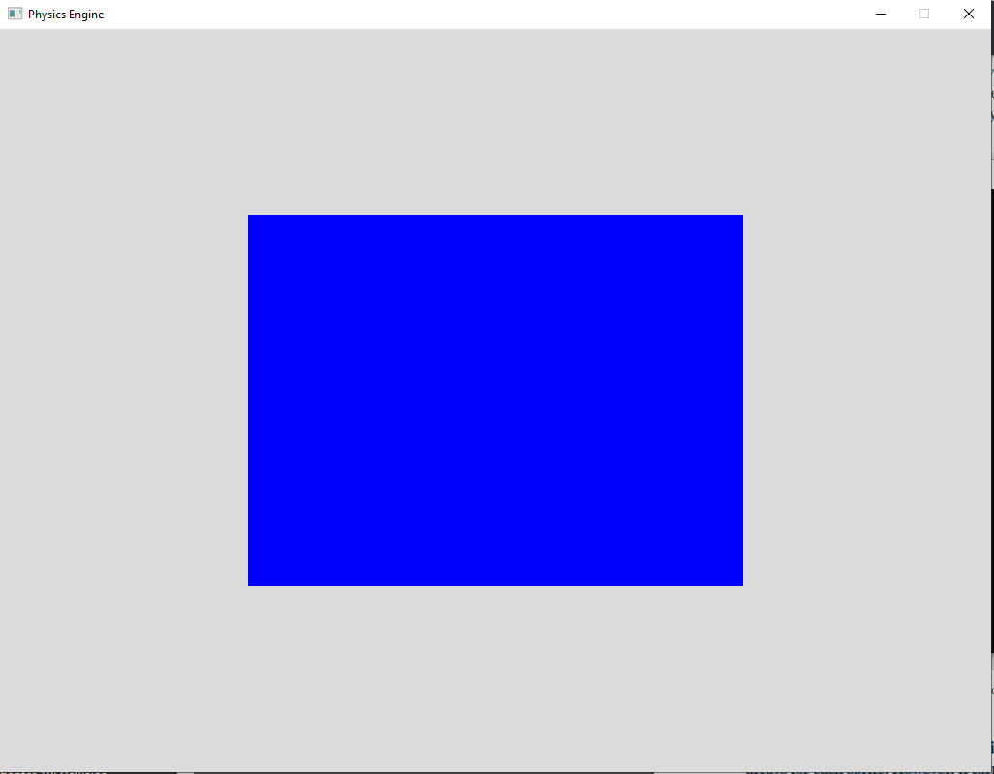

### TRANSFORMATION BASICS

You could represent these 10 asteroids individually with different vertex array objects. However, you need these asteroids to show up in different locations onscreen. This means the triangles you draw for each asteroid need different normalized device coordinates.

A naïve idea is to create 10 different vertex buffers, 1 for each of the 10 asteroids, and recompute the vertex positions in these vertex buffers as needed. But this is wasteful both in terms of memory usage and in terms of computation. Changing vertices in vertex buffers and resubmitting them to OpenGL is not efficient.

Thinking of it this way, a more efficient solution is to have a single vertex buffer for the rectangle and just reuse it. Every time you draw the rectangle, you may have a position offset, scale, or rotation. But given the NDC unit square, you can change, or transform, it such that it is an arbitrary rectangle with an arbitrary position, scale, and/or orientation.

This same concept of reusing a single vertex buffer for a type of object also extends to 3D.

For example, a game taking place in the forest might have hundreds of trees, many of which are only slight variations of each other. It’s inefficient to have a separate vertex buffer for every single instance of the same tree. Instead, you could create a single tree vertex buffer, and the game could draw many instances of this same tree with some variation in position, scale, and orientation.

Object Space

When you create a 3D object (such as in a 3D modeling program), you generally don’t express vertex positions in normalized device coordinates. Instead, the positions are relative to an arbitrary origin of the object itself. This origin is often in the center of the object, but it does not have to be. This coordinate space relative to the object itself is object space, or model space.

defining a coordinate space requires knowing both the origin of the coordinate space and the direction in which the various components increase (the basis vectors).

For example, some 3D modeling programs use +y as up, whereas others use +z as up. These different basis vectors define different object spaces for the objects.

imagine a game that takes place in an office building. You’d need models for computer monitors, keyboards, desks, office chairs, and so on. You’d create each of these individual models in its own object space, which means each object’s vertex positions are relative to that model’s unique object space origin. At runtime, you load each unique model into its own vertex array object (VAO). For example, you might have a VAO for the monitor, one for the keyboard, and so on. When it’s time to render the scene, each vertex of each object you draw goes to the vertex shader. If you just directly passed along the vertex positions, as in Basic.vert, then you’re saying that these vertex positions are in normalized device coordinates.

This is a problem because the coordinates for the models are not in NDC but instead are relative to each object’s unique object space. Passing through the vertex positions as is would yield garbage output.

World Space

To solve the problem with different objects having different object space coordinates, you first define a coordinate space for the game world itself. This coordinate space, called world space, has its own origin and basis vectors. For the game in the office building, the origin of world space might be in the center of the building on the ground floor.

Much as an office planner might place the desks and chairs at different positions and orientations in the office, you can think of the objects in the game as having arbitrary positions, scales, or orientations relative to the world space origin. For example, if there are five instances of the same desk placed in the office, each of these instances needs information describing how the object appears in world space.

When you draw each instance of the desk, you use the same vertex array object for each desk. However, each instance now needs some additional information, specifying how you want to transform the object space coordinates into world space. You can send this extra data to the vertex shader when drawing an instance, which allows the vertex shader to adjust the vertex positions as needed. Of course, the graphics hardware ultimately needs the coordinates in NDC to draw them, so you still have an additional step after transforming the vertices into world space.

For now, let’s look at how to transform vertices from their object space into world space.

Transforming to World Space

When transforming between coordinate spaces, you need to know whether the basis vectors between the two coordinate spaces are the same. For example, consider the point (0, 5) in object space. If you define object space with +y as up, this means that the point (0, 5) is five units “above” the origin. However, if you choose to define world space such that +y is to the right, (0, 5) is instead five units to the right. For now, assume that the basis vectors in object and world space are the same. Because the game currently is 2D, you can assume that +y is up and +x is to the right for both object space and world space.

The 2D coordinate system used here is different from the SDL coordinate system where +y is down! This means the code for Actor::GetForward no longer negates the y component. Furthermore, if you use atan2 for any calculations, you no longer negate the first parameter.

Now consider a unit square centered around the object space origin. Assume that the world space origin is the center of the game window. The goal is to take the unit square centered around its object space origin and express it as a rectangle with an arbitrary position, scale, or orientation relative to the world space origin.

For example, suppose one instance of the rectangle should appear in world space such that it’s double in size and is 50 units to the right of the world space origin. You can accomplish this by applying mathematical operations to each vertex of the rectangle.

One approach is to use algebra equations to compute the correct vertex positions. Although you ultimately won’t approach it in this manner, this is a useful bridge to understanding the preferred solution.

Translation

Translation takes a point and translates, or moves, it by an offset. Given the point (x, y), you can translate it by the offset (a, b) by using the following equations:

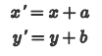

For example, you could translate the point (1, 3) by the offset (20, 15) as follows:

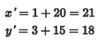

If you apply the same translation to every vertex of a triangle, you translate the entire triangle.

Scale

When applied to each vertex in a triangle, scale increases or decreases the size of the triangle. In a uniform scale, you scale each component by the same scale factor, s:

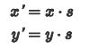

So, you can uniformly scale (1, 3) by 5 as follows:

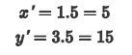

Scaling each vertex in the triangle by 5 would quintuple the size of the triangle.

In a non-uniform scale, there are separate scale factors (sx, sy) for each component:

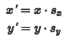

For the example of transforming a unit square, a nonuniform scale results in a rectangle instead of a square.

Rotation

The unit circle begins at the point (1, 0). A rotation of 90˚, or  radians, is counterclockwise to the point (0, 1), a rotation of 180˚, or π radians, is the point (–1, 0), and so on. This is technically a rotation about the z-axis, even though you don’t draw the z-axis in a typical unit x y circle diagram.

Using sine and cosine, you can rotate an arbitrary point (x, y) by the angle θ as follows:

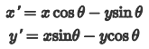

Notice that both equations depend on the original x and y values. For example, rotating (5, 0) by 270˚ is as follows:

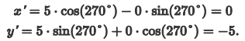

As with the unit circle, the angle θ represents a counterclockwise rotation. a rotation about the origin.

Given a triangle centered around the object space origin, rotating each vertex would rotate the triangle about the origin.

Combining Transformations

Although the preceding equations apply each transformation independently, it’s common to require multiple transformations on the same vertex. For example, you might want to both translate and rotate a quad. It’s important to combine these transformations in the correct order.

e.g. a triangle has these points:

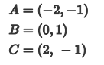

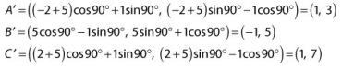

In the case of translation first, rotation second, you end up with a triangle still facing to the left but positioned several units above the origin

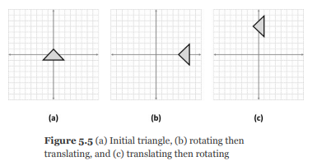

Because the order of transformations matter, it’s important to have a consistent order. For the transformation from object space to world space, always apply the transformations in the order scale, then rotation, then translation.

you could combine all three separate equations for scale, rotation, and translation into one set of equations to scale by (s , s ), rotate by θ, and translate by (a, b):

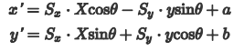

Issues with Combining Equations

The combined equations derived in the previous section may seem like a solution to the problem: Take an arbitrary vertex in object space, apply the equations to each component, and you now have the vertex transformed into world space with an arbitrary scale, rotation, and position.

this only transforms the vertices from object space to world space. Because world space is not normalized to device coordinates, you still have more transformations to apply in the vertex shader. These additional transformations typically do not have equations as simple as the equations covered thus far. This is especially because the basis vectors between these different coordinate spaces might be different. Combining these additional transformations into one equation would become unnecessarily complex.

The solution to these issues is to not use separate equations for each component. Instead, you use matrices to describe the different transformations, and you can easily combine these transformations with matrix multiplication.

MATRICES AND TRANSFORMATIONS

You use matrices to represent transformations in computer graphics.

All the transformations from the preceding section have corresponding matrix representations.

Matrix Multiplication

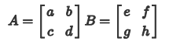

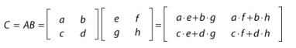

the top-left element of C is the dot product of the first row of A with the first column of B.

the number of columns in the left matrix must be equal to the number of rows in the right matrix.

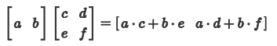

Matrix multiplication is not commutative, though it is associative:

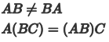

you can represent an arbitrary point as a matrix. For example, you can represent the point p=(x, y) as a single row (called a row vector):



You can instead represent p as a single column (called a column vector):

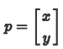

Either representation works, but it’s important to consistently use one approach. This is because whether the point is a row or a column determines whether the point appears on the left- or right-hand side of the multiplication.

i.e.

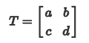

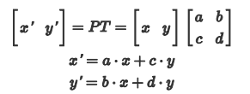

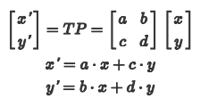

You can switch between row and column vectors by taking the transpose of each transform matrix

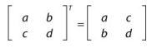

If you wanted to switch the equation to transform q using column vectors, you would calculate as follows:



Finally, the identity matrix is a special type of matrix represented by an uppercase l. An identity matrix always has an equal number of rows and columns. All values in the identity matrix are 0, except for the diagonal, which is all 1s. For example, the 3×3 identity matrix is as follows:

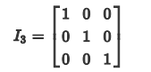

Any arbitrary matrix multiplied by the identity matrix does not change. In other words:



Transforming to World Space

You can represent the scale, rotation, and translation transformations with matrices. To combine the transformations, instead of deriving a combined equation, multiply the matrices together. Once you have a combined world transform matrix, you can transform every vertex of the object by this world transform matrix.

Scale Matrix

You can use a 2×2 scale matrix to apply the scale transformation:

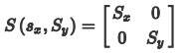

For example, this would scale (1,3) by (5,2):

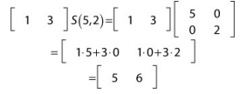

Rotation Matrix

A 2D rotation matrix represents a rotation (about the z-axis) by angle θ:

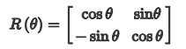

, you can rotate (0,3) by 90˚ with the following:

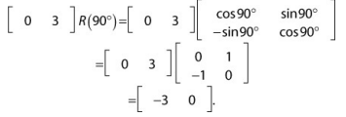

Translation Matrices

You can represent 2D scale and rotation matrices with 2×2 matrices. However, there’s no way to write a generic 2D translation matrix of size 2×2. The only way to express the translation T(a,b) is with a 3×3 matrix:

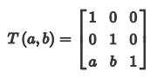

However, you can’t multiply a 1×2 matrix representing a point by a 3×3 matrix because the 1×2 matrix doesn’t have enough columns. The only way you can multiply these together is if you add an additional column to the row vector, making it a 1×3 matrix. This requires adding an extra component to the point. Homogenous coordinates use n+1 components to represent an ndimensional space. So, for a 2D space, homogeneous coordinates use three components. Although it might seem reasonable to call this third component the z component, it’s a misnomer. That’s because you’re not representing a 3D space, and you want to reserve the z component for 3D spaces. Thus this special homogeneous coordinate is the w component. You use w for both 2D and 3D homogeneous coordinates. So, a 2D point represented in homogeneous coordinates is (x,y,w), while a 3D point represented in homogeneous coordinates is (x,y,z,w).

you will only use a value of 1 for the w component. For example, you can represent the point p= (x,y) with the homogeneous coordinate (x,y,1). To understand how homogeneous coordinates work, suppose you wish to translate the point (1,3) by (20,15). First, you represent the point as a homogeneous coordinate with a w component of 1 and then you multiply the point by the translation matrix:

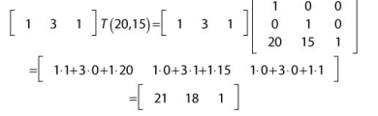

in this calculation, the w component remains 1. However, you’ve translated the x and y components by the desired amount.

you can combine multiple transform matrices by multiplying them together. However, you can’t multiply a 2×2 matrix with a 3×3 matrix. Thus, you must represent the scale and rotation transforms with 3×3 matrices that work with homogeneous coordinates:

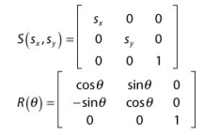

Now that you’ve represented the scale, rotation, and translation matrices as 3×3 matrices, you can multiply them together into one combined transform matrix. This combined matrix that transforms from object space to world space is the world transform matrix. To compute the world transform matrix, multiply the scale, rotation, and translation matrices in the following order:

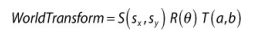

This order of multiplication corresponds to the order in which you wish to apply the transformations (scale, then rotate, then translate). You can then pass this world transform matrix to the vertex shader and use it to transform every vertex of an object by its world transform matrix.

Adding World Transforms to Actor

the Actor class already has a Vector2 for position, a float for scale, and a float for the angle rotation. You now must combine these different attributes into a world transform matrix.

First, add two member variables to Actor, a Matrix4 and a bool

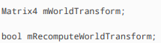

The mWorldTransform variable obviously stores the world transform matrix. The reason you use a Matrix4 here instead of a Matrix3 is because the vertex layout assumes that all vertices have a z component (even though in 2D, you don’t actually need the z component).

Since the homogenous coordinates for 3D are (x, y, z, w), you need a 4×4 matrix.

The Boolean tracks whether you need to recalculate the world transform matrix. The idea is that you want to recalculate the world transform only if the actor’s position, scale, or rotation changes. In each of the setter functions for the position, scale, and rotation of the actor, you set mRecomputeWorldTransform to true.

You also initialize mRecomputeWorldTransform to true in the constructor

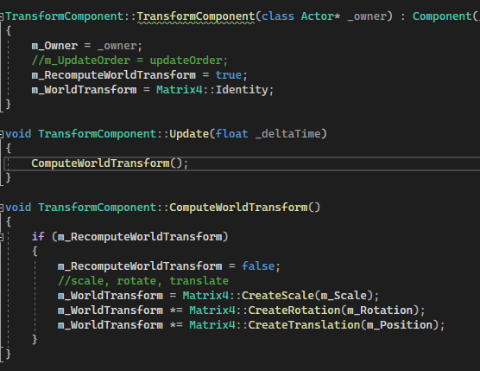

have a way to notify components when their owner’s world transform gets updated. This way, the component can respond as needed. To support this, first add a virtual function declaration to the base Component class:

Although actors now have world transform matrices, you aren’t using the matrices in the vertex shader yet. Before you can use the world transform matrices in the shader, we need to discuss one other transformation

Transforming from World Space to Clip Space

With the world transform matrix, you can transform vertices into world space. The next step is to transform the vertices into clip space, which is the expected output for the vertex shader. Clip space is a close relative of normalized device coordinates.

The next step is to transform the vertices into clip space, which is the expected output for the vertex shader. Clip space is a close relative of normalized device coordinates.

The only difference is that clip space also has a w component. This was why you created a vec4 to save the vertex position in the gl_Position variable.

The view-projection matrix transforms from world space to clip space.

the view-projection matrix has two component matrices: the view and the projection. The view accounts for how a virtual camera sees the game world, and the projection specifies how to convert from the virtual camera’s view to clip space.

because the game is 2D, you can use a simple viewprojection matrix.

normalized device coordinates, the bottom-left corner of the screen is (–1, –1) and the topright corner of the screen is (1, 1). Now consider a 2D game that does not have scrolling. A simple way to think of the game world is in terms of the window’s resolution. For example, if the game window is 1024×768, why not make the game world that big

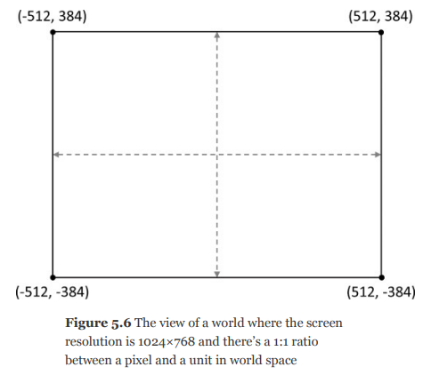

With this view of the world, it’s not too difficult to convert from world space into clip space. Simply divide the x-coordinate by width / 2 and divide the ycoordinate by height / 2. In matrix form, assuming 2D homogeneous coordinates, this simple view projection matrix is as follows:

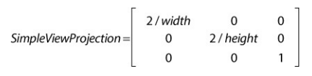

For example, given the 1024×768 resolution and the point (256,192) in world space, if you multiply the point by SimpleViewProjection, you get this:

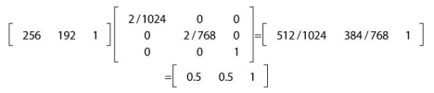

The reason this works is that you normalize the range [– 512, 512] of the x-axis to [–1, 1], and the range of [–384, 384] on the y-axis [–1, 1], just as with normalized device coordinates!

Combining the SimpleViewProjection matrix with the world transform matrix, you can transform an arbitrary vertex v from its object space into clip space with this:

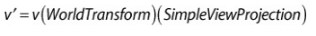

This is precisely what you will calculate in the vertex shader for every single vertex, at least until SimpleViewProjection has outlived its usefulness.

Updating Shaders to Use Transform Matrices

In this section, you’ll create a new vertex shader file called Transform.vert. It starts initially as a copy of the Basic.vert shader.

you declare two new global variables in Transform.vert with the type specifier uniform.

A uniform is a global variable that typically stays the same between numerous invocations of the shader program. This contrasts in and out variables, which will change every time the shader runs (for example, once per vertex or pixel).

To declare a uniform variable, use the keyword uniform, followed by the type, followed by the variable name.

In this case, you need two uniforms for the two different matrices.

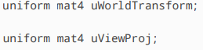

Here, the mat4 type corresponds to a 4×4 matrix, which is needed for a 3D space with homogeneous coordinates.

Then you change the code in the vertex shader’s main function. First, convert the 3D inPosition into homogeneous coordinates

Remember that this position is in object space. So you next multiply it by the world transform matrix to transform it into world space, and then multiply it by the view-projection matrix to transform it into clip space:

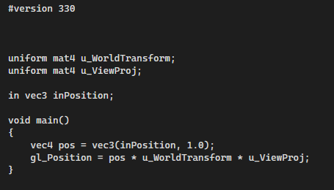

You then change the code in Game::LoadShaders to use the Transform.vert vertex shader instead of Basic.vert.

you have uniforms in the vertex shader for the world transform and view-projection matrices, you need a way to set these uniforms from C++ code.

OpenGL provides functions to set uniform variables in the active shader program. It makes sense to add wrappers for these functions to the Shader class. For now, you can add a function called SetMatrixUniform

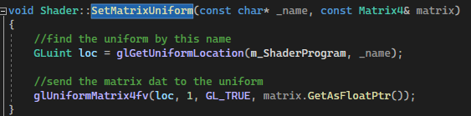

SetMatrixUniform takes in a name as a string literal, as well as a matrix. The name corresponds to the variable name in the shader file. So, for uWorldTransform, the parameter would be "uWorldTransform". The second parameter is the matrix to send to the shader program for that uniform.

In the implementation of SetMatrixUniform, you get the location ID of the uniform with glGetUniformLocation. Technically, you don’t have to query the ID every single time you update the same uniform because the ID doesn’t change during execution.

You could improve the performance of this code by caching the values of specific uniforms.

the glUniformMatrix4fv function assigns a matrix to the uniform. The third parameter of this function must be set to GL_TRUE when using row vectors. The GetAsFloatPtr function is simply a helper function in Matrix4 that returns a float* pointer to the underlying matrix.

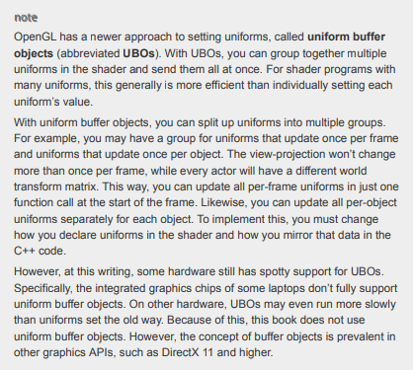

Because the simple viewprojection won’t change throughout the course of the program, you only need to set it once. However, you need to set the world transform matrix once for each sprite component you draw because each sprite component draws with the world transform matrix of its owning actor.

In Game::LoadShaders, add the following two lines to create and set the view-projection matrix to the simple view projection, assuming a screen width of 1024×768:

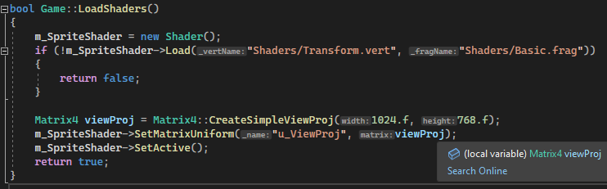

The world transform matrix for SpriteComponent is a little more complex. However, for a sprite, you also want to scale the size of the rectangle based on the size of the texture. For example, if an actor has a scale of 1.0f, but the texture image corresponding to its sprite is 128×128, you need to scale up the unit square to 128×128.

**Temporary SpriteComponent::Draw function**

First, create a scale matrix to scale by the width and height of the texture. You then multiply this by the owning actor’s world transform matrix to create the desired world transform matrix for the sprite. Next, call SetMatrixUniform to set the uWorldTransform in the vertex shader program. Finally, you draw the triangles as before, with glDrawElements.

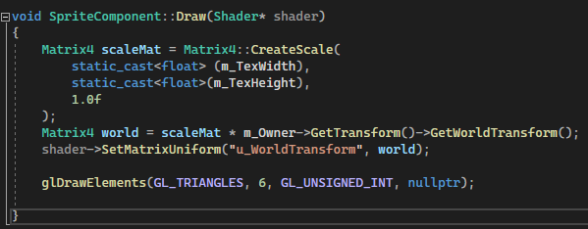

### TEXTURE MAPPING

Texture mapping is a technique for rendering a texture (image) on the face of a triangle. It allows you to use colours from a texture when drawing a triangle instead of using just a solid colour.

To use texture mapping, you need an image file. Next, you need to decide how to apply textures to each triangle.

If you have just the sprite rectangle, it makes sense that the top-left corner of the rectangle should correspond to the top-left corner of the texture. However, you can use texture mapping with arbitrary 3D objects in the game. For example, to correctly apply a texture to a character’s face, you need to know which parts of the texture should correspond to which triangles. To support this, you need an additional vertex attribute for every vertex in the vertex buffer. Previously, the vertex attributes only stored a 3D position in each vertex. For texture mapping, each vertex also needs a texture coordinate that specifies the location in the texture that corresponds to that vertex. Texture coordinates typically are normalized coordinates.

In OpenGL, the coordinates are such that the bottom-left corner of the texture is (0, 0) and the top-right corner is (1, 1)

The U component defines the right direction of the texture, and the V component defines the up direction of the texture. Thus, many use the term UV coordinates as a synonym for texture coordinates.

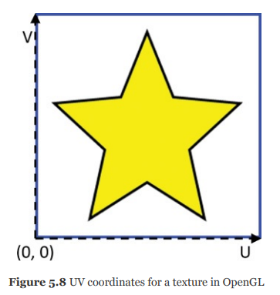

Because OpenGL specifies the bottom left of the texture as its origin, it also expects the image pixel data format as one row at a time, starting at the bottom row. However, a big issue with this is that most image file formats store their data starting at the top row. Not accounting for this discrepancy results in textures that appear upside down. There are multiple ways to solve this problem: invert the V-component, load the image upside down, or store the image on disk upside down. This book simply inverts the V component—that is, assumes that the top-left corner is (0, 0).

Each vertex of a triangle has its own separate UV coordinates. Once you know the UV coordinates for each vertex of a triangle, you can fill in every pixel in the triangle by blending (or interpolating) the texture coordinate, based on the distance from each of the three vertices. For example, a pixel exactly in the center of the triangle corresponds to a UV coordinate that’s the average of the three vertices’ UV coordinates.

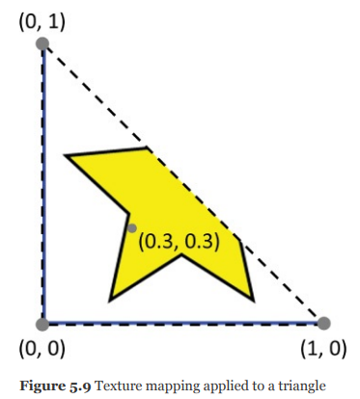

a 2D image is just a grid of pixels with different colors. So, once you have a texture coordinate for a specific pixel, you need to convert this UV coordinate to correspond to a specific pixel in the texture. This “pixel in the texture” is a texture pixel, or texel. The graphics hardware uses a process called sampling to select a texel corresponding to a specific UV coordinate.

One complication of using normalized UV coordinates is that two slightly different UV coordinates may end up closest to the same texel in the image file. The idea of selecting the texel closest to a UV coordinate and using that for the color is called nearest-neighbor filtering.

However, nearest-neighbor filtering has some issues. Suppose you map a texture to a wall in a 3D world. As the player gets closer to the wall, the wall appears larger and larger onscreen. This looks like zooming in on an image file in a paint program, and the texture appears blocky or pixelated because each individual texel is very large onscreen.

To solve this pixelation, you can instead use bilinear filtering. With bilinear filtering, you select a color based on the blending of each texel neighboring the nearest neighbor. If you use bilinear filtering for the wall example, as the player gets closer, the wall seems to blur instead of appearing pixelated.

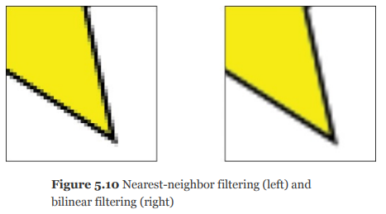

To use texture mapping in OpenGL, there are three things you need to do:

Load image files (textures) and create OpenGL texture objects.

Update the vertex format to include texture coordinates.

Update the shaders to use the textures.

Loading the Texture

Although you can use the SDL Image library to load images for OpenGL, the Simple OpenGL Image Library (SOIL) is a little easier to use. SOIL can read in several file formats, including PNG, BMP, JPG, TGA, and DDS.

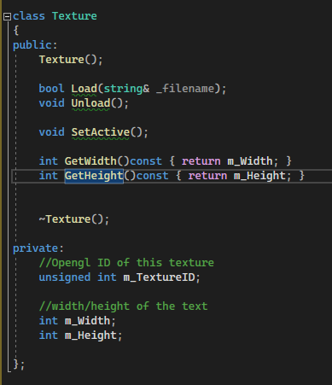

the declaration of a Texture class that encapsulates loading in a texture file and using it with OpenGL.

Load() function loads the texture from the file.

you need to determine whether the image is RGB or RGBA. You can assume that this is based on the number of channels (three means RGB, four means RGBA):

you need to determine whether the image is RGB or RGBA. You can assume that this is based on the number of channels (three means RGB, four means RGBA).

use glGenTextures to create an OpenGL texture object (saving the ID in mTextureID) and glBindTexture to set the texture as active:

he GL_TEXTURE_2D target passed to glBindTexture is by far the most common texture target, but there are other choices for advanced types of textures. the next step is to copy the raw image data into it with the glTexImage2D function, which takes quite a few parameters. Once you’ve copied the image data to OpenGL, you can tell SOIL to free the image from memory:

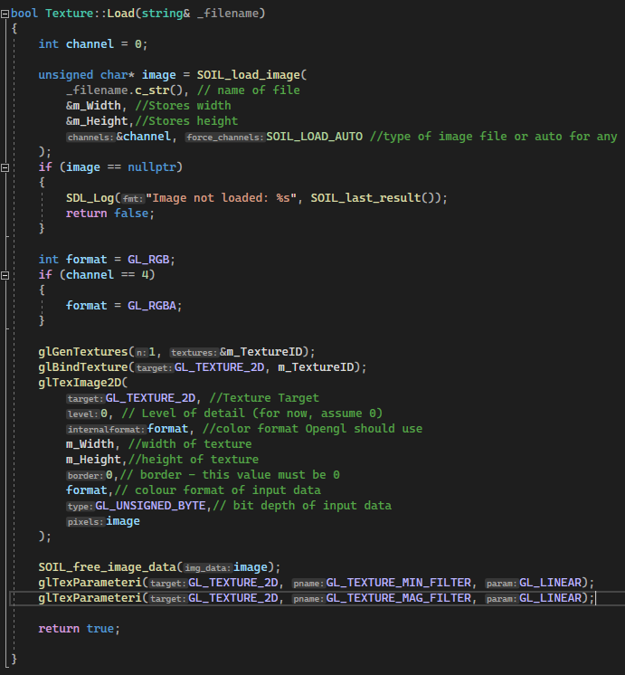

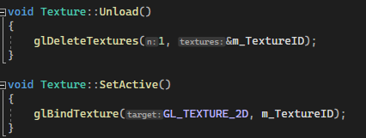

You can then load textures into a map in Game.

The Game::GetTexture function then returns a Texture* for the requested texture. Next, SpriteComponent needs a Texture* member variable.

in SpriteComponent::Draw, add a call to SetActive on mTexture, right before drawing the vertices. This means you can now set a different active texture for each sprite component you draw

Updating the Vertex Format To use texture mapping, the vertices need to have texture coordinates, so you need to update the sprite VertexArray:

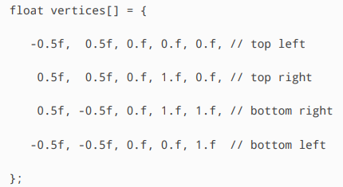

the V texture coordinate is flipped to account for OpenGL’s idiosyncrasy with how it expects the image data. For each vertex, the first three floating-point values are the position and the next two floating-point values are the texture coordinates.

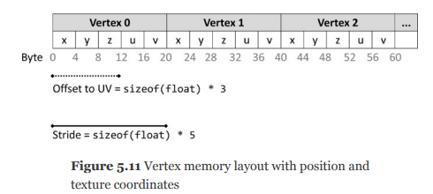

the memory layout of this new vertex format.

Because you’re changing the vertex layout, you must change code in the VertexArray constructor. For simplicity, assume that all vertices must have a 3D position and 2D texture coordinates. Because the size of each vertex has changed, you need to update the glBufferData call to specify that each vertex now has five floats per vertex.

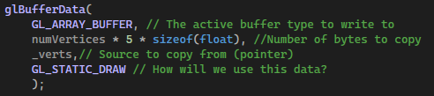

Because the index buffer is still the same, the glBufferData call for that doesn’t change. However, you must change vertex attribute 0 to specify that the stride of the vertex is now five floats:

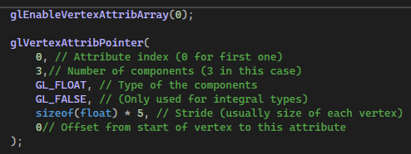

This only fixes the position vertex attribute. However, because you now have a second vertex attribute for the texture coordinate, you must enable vertex attribute 1 and specify its format

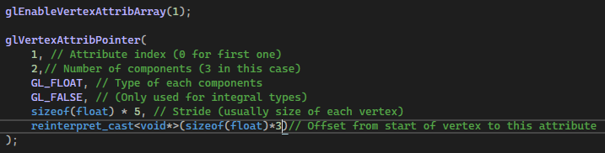

The last parameter to this glVertexAttribPointer call is rather ugly. OpenGL needs to know the number of bytes from the start of a vertex to this attribute. That’s where the sizeof(float) * 3 comes from. However, OpenGL wants this as an offset pointer. Thus, you must use reinterpret_cast to coerce the type into a void* pointer.

Updating the Shaders

Because the vertex format now uses texture coordinates, you should create two new shaders: Sprite.vert (initially a copy of Transform.vert) and Sprite.frag (initially a copy of Basic.frag)

Because the vertex format now uses texture coordinates, you should create two new shaders: Sprite.vert (initially a copy of Transform.vert) and Sprite.frag (initially a copy of Basic.frag).

The Sprite.Vert Shader

There previously was only one vertex attribute, so you could just declare position as an in variable, and GLSL knew which vertex attribute it corresponded to. However, now that there are multiple vertex attributes, you must specify which attribute slot corresponds to which in variable. This changes the variable declarations to the following.

The layout directive specifies which attribute slot corresponds to which in variable. Here, you specify that there’s a 3D vector of floats for vertex attribute slot 0 and a 2D vector of floats for vertex attribute slot 1.

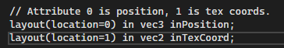

This corresponds to the slot numbers in the glVertexAttribPointer calls

although the texture coordinates are an input to the vertex shader (because it’s in the vertex layout), the fragment shader also needs to know the texture coordinates. This is because the fragment shader needs to know the texture coordinates to determine the color at the pixel. Luckily, you can pass data from the vertex shader to the fragment shader by declaring a global out variable in the vertex shader.

Then, inside the vertex shader’s main function

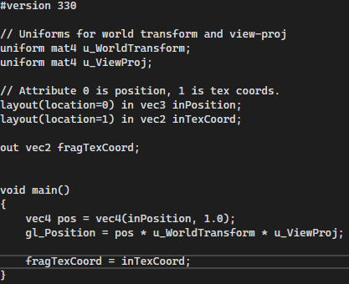

copies the texture coordinates directly from the vertex input variable to the output variable.

The reason this ultimately works is that OpenGL automatically interpolates vertex shader outputs across the face of the triangle. Therefore, even though a triangle has only three vertices, any arbitrary pixel on the face of a triangle will know its corresponding texture coordinates in the fragment shader.

The Sprite.frag Shader

any out variables in the vertex shader should have a corresponding in in the fragment shader. The name and type of the in variable in the fragment shader must have the same name and type as the corresponding out variable in the vertex shader.

add a uniform for a texture sampler (that can get the color from a texture given a texture coordinate). The sampler2D type is a special type that can sample 2D textures. Unlike with the world transform and view- projection uniforms in the vertex shader, you currently don’t need any code in C++ to bind this sampler uniform. This is because you currently bind only one texture at a time, so OpenGL automatically knows that the only texture sampler in the shader corresponds to the active texture.

replace the outColor assignment in the main function with

# SDL

a game performs the following steps on each frame:

1. It processes any inputs.

2. It updates the game world.

3. It generates any outputs.

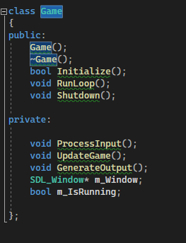

the Initialize function initializes the Game class, the Shutdown function shuts down the game, and the RunLoop function runs the game loop. Finally, ProcessInput, UpdateGame, and GenerateOutput correspond to the three steps of the game loop.

The Initialize function returns true if initialization succeeds and false otherwise. You need to initialize the SDL library with the **SDL_Init()** function. This function takes in a single parameter, a bitwise-OR of all subsystems to initialize. For now, you only need to initialize the video subsystem.

It returns 0 on success or a negative error code on failure; call **SDL_GetError()** for more information.

**SDL_Init()** simply forwards to calling **SDL_InitSubSystem()**. Therefore, the two may be used interchangeably. Though for readability of your code **SDL_InitSubSystem()** might be preferred.

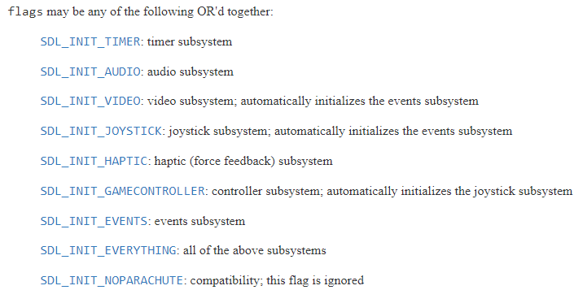

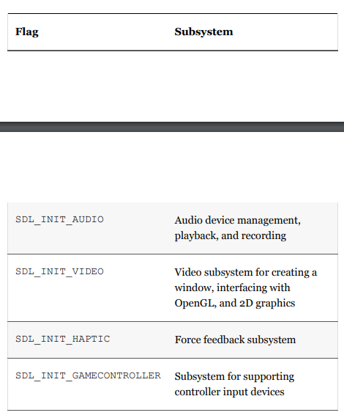

For more info on each subsystem - <https://www.libsdl.org/release/SDL-1.2.15/docs/html/sdlinit.html>

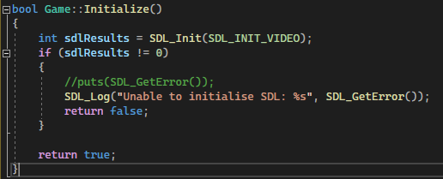

**SDL_Log()** uses the same syntax as the printf function.

If SDL initializes successfully, the next step is to create a window with the SDL_CreateWindow function. The SDL_CreateWindow function takes in several parameters: the title of the window, the x/y coordinates of the top-left corner, the width/height of the window, and optionally any window creation flags

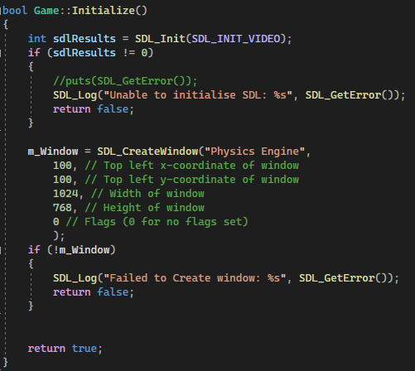

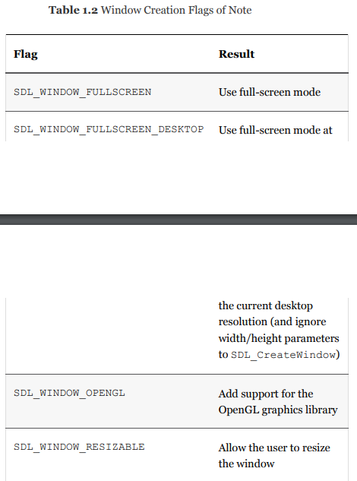

The Shutdown function does the opposite of Initialize. It first destroys the SDL_Window with SDL_DestroyWindow and then closes SDL with SDL_Quit

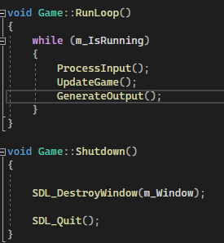

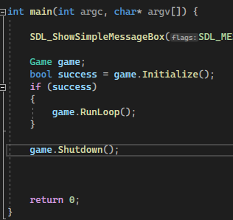

A common way to represent these different actions is with events. When the user does something, the program receives events from the operating system and can choose to respond to these events.

SDL manages an internal queue of events that it receives from the operating system. This queue contains events for many different window actions, as well as events related to input devices. Every frame, the game must poll the queue for any events and choose either to ignore or process each event in the queue. For some events, such as moving the window around, ignoring the event means SDL will just automatically handle it. But for other events, ignoring the event means nothing will happen.

Because events are a type of input, it makes sense to implement event processing in ProcessInput. Because the event queue may contain multiple events on any given frame, you must loop over all events in the queue. The **SDL_PollEvent** function returns true if it finds an event in the queue. So, a very basic implementation of ProcessInput would keep calling **SDL_PollEvent** as long as it returns true.

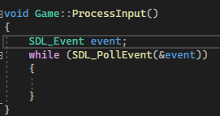

Note that the SDL_PollEvent function takes in an SDL_Event by pointer. This stores any information about the event just removed from the queue.

There is still no way to quit the game. This is because you simply remove all the events from the queue and don’t respond to them.

Given an SDL_Event, the type member variable contains the type of the event received. So, a common approach is to create a switch based on the type inside the PollEvent loop.

One useful event is SDL_QUIT, which the game receives when the user tries to close the window

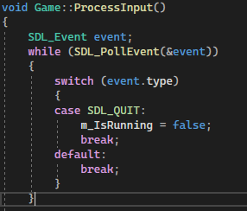

If you wan to check for keyboard input you could use the switch statement or you could check the state of the key with SDL_GetKeyboardState, it returns a pointer to an array that contains the current state of the keyboard. Given this array, you can then query a specific key by indexing into this array with a corresponding SDL_SCANCODE value for the key.

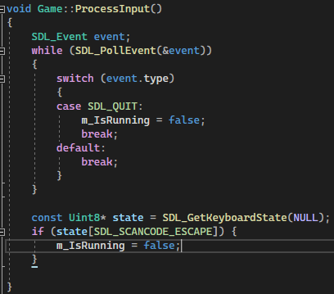

## BASIC 2D GRAPHICS

Most displays in use today—whether televisions, computer monitors, tablets, or smartphones—use raster graphics, which means the display has a two-dimensional grid of picture elements (or pixels). These pixels can individually display different amounts of light as well as different colours. The intensity and colour of these pixels combine to create a perception of a continuous image for the viewer. Zooming in on a part of a raster image makes each individual pixel discernable.

The resolution of a raster display refers to the width and height of the pixel grid. For example, a resolution of 1920×1080, commonly known as 1080p, means that there are 1080 rows of pixels, with each row containing 1920 pixels.

Colour displays mix colours additively to create a specific hue for each pixel. A common approach is to mix three colours together: red, green, and blue (abbreviated RGB). Different intensities of these RGB colours combine to create a range (or gamut) of colours.

In computer graphics, the colour buffer is a location in memory containing the colour information for the entire screen.

The display can use the colour buffer for drawing the contents screen. Think of the colour buffer as a two dimensional array, where each (x, y) index corresponds to a pixel on the screen. In every frame during the “generate outputs” phase of the game loop, the game writes graphical output into the colour buffer.

The memory usage of the colour buffer depends on the number of bits that represent each pixel, called the colour depth. For example, in the common 24-bit colour depth, red, green, and blue each use 8 bits. This means there are 2 , or 16,777,216, unique colours. If the game also wants to store an 8-bit alpha value, this results in a total of 32 bits for each pixel in the colour buffer. A colour buffer for a 1080p (1920×1080) target resolution with 32 bits per pixel uses 1920×1080×4 bytes, or approximately 7.9 MB.

Many game programmers also use the term framebuffer to reference the location in memory that contains the color data for a frame. However, a more precise definition of framebuffer is that it is the combination of the color buffer and other buffers (such as the depth buffer and stencil buffer).

Given an 8-bit value for a color, there are two ways to reference this value in code. One approach involves simply using an unsigned integer corresponding to the number of bits for each color (or channel)

So, for a color depth with 8 bits per channel, each channel has a value between 0 and 255. The alternative approach is to normalize the integer over a decimal range from 0.0 to 1.0.

How you would convert between these two representations is Given an unsigned integer value, divide it by the maximum unsigned integer value to get the normalized value. Conversely, given a normalized decimal value, multiply it by the maximum unsigned integer value to get an unsigned integer value. For now, you should use unsigned integers because the SDL library expects them.

As mentioned earlier in this chapter, games update several times per second (at the common rates of 30 and 60 FPS). If a game updates the color buffer at the same rate, this gives the illusion of motion, much the way a flipbook appears to show an object in motion when you flip through the pages.

… Come back to this

To use SDL’s graphics code, you need to construct an **SDL_Renderer** via the **SDL_CreateRenderer()** function. The term renderer generically refers to any system that draws graphics, whether 2D or 3D. Because you need to reference this **SDL_Renderer** object every time you draw something, first add an *m_Renderer* member variable to Game.

The first parameter to **SDL_CreateRenderer()** is the pointer to the window, The second parameter specifies which graphics driver to use; this might be relevant if the game has multiple windows. But with only a single window, the default is -1, which means to let SDL decide. the last parameter is for initialization flags :

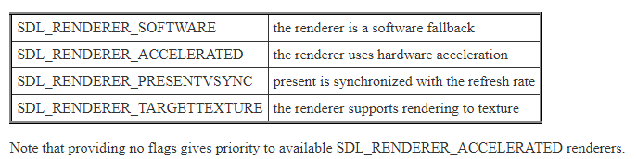

accelerated renderer (meaning it takes advantage of graphics hardware) and enable vertical synchronization.

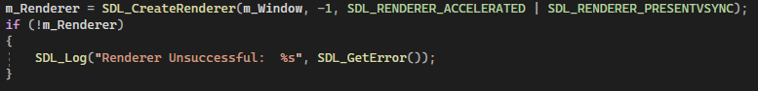

To shut down the renderer, simply add a call to SDL_DestroyRenderer in Game::Shutdown

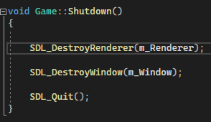

## GameObjects

The term game object refers to anything in the game world that updates, draws, or both updates and draws. There are several methods to represent game objects. Some games employ object hierarchies, others employ composition, and still others utilize more complex methods.

### Types of Game Objects

A common type of game object is one that’s both updated every frame during the “update game world” phase of the loop and drawn every frame during the “generate outputs” phase. Any character, creature, or otherwise movable object falls under this umbrella. For example, in Super Mario Bros., Mario, any enemies, and all the dynamic blocks are game objects that the game both updates and draws.

Developers sometimes use the term static object for game objects that draw but don’t update. These objects are visible to the player but never need to update. An example of this is a building in the background of a level. In most games, a building doesn’t move or attack the player but is visible onscreen.

A camera is an example of a game object that updates but doesn’t draw to the screen.

### Game Object Models

**Game Objects as a Class Hierarchy**

One game object model approach is to declare game objects in a standard object-oriented class hierarchy, which is sometimes called a monolithic class hierarchy because all game objects inherit from one base class:

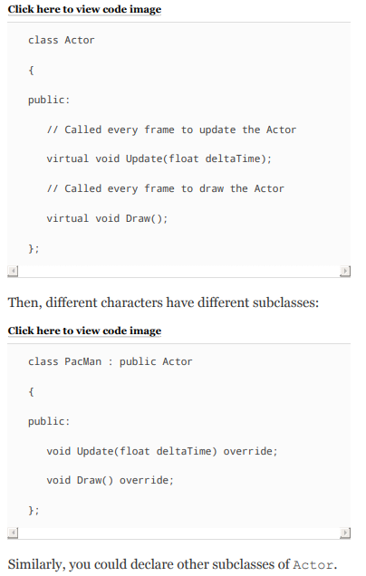

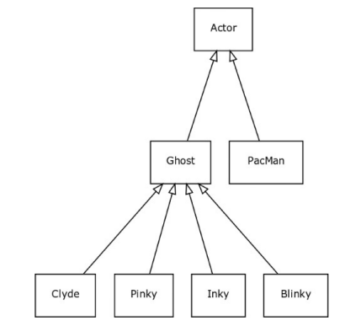

A disadvantage of this approach is that it means that every game object must have all the properties and functions of the base game object (in this case, Actor).

The problem becomes more apparent as the functionality of the game increases. Suppose many of the actors in the game—but not all of them—need to move. In the case of Pac-Man, the ghosts and Pac-Man need to move, but the pellets do not. One approach is to place the movement code inside Actor, but not every subclass will need this code. Alternatively, you could extend the hierarchy with a new MovingActor that exists between Actor and any subclasses that need movement. However, this adds more complexity to the class hierarchy.

having one big class hierarchy can cause difficulties when two sibling classes later need to have features shared between them. For instance, a game in the vein of Grand Theft Auto might have a base Vehicle class. From this class, it might make sense to create two subclasses: LandVehicle (for vehicles that traverse land) and WaterVehicle (for water-based vehicles like boats). But what happens if one day a designer decides to add an amphibious vehicle? It may be tempting to create a new subclass called AmphibiousVehicle that inherits from both LandVehicle and WaterVehicle. However, this requires use of multiple inheritance and, furthermore, means that AmphibiousVehicle inherits from Vehicle along two different paths. This type of hierarchy, called diamond inheritance, can cause issues because the subclass might inherit multiple versions of a virtual function.

### Game Objects with Components

many games instead use a component-based game object model. Instead, the game object class has-a collection of component objects that implement needed functionality.

in a component-based model, Pinky is a GameObject instance containing four components: PinkyBehavior, CollisionComponent, TransformComponent, and DrawComponent

One advantage of the component-based game object model is that it’s easier to add functionality only to the specific game objects that require it. Any object that needs to draw can have a DrawComponent, but objects that don’t simply don’t have one.

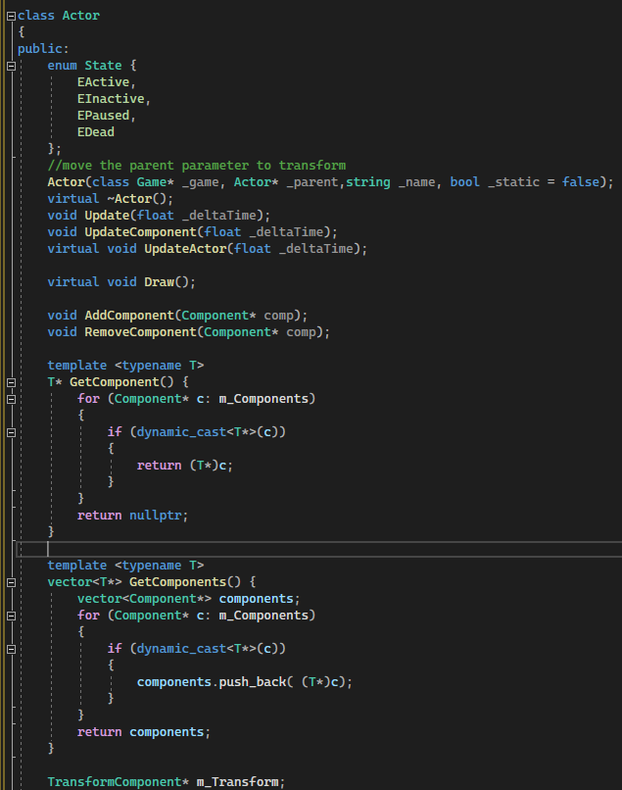

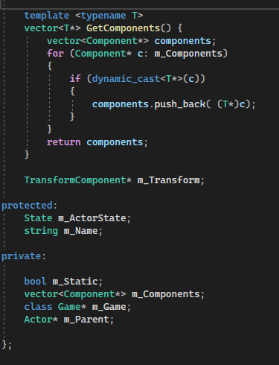

However, a disadvantage of pure component systems is that dependencies between components in the same game object are not clear. For instance, it’s likely that the DrawComponent needs to know about the TransformComponent in order know where the object should draw. This means that the DrawComponent likely needs to ask the owning GameObject about its TransformComponent. Depending on the implementation, the querying can become a noticeable performance bottleneck.

### Game Objects as a Hierarchy with Components

The state enum tracks the status of the actor. For example, Update only updates the actor when in the EActive state. The EDead state notifies the game to remove the actor. The Update function calls UpdateComponents first and then UpdateActor. UpdateComponents loops over all the components and updates each in turn. The base implementation of UpdateActor is empty, but Actor subclasses can write custom behavior in an overridden UpdateActor function.

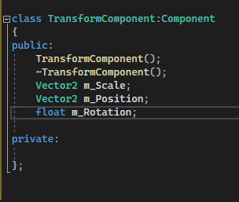

the Actor class needs access to the Game class for several reasons, including to create additional actors. One approach is to make the game object a singleton. Instead of using singletons, this book uses an approach called dependency injection.

In this approach, the actor constructor receives a pointer to the Game class. Then an actor can use this pointer to create another actor (or access any other required Game functions).

Currently, the implementations of Actor and Component do not account for player input devices.

This hybrid approach does a better job of avoiding the deep class hierarchies in the monolithic object model, but certainly the depth of the hierarchy is greater than in a pure component-based model. The hybrid approach also generally avoids, though does not eliminate, the issues of communication overhead between components. This is because every actor has critical properties such as the transform data.

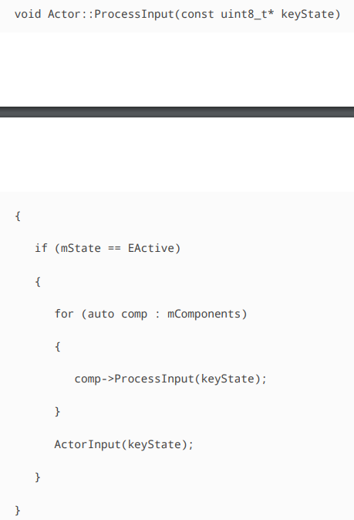

**Other Approaches**

There are many other approaches to game object models. Some use interface classes to declare the different possible functionalities, and each game object then implements the interfaces necessary to represent it. Other approaches extend the component model a step further and eliminate the containing game object entirely. Instead, these approaches use a component database that tracks objects with a numeric identifier. Still other approaches define objects by their properties. In these systems, adding a health property to an object means that it can take and receive damage.

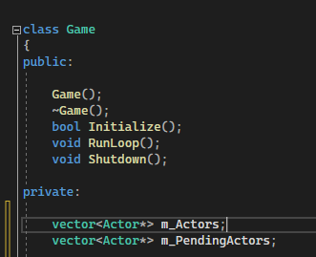

You need the pending actors vector to handle the case where, while updating the actors (and thus looping over mActors), you decide to create a new actor. In this case, you cannot add an element to mActors because you’re iterating over it. Instead, you need to add to the mPendingActors vector and then move these actors into mActors after you’re done iterating.

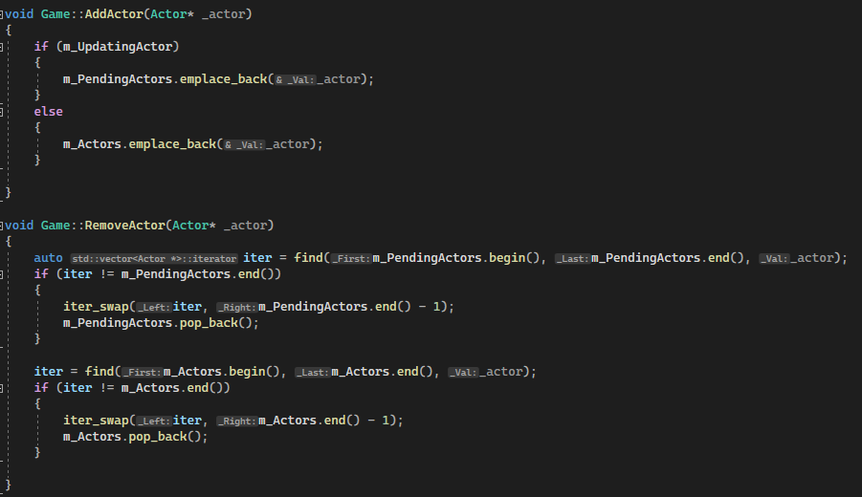

Similarly, RemoveActor removes the actor from whichever of the two vectors it is in. You then need to change the UpdateGame function so that it updates all the actors.

you move any pending actors into the main mActors vector. Finally, you see if any actors are dead, in which case you delete them.

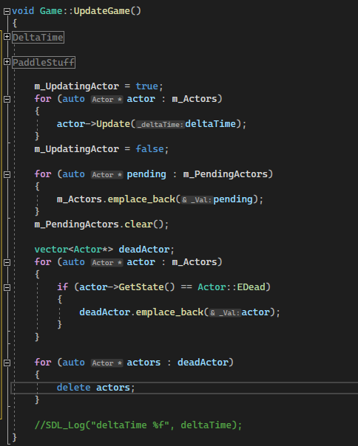

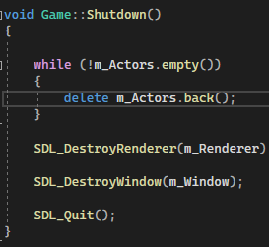

## SPRITES

A sprite is a visual object in a 2D game, typically used to represent characters, backgrounds, and other dynamic objects. Most 2D games have dozens if not hundreds of sprites, and for mobile games, the sprite data accounts for much of the overall download size of the game. Because of the prevalence of sprites in 2D games, it is important to use them as efficiently as possible.

Each sprite has one or more image files associated with it. There are many different image file formats, and games use different formats based on platform and other constraints. For example, PNG is a compressed image format, so these files take up less space on disk. But hardware cannot natively draw PNG files, so they take longer to load. Some platforms recommend **using graphics hardware–friendly formats such as PVR (for iOS) and DXT (for PC and Xbox)**.

initialize SDL Image by using IMG_Init, which takes in a flag parameter for the requested file formats.

SDL already supports the BMP file format

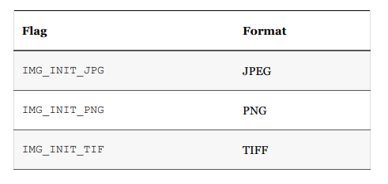

Once SDL Image is initialized, you can use IMG_Load to load an image file into an SDL_Surface

Next, SDL_CreateTextureFromSurface converts an SDL_Surface into an SDL_Texture (which is what SDL requires for drawing)

Suppose a game has a basic 2D scene with a background image and a character. A simple way to draw this scene is by first drawing the background image and then the character. This is like how a painter would paint the scene, and hence this approach is known as the painter’s algorithm. In the painter’s algorithm, the game draws the sprites in back-to-front order

To draw textures, there are two different texture drawing functions in SDL. The simpler function is SDL_RenderCopy, for more advanced behavior (such as rotating sprites), you can use SDL_RenderCopyEx.

## MATHS

SDL expects an angle in degrees, but Actor uses an angle in radians

in SDL a positive angle is clockwise, but this is the opposite of the unit circle (where positive angles are counterclockwise). Thus, negate the angle to maintain the unit circle behavior

## INPUT

### MoveComponent

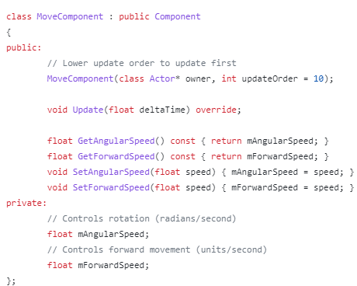

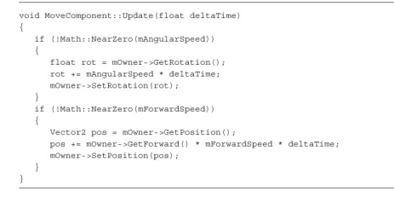

### Creating an InputComponent Class

The base MoveComponent is fantastic for objects like the asteroids that the player doesn’t control. However, if you want a ship that the player can control with the keyboard, you have a dilemma. One idea is to create a custom function for input in the Ship class.

However, because hooking up input to an actor or a component is a common need, it’s sensible to incorporate this into the game object model

you first add a virtual ProcessInput function to Component, with an empty default implementation



Then in Actor, you declare two functions: a non-virtual ProcessInput and a virtual ActorInput function. The idea here is that actor subclasses that want custom input can override ActorInput but not ProcessInput (like how there are separate Update and UpdateActor functions):

